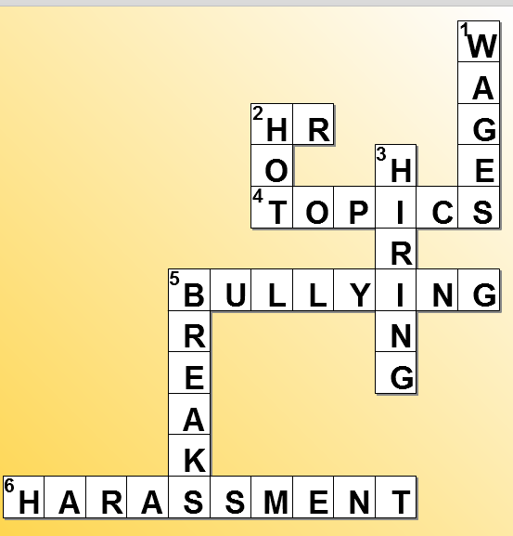
In today’s work environment, employers are required to maintain harmony and balance for their employees regarding behavior in the workplace as it relates to harassment. In the State of California, companies with 50 or more employees must conduct Harassment Avoidance Training every 18 months; and within 6 months of promoting an individual into a supervisory role. It includes:
  - Sexual Harassment is unwelcomed sexual conduct that affects work or the employment status of an employee. Examples are: Visual Conduct: leering, making sexual gestures, displaying of sexually suggestive objects or pictures; Verbal Conduct: making or using derogatory comments, and verbal abuse of a sexual nature, sexually degrading words used to describe an individual; and Physical Conduct: touching, assault, impeding, or blocking movements.
  - Hostile Environment arises from inattentive management allowing a pattern of harassment, so severe, pervasive and repetitive that it creates an intimidating, hostile or offensive work environment. It can exist even if there are no sexual advances or romantic overtures. Examples: jokes, emails/voicemails, leering, touching, team building at strip clubs, etc.
  - Quid Pro Quo harassment occurs when employment decisions or expectations are based on an employee’s submission to or rejection of sexual advances, requests for sexual favors, or other behavior of a sexual nature. Example: “If you go on a date with me, I will give you a promotion, increase your salary, give you prime shift hours”, etc.
  - Retaliation occurs after an employee reports an issue or files a claim against the company, and can take many forms (not merely termination). Examples: cold shoulder treatment; stricter evaluation of performance; adverse action shortly after a complaint; and adverse action not supported by legitimate business reasons.
  - Bullying is repeated, health-harming mistreatment of one or more persons (the targets) by one or more perpetrators. It is abusive conduct that is threatening, humiliating or intimidating; or work interference – sabotage – which prevents work from getting one; or verbal abuse. It includes cyber-stalking and cyber-bullying as well.

In order to protect their company and their employees, employers must take the lead to maintain a harassment-free, productive work environment. Here are some tips to support those efforts.

- Conduct training for all employees, regardless of company size.
- Address problem performances before they get to the end of their rope.
- Never retaliate –
  - Don’t reduce an employee’s hours for any reasons other than business need;
  - Don’t schedule an employee for difficult shifts unless there is a true business need;
  - Don’t cut an employee’s pay, or reduce/eliminate a bonus, unless you have discussed the reasons for doing so with HR;
- Lastly, don’t ever overtly threaten an employee with physical harm.

Penalties are enormous – all it takes is one complaint.

