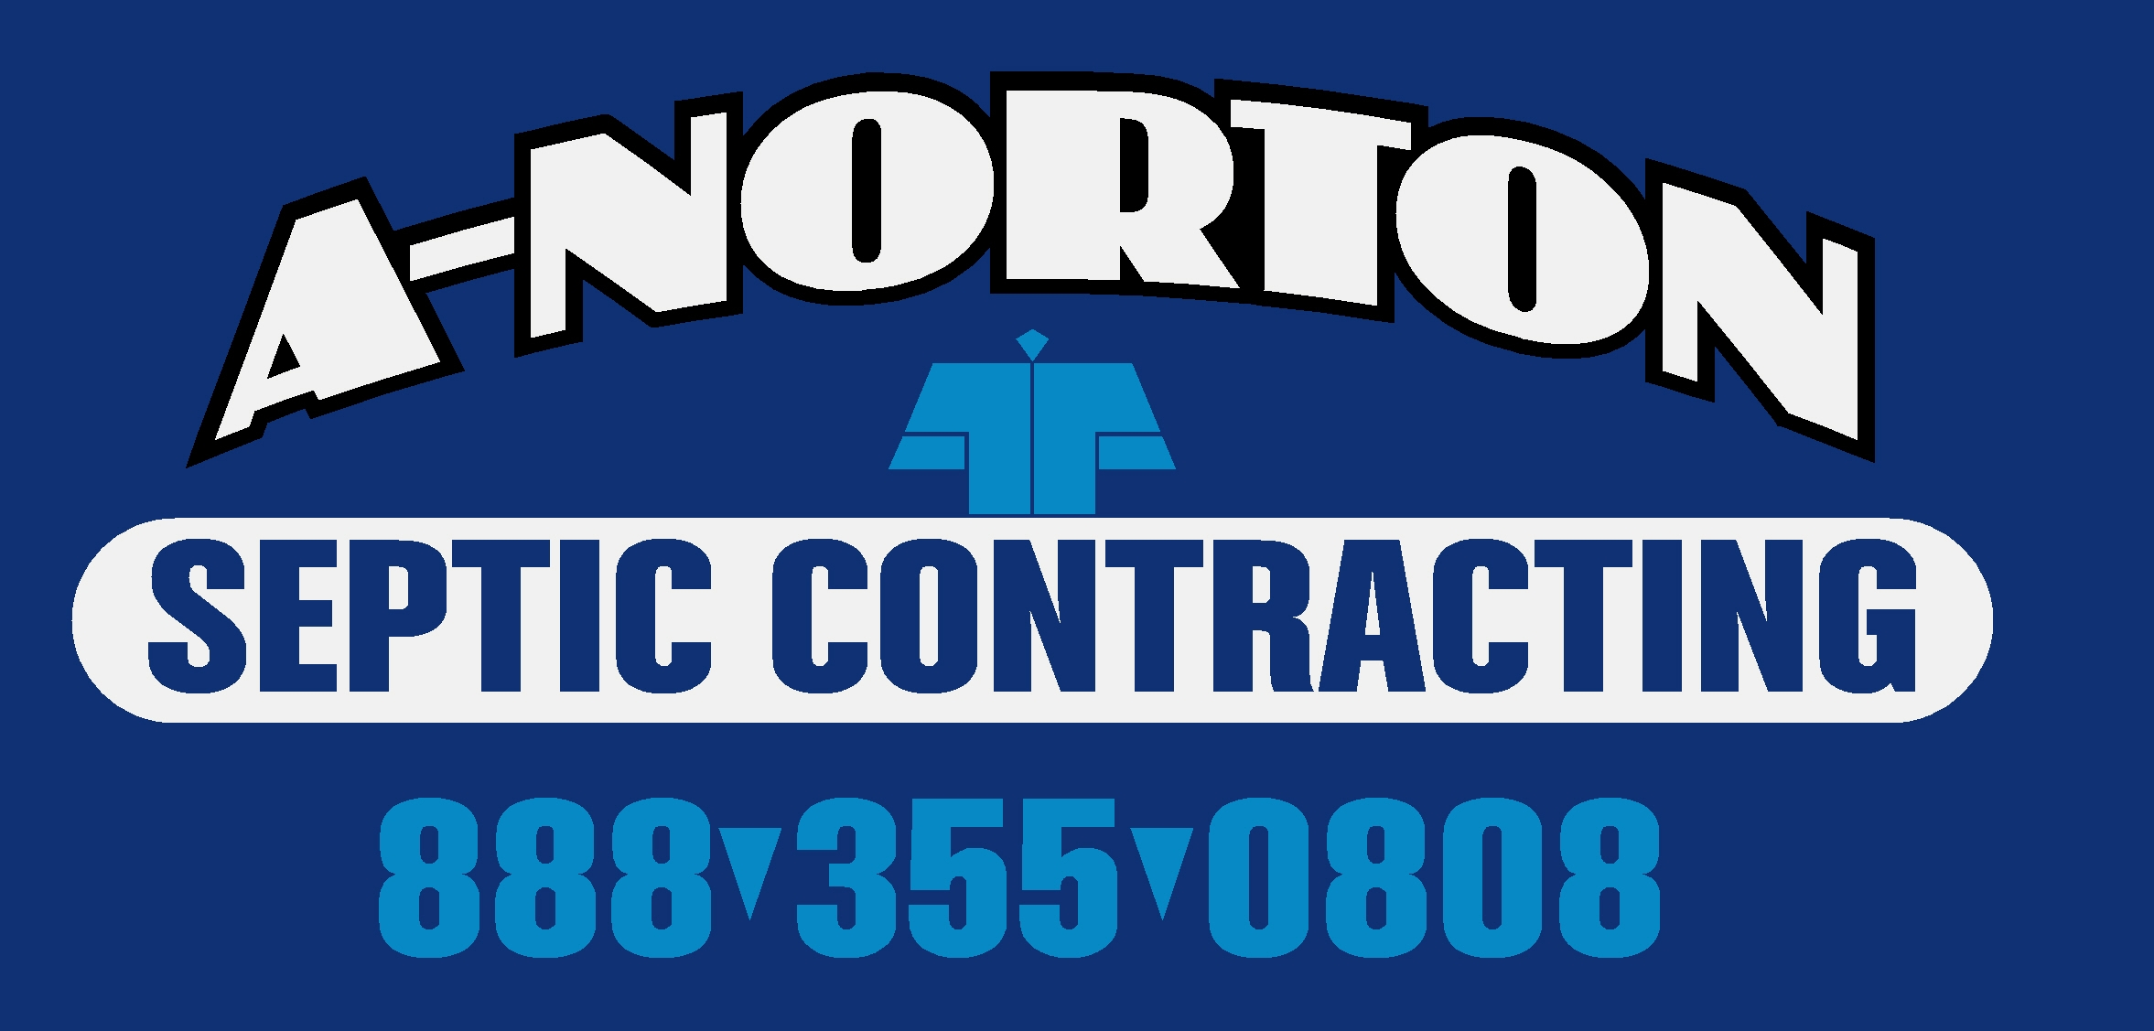

Further Information Links:

State of New Jersey DEP
Department of Water Quality
http://www.state.nj.us/dep/dwq/

Eco-Pure Waste Water Systems/Planet Care, Inc.
http://www.eco-purewastewatersystems.com/homepage.html

NJ One Call (Utility Mark-out)
800-272-1000

PSMA/NJSMA (Pennsylvania & NJ Septage Management Association)
http://www.psma.net/ 717-763-PSMA

NJ Township & Municipal Directory
http://www.nj.gov/

Division of Consumer Affairs
http://www.njconsumeraffairs.gov/

Local Health Departments in NJ
http://www.state.nj.us/health/lh/directory/lhdselectcounty.shtml

Mercer County-Hamilton Township Division of Health
609-890-3820 609-890-6093 Fax
http://www.hamiltonnj.com/

EAST WINDSOR TWP * HAMILTON TWP (MERCER CO.)

Mercer County-Princeton Regional Health Commission
609-497-7608 609-924-7627 Fax
http://www.princetonboro.org/

PRINCETON BORO * PRINCETON TWP

Mercer County-West Windsor Health Department
609-799-2400 609-799-2136 Fax
http://www.westwindsornj.org/

HIGHTSTOWN BORO * ROBBINSVILLE * WEST WINDSOR TWP

Middlesex County Health Department
732-745-8489 732-745-8484 Fax
http://co.middlesex.nj.us/publichealth/

CARTERET * CRANBURY * DUNELLEN * EAST BRUNSWICK * HELMETTA * HIGHLAND PARK * JAMESBURG
METUCHEN * MILLTOWN * MONROE TWP (MIDDLESEX CO.) * NEW BRUNSWICK * NORTH BRUNSWICK
OLD BRIDGE * PERTH AMBOY * PISCATAWAY * PLAINSBORO * SAYREVILLE * SOUTH AMBOY
SOUTH PLAINFIELD * SOUTH RIVER * SPOTSWOOD

Middlesex County-South Brunswick Health Department
732-4000 ext 7237 732-329-4168 Fax
http://www.sbtnj.net/

Monmouth County Health Department
    - 732-409-7579 Fax
http://www.visitmonmouth.com/

ABERDEEN * ALLENTOWN BORO * ASBURY PARK CITY * ATLANTIC HIGHLANDS * AVON-BY-THE-SEA * BELMAR BRADLEY BEACH * ENGLISHTOWN * FARMINGDALE * HAZLET * HOWELL TWP * LAKE COMO BORO
MANASQUAN * MARLBORO TWP * MATAWAN * MILLSTONE TWP * NEPTUNE CITY * NEPTUNE TWP
OCEANPORT * ROOSEVELT BORO * UNION BEACH

Monmouth County-Colts Neck Health Department
732-462-5470 ext 109 732-431-3173 Fax
http://www.colts-neck.nj.us/

Monmouth County-Freehold Health Department
732-294-2060 732-462-2340 Fax
http://www.twp.freehold.nj.us/

FREEHOLD BORO * FREEHOLD TWP * UPPER FREEHOLD

Monmouth County-Holmdel Health Department
732-946-2820 Ext 1502
http://www.holmdeltownship-nj.com/

Monmouth County-Manalapan Health Department
    - 732-446-1576 Fax
http://www.mtnj.org/

Monmouth County-Middletown Health Department
    - 732-671-8697 Fax
http://www.middletownnj.org/

Monmouth County-Regional Health Commission
732-493-9520 732-493-9521 Fax
http://www.mcrhc.org/

ALLENHURST * BRIELLE * DEAL * EATONTOWN * FAIR HAVEN * HIGHLANDS * INTERLAKEN
KEANSBURG * KEYPORT * LITTLE SILVER * LOCH ARBOR VILLAGE * MONMOUTH BEACH * OCEAN TWP
RED BANK & RUMSON * SEA BRIGHT * SEA GIRT BORO * SHREWSBURY * SHREWSBURY TWP
SPRING LAKE BORO * SPRING LAKE HEIGHTS * TINTON FALLS * WALL TWP * WEST LONG BRANCH

Somerset County-Hillsborough Health Department
    - 908-369-8565 Fax
http://www.hillsborough-nj.org/

HILLSBOROUGH * MILLSTONE BORO

Somerset County Division of Health
    - 908-704-8042 Fax
http://www.co.somerset.nj.us/health/

BEDMINSTER * FAR HILLS * FRANKLIN TWP (SOMERSET CO. * NORTH PLAINFIELD
ROCKY HILL (SOMERSET CO.)

Note: Alteration of, or interlineations to, this document by anyone other than A-Norton Septic and Waste is null and void for all purposes

