OPTION #1 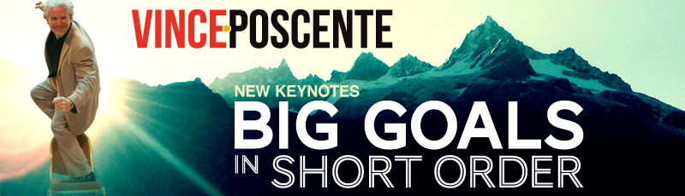

Vince Poscente
(>100 word Biography)

Use Vince Poscente’s expertise to your advantage. His against-all-odds Olympic strategy is powerful way to have your team reach BIG GOALS fast. Vince is a business guy who decided he would compete in the Olympics four years after his 26th birthday. At the age of 30 Poscente was vying for Gold, blasting down the mountain at an incredible 135 mph on skis. With his acumen for speedy goals, he soon became a New York Times bestselling author and Internationally award winning speaker.

Vince Poscente will help you accelerate towards BIG GOALS in Short Order.

OPTION #2

Vince Poscente
(>100 word Biography)

Vince Poscente’s is a master communicator uniquely qualified to help leaders, influencers and sales people raise their Communication IQ. As President and CEO of Communication IQ, he is also an Olympian, New York Times bestselling author, Internationally award winning speaker and serial entrepreneur (notably - founder of Pattern Video Productions and former SVP of International Investment Properties). He has invigorating perspectives on powerful and sustained messaging.

Vince Poscente will help you create INSTANT IMPACT & LASTING INFLUENCE.

