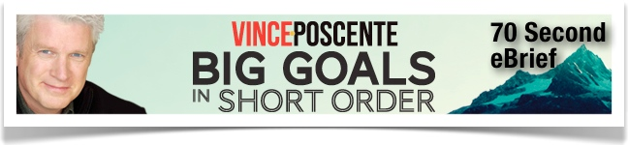

Learning to Thrive in a More-Faster-Now World

The four profiles organizations and individuals respond to in the speed of business and life. The final profile, a Jet, identifies the three qualities to thrive in The Age of Speed.

Participants identified the defining moments they’ve had in their life.
These defining moments reveal patterns of decision making.
Once these patterns are identified it’s easier for the individual to realize they have the choice to make decisions the same way or make new kinds of decisions.

Four Profiles

1. Zeppelins – Organizations and individuals are Zeppelins when they stubbornly resist the speed of change or anything new. Zeppelins lose out on future opportunity.

2. Balloons – When a company or person checks out from the speed in the business of life, he is a Balloon. Balloons aren’t just the realm of the idle rich. Balloons learn how to let speed go on around them in a flowing way.

3. Bottle Rockets – A Bottle Rocket embraces speed but doesn’t harness it. People and groups suffer when they charge ahead without addressing necessary adaptations along the way.

4. Jets – Individuals and companies who are aligned, agile and aerodynamic will respond the best in the age of speed.

- Aligned – Understand that alignment is not just an organizational issue. In fact, it starts with people with an emotional connection to goals. This is called the emotional buzz. Understanding the concept of the ant-like conscious mind and the elephantine subconscious mind leads to more alignment. See The Ant and the Elephant.

Participants became aware of the “emontional buzz” indicating WHY they do the job they do.

Attaching emotion to a job makes the job easier and increases the level of commitment by the person on the job.

- Agility – For optimum results at speed, agility is critical. Adapting efficiently to change in real time is possible when organizations and individuals have sufficiently prepared.

The participant identified the kinds of things someone like them at a competing company is not willing to do. (Typically, those are the things the participant is not willing to do either. Hence they became clear on the kinds of actions that will produce the best results.)

Participants became aware of the 360 Degree Research concept to better understand the variety of ways to “do what the competition is not willing to do.”

- Aerodynamic – It is important for everyone to look for ways to eliminate drag in everyday life. Two areas that must be addressed are interruptions and multitasking. Use technology in a way that minimizes interruptions. Do not multitask significant responsibilities.

Participants identifed the list of things that cause drag in the business of life.

They split their list into Micro Drag (interruptions, multitasking, etc.) and Macro Drag (high fear, low confidence)

Participants conclude the session identifying the ways they reconcile results, good or bad, big bumps or small bumps in life, in order to continue to reinvent themselves and how they show up at work and at home.

To receive a free, 70 Second eBrief designed to coach business professionals and entrepreneurs in the areas of leadership and communication – click here.

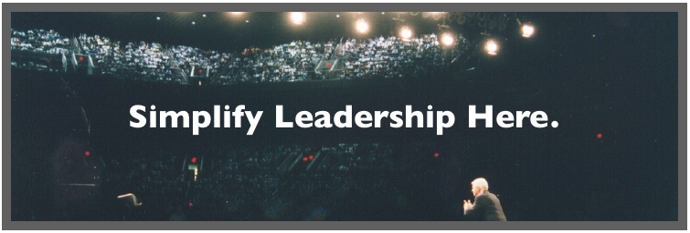

For more information about creating instant impact and lasting influence in your life and the lives of others contact:
Vince Poscente International 214.752.7400 or info@vinceposcente.com

