OPPORTUNITY REVIEW WORKSHEET:
Explore and Strategize
+ Present and Close

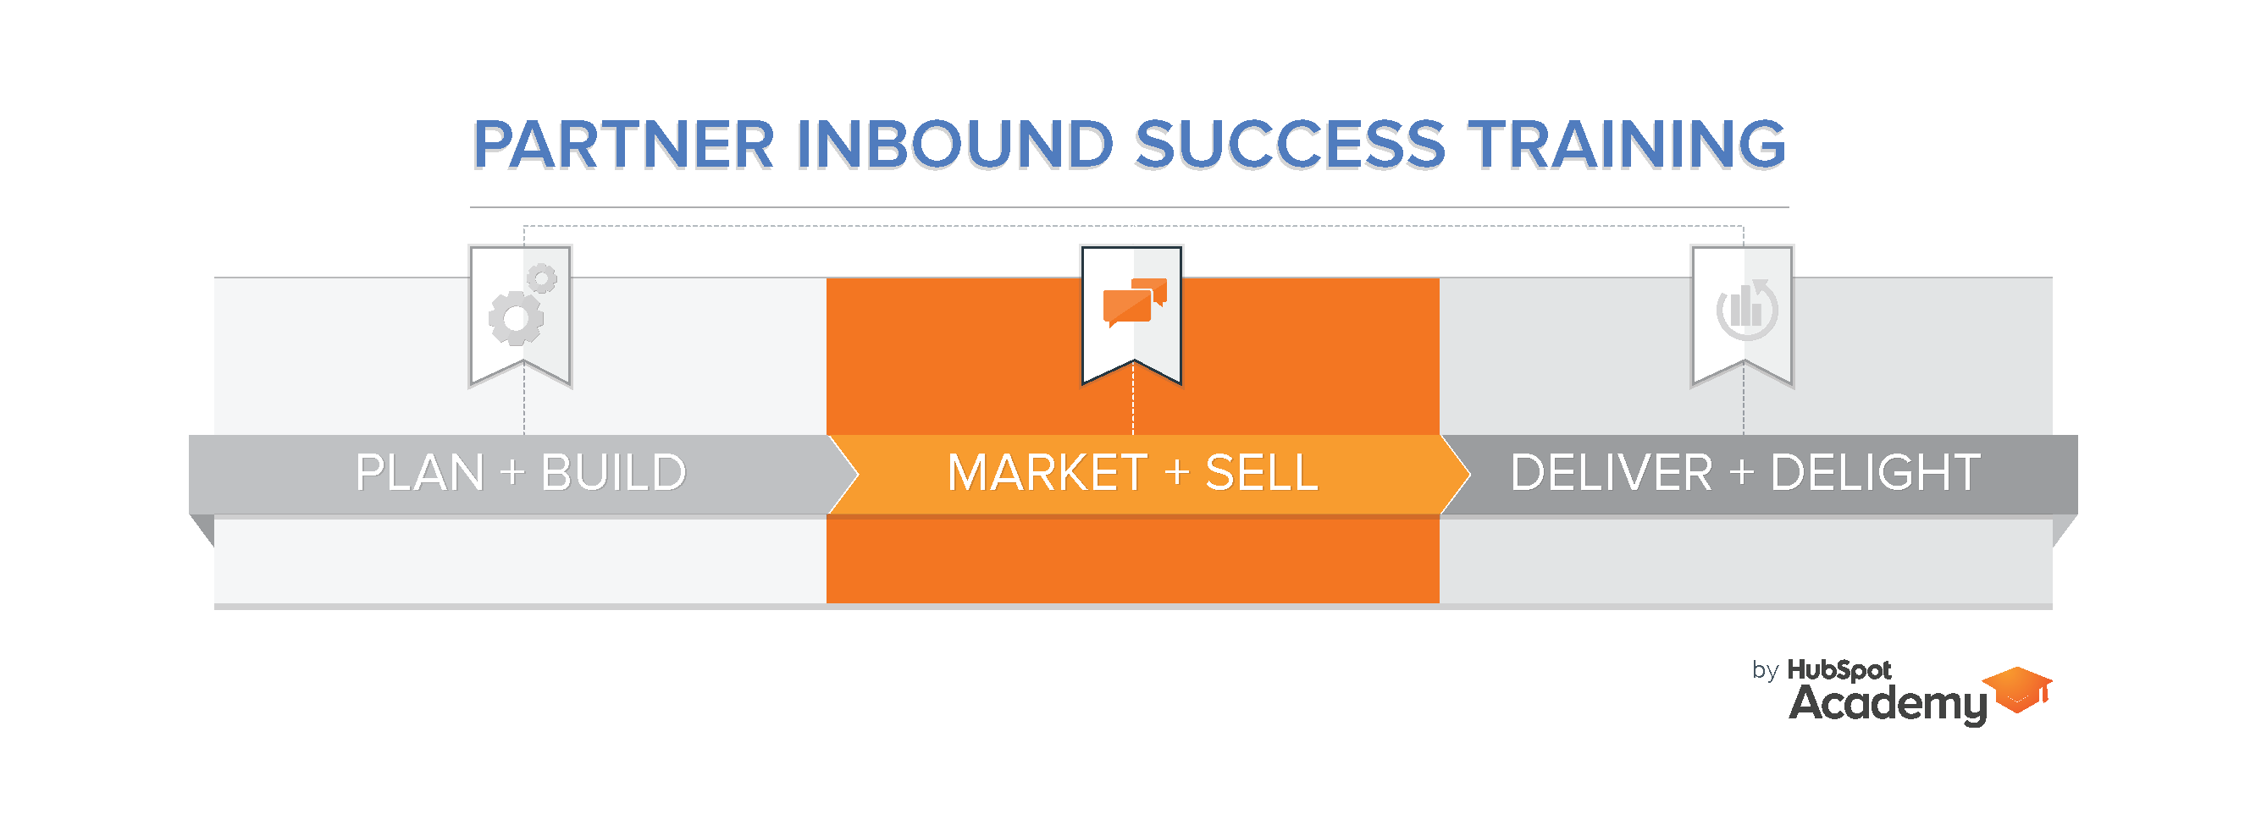

Opportunity Review Worksheet
Instructions:
1. Use this worksheet to prepare for any prospect meeting, including the Exploratory Call, Goal Setting & Planning Call, or the Present & Close Call.
2. Use [File | Make a Copy] to save a copy to your own Google Drive. You can then edit, as well as share with your CAM or others by using [File | Share]
3. Complete as much as you can given where you are in the sales process. Plan to gather information to fill in blanks at your next meeting.

Company Information
Company name: | URL:
Is the lead registered with Hubspot? | Other Important Company Information:

Key Contact Information
Name | Role | LinkedIn URL | Other Notes

Excite
Is the prospect excited about Inbound?
If yes, what aspect do they find most exciting?
What other aspects do they find exciting?
Qualify
BANT
What is the Prospect’s…. | Score (1-10) | Comments
Overall BANT
Budget
Authority
Need
Timing

Goals, Plans, Challenges
What are the Prospect’s…. | Description
Goals
Plans
Challenges

Cost of Inaction & Compelling Reason
What is the Prospect’s…. | Description
Compelling Reason to Make a Change?
Cost of Inaction?

For Hubspot Demo (especially useful if involving your CAM in a demo)
Description
On what Hubspot tools should the CAM focus?
What potential hazards should be avoided (i.e. areas of political or other sensitivities)?
What happens after the demo?
What systems are currently in place? (i.e. CRM, email, SEO, analytics, content management, etc)

