Verifone CR600 & MagTek MiniMICR
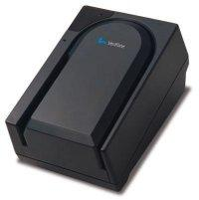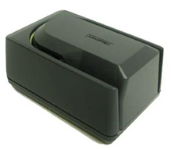
- Baud Rate: 4800-19200 (Should be configured for 19200)
- USB: Must use Prolific USB-to-Serial Converter.
NOTE: The adapter only emulates a serial port. It does not make it a "USB enabled" device.
- MagTek MiniMICR Serial: Must use proprietary cable Part#: 22517579
- Verifone CR600 Serial: Must use proprietary cable Part#: 05465-00

Setup Process for serial cable:
  - Plug the serial cable into the device and the COM port on the back of the PC, or the USB-to-Serial converter. Plug in the power supply which plugs into the device.
  - Log on www.cross-check.com/logon
  - Click on either Approve a Check, then MICR Scan Single Check.
  - License agreement page will show ¹ and a pop-up window needs to happen. The browser must allow pop-ups for the "print receipt". If a pop-up is blocked, a pop-up blocker detector should detect this and give a warning. Refresh the page to make the pop-up window appear again. The pop-up window must be open for at least 1-2 seconds before closing it.
  - If using the Prolific USB-to-Serial Converter we provide, the driver needs to be downloaded and installed from this popup window first before closing the window. SEE USB-TO-SERIAL SETUP INSTRUCTIONS
  - Close the popup window.
  - Click I Accept
  - Install the MagTek MICRImage plug-in (created by MagTek), which allows a web page to communicate with the device . Both the Verifone CR600 and the MagTek MiniMICR use this.
  - *** SCAN CHECK THROUGH MICR READER NOW *** should show and the device should be ready for scanning if the correct config settings are set.
  - Scan a test check through.²
Trouble Shooting:
- If receiving an error message communicating with the device, verify the PC meets all system requirements (internet browser, hard drive space, operating system, etc.)
- Verify the user has administrative privileges on their PC as this is required. Script errors being reported by the browser usually means they don’t have adequate privileges.
- Verify COM ports in the device manager of the merchant’s PC and that they have it plugged into appropriate COM port. This can be accessed on XP by right clicking on my computer in Explore, choosing properties, choosing Hardware tab, then Device Manager.
- On the Error page click “Manual Configure” and try other baud ratings. Click “Save Settings” after setting COM port and baud rate each time. Click “Back to Scan Check” to test each setting. If error still appears, try using “Activate AutoDetect” – this can take several minutes.
¹ If a device is already configured, the license agreement page will not display. Use the Reconfigure Device link at bottom, then click the Change Device button to go back to the license agreement page.
² Business Office Conversion Plus requires the Bank Route # on the check to be “123456780” in order to issue a test approval. MICR Scan Conversion Plus requires ID State “ZZ” and ID Number of “12345” to issue a test approval.

MagTek Excella & Excella STX
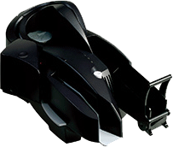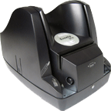
- USB: Standard USB 2.0 cable
- Serial: NOT Supported by CrossCheck
- Ethernet: NOT Supported by CrossCheck

Setup Process for USB cable:
- Do NOT plug in the device to the PC just yet. (This allows a smooth install)
- Log on www.cross-check.com/logon
- Click on either MICR Scan Conversion Plus or Business Office Conversion Plus
- License agreement page will show ¹ and a pop-up window needs to happen. The browser must allow pop-ups. If a pop-up is blocked, a pop-up blocker detector should detect this and give a warning. Refresh the page to make the pop-up window appear again.
- Within the window, click on Download CrossCheck Excella Setup Installation and install..
- Plug the USB cable into the device and the PC. Plug in power supply Part#: DTS240250U-P5P-R/A-ET . Windows should detect the device being plugged and show "Magtek Excella" device detected.
- Restart Internet Explorer and log on to www.cross-check.com/logon again and click on either MICR Scan Conversion Plus or Business Office Conversion Plus
- Back at the “License Agreement” web page, close the pop-up window.
- Choose Excella / Excella STX under Choose Device
- Click I Accept
- The first ActiveX control will install after approving installation: A CrossCheck FS (file system) Utility created by CrossCheck to allow file renaming and deleting of the scanned images.
- Place a check into one of the input trays on the left of the Excella or Excella STX. Click on Start Scanning Checks for a check to pull through the scanner. Enter any necessary test check information². Verify and click “Approve” to begin processing.
- Test responses for each check should appear and a new popup window will appear that will upload all images. Install the last ActiveX control: Persits XUpload Control. This will install after approving installation. When the window says “Finished uploading images”, this window can be closed. A support rep should verify the image has been received. An image can take up to a minute to show up on CrossCheck's system for a support rep to pull up.
Trouble Shooting:
- If receiving an error message communicating with the device, verify the PC meets all system requirements (internet browser, hard drive space, operating system, etc.)
- Verify the user has administrative privileges on their PC as this is required. Script errors being reported by the browser usually means they don’t have adequate privileges.
- Ensure the Excella does not show any red lights or blinking lights. The Excella should have both side latches pressed down (will click in) and all 3 lights should not be blinking and green.

¹ If a device is already configured, the license agreement page will not display. Use the Reconfigure Device link at bottom, then click the Change Device button to go back to the license agreement page.
² Business Office Conversion Plus requires the Bank Route # on the check to be “123456780” in order to issue a test approval. MICR Scan Conversion Plus requires ID State “ZZ” and ID Number of “12345” to issue a test approval.

Ingenico 2500/2600 series
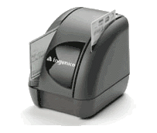
- Baud Rate: 4800-57600 (Should be configured for 38400 for reliability)
- USB: Must use proprietary USB cable Part#: 6035060790100
- Serial: Proprietary RDM serial cable Part#: AC00454
  - Note: Will NOT work with the Prolific USB-to-Serial Converter
Setup Process for serial cable:
  - Plug the 9-pin DIN part of the serial cable into "HOST" on the back of the Ingenico. Plug the other end into a COM port on the PC. Plug the power supply which plugs into the cable Part#: WD1E1500LCP-N .
  - Log on www.cross-check.com/logon
  - Click on either MICR Scan Conversion Plus or Business Office Conversion Plus
  - License agreement page will show ¹ and a pop-up window needs to happen. The browser must allow pop-ups. If a pop-up is blocked, a pop-up blocker detector should detect this and give a warning. Refresh the page to make the pop-up window appear again. The pop-up window must be open for at least 1-2 seconds before closing it.
  - Do NOT close the popup window. Click on Download CrossCheck Ingenico Setup Installation and install.
  - Close the popup window.
  - Choose Ingenico 2500/2600 under Choose Device
  - Click I Accept
  - The first ActiveX control will install after approving installation: A CrossCheck FS (file system) Utility created by CrossCheck to allow file renaming and deleting of the scanned images on the merchant’s PC.
  - *** SCAN CHECK THROUGH INGENICO IMAGER NOW *** should show and the device should be ready for scanning.
  - Scan a test check through. Enter any necessary test check information². Verify and click “Approve” to begin processing.
  - “Test Completed Normally” should appear and a new popup window will appear that will upload the image. Install the last ActiveX control: Persits XUpload Control. This will install after approving installation. When the window says “Finished uploading images”, this window can be closed. A support rep should verify the image has been received. An image can take up to a minute to show up on CrossCheck's system for a support rep to pull up.
Setup Process for USB cable:
  - Do NOT plug in the device to the PC just yet. (This allows a smooth install)
  - Log on www.cross-check.com/logon
  - Click on either MICR Scan Conversion Plus or Business Office Conversion Plus
  - License agreement page will show ¹ and a pop-up window needs to happen. The browser must allow pop-ups. If a pop-up is blocked, a pop-up blocker detector should detect this and give a warning. Refresh the page to make the pop-up window appear again.
  - Within the window, click on “Download Ingenico USB Driver"
  - Unzip the IngenicoUSB.zip to the hard drive.
  - Plug the 9-pin DIN part of the serial cable into "HOST" on the back of the Ingenico. Plug the other end into a COM port on the PC. Plug the power supply which plugs into the cable Part#: WD1E1500LCP-N .
  - Double click on the USB hardware list icon (found in bottom right), you will see the with an unknown device or ACG PC/SC
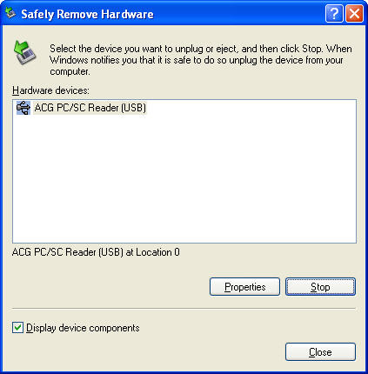
  - Click on Properties
  - Click on Driver Tab
  - Click on "Update Driver" button
  - Choose "Install from a list or specific location"
  - Choose "Don't search. I will choose the driver to install."
  - Click "Have Disk" button
  - Select the location you extracted the zip file and "USB Serial Converter" will appear.
  - Back at the “License Agreement” web page, close the pop-up window.
  - Choose Ingenico 2500/2600 under Choose Device.
  - License agreement page will show ¹ and a pop-up window needs to happen. The browser must allow pop-ups. If a pop-up is blocked, a pop-up blocker detector should detect this and give a warning. Refresh the page to make the pop-up window appear again. The pop-up window must be open for at least 1-2 seconds before closing it.
  - Do NOT close the popup window. Click on Download CrossCheck Ingenico Setup Installation and install.
  - Close the popup window.
  - Choose Ingenico 2500/2600 under Choose Device
  - Click I Accept
  - The first ActiveX control will install after approving installation: A CrossCheck FS (file system) Utility created by CrossCheck to allow file renaming and deleting of the scanned images on the merchant’s PC.
  - *** SCAN CHECK THROUGH INGENICO IMAGER NOW *** should show and the device should be ready for scanning.
  - Scan a test check through. Enter any necessary test check information². Verify and click “Approve” to begin processing.
  - “Test Completed Normally” should appear and a new popup window will appear that will upload the image. Install the last ActiveX control: Persits XUpload Control. This will install after approving installation. When the window says “Finished uploading images”, this window can be closed. A support rep should verify the image has been received. An image can take up to a minute to show up on CrossCheck's system for a support rep to pull up.
Trouble Shooting:
- If receiving an error message communicating with the device, verify the PC meets all system requirements (internet browser, hard drive space, operating system, etc.)
- Verify the user has administrative privileges on their PC as this is required. Script errors being reported by the browser usually means they don’t have adequate privileges.
- Verify COM ports in the device manager of the merchant’s PC and that they have it plugged into appropriate COM port. This can be accessed on XP by right clicking on My Computer in Explore, choosing properties, choosing Hardware tab, then Device Manager.
- Ensure there is a solid green light on the RDM Imager.
- On the Error page click “Manual Configure” and try baud ratings 57600, 38400, & 19200. Click “Save Settings” after setting COM port and baud rate each time. Click “Back to Scan Check” to test each setting. If error still appears, try using “Activate AutoDetect” – this can take several minutes.

¹ If a device is already configured, the license agreement page will not display. Use the Reconfigure Device link at bottom, then click the Change Device button to go back to the license agreement page.
² Business Office Conversion Plus requires the Bank Route # on the check to be “123456780” in order to issue a test approval. MICR Scan Conversion Plus requires ID State “ZZ” and ID Number of “12345” to issue a test approval.

MagTek MICRImage RS232
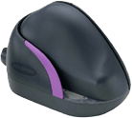
- Baud Rate: 19200-115200 (Should be configured for 115200)
- USB: Must use proprietary MagTek MICRImage USB cable Part#: 22410313
(NOTE: will not work with the Prolific USB-to-Serial converter)
- Serial: Must use proprietary MagTek MICRImage serial cable Part#: 22410302

Setup Process for serial cable:
  - Plug the serial cable into the device and the COM port on the back of the PC. Plug in the power supply which plugs into the cable Part#: DSA-0151F-12 A .
  - Log on www.cross-check.com/logon
  - Click on either MICR Scan Conversion Plus or Business Office Conversion Plus
  - License agreement page will show ¹ and a pop-up window needs to happen. The browser must allow pop-ups. If a pop-up is blocked, a pop-up blocker detector should detect this and give a warning. Refresh the page to make the pop-up window appear again. The pop-up window must be open for at least 1-2 seconds before closing it.
  - Close the popup window. Nothing needs to be done here.
  - Choose MagTek MICR Image under Choose Device
  - Click I Accept
  - TWO ActiveX controls will install after approving installation: A MagTek MICRImage plug-in created by MagTek, which allows a web page to communicate with the device, and a CrossCheck FS (file system) Utility created by CrossCheck to allow file renaming and deleting of the scanned images on the merchant’s PC.
  - *** SCAN CHECK THROUGH MICR READER NOW *** should show and the device should be ready for scanning.
  - Scan a test check through. Enter any necessary test check information². Verify and click “Approve” to begin processing.
  - “Test Completed Normally” should appear and a new popup window will appear that will upload the image. Install the last ActiveX control: Persits XUpload Control. This will install after approving installation. When the window says “Finished uploading images”, this window can be closed. A support rep should verify the image has been received. An image can take up to a minute to show up on CrossCheck's system for a support rep to pull up.

Setup Process for USB cable:
- Do NOT plug in the device to the PC just yet. (This allows a smooth install)
- Log on www.cross-check.com/logon
- Click on either MICR Scan Conversion Plus or Business Office Conversion Plus
- License agreement page will show ¹ and a pop-up window needs to happen. The browser must allow pop-ups. If a pop-up is blocked, a pop-up blocker detector should detect this and give a warning. Refresh the page to make the pop-up window appear again.
- Within the window, click on “Download Magtek USB Driver"- Another window will open.
- Click on “Download” at bottom of page
- Download and run the software
- Specify a location to install the USB drivers
- In the location you specified, run MT3410Installer.exe from the USB-2k-XP folder if running Windows 2000 or Windows XP. Install from the USB-03 folder if running Windows 2003. A quick “dos prompt” box will appear and then disappear.
- Plug the USB cable into the device and the USB port on the back of the PC. Plug in the power supply which plugs into the cable. Windows should detect the device being plugged in and a “New Hardware Found” prompt should appear. Finish the driver installation here as it should automatically detect the USB driver you just installed.
- Double click on the USB hardware list icon (found in bottom right), you will see the USB device “MagTek MICRImage” and an assigned COM port. Take note of this emulated COM port.
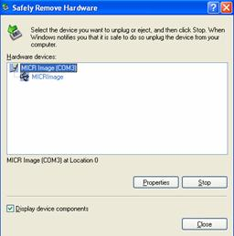
If this is not appearing, try rebooting the PC.
- Back at the “License Agreement” web page, close the pop-up window.
- Choose MagTek MICRImage under Choose Device.
- The USB Enabled check box does not need to be checked as a COM port must still be specified for this device.
- Click I Accept
- TWO ActiveX controls will install after approving installation: A CrossCheck FS (file system) Utility created by CrossCheck to allow file renaming and deleting of the scanned images on the merchant’s PC, and the MagTek MICRImage plug-in created by MagTek, which allows a web page to communicate with the device.
- More likely an error will occur when attempting to connect to device the first time. Use the “Manual Configure” optionand choose the assigned COM port that shows from step# 11 above. Click “Back to Scan Check” to try again. “*** SCAN CHECK THROUGH MICR READER NOW ***” should show when a connection is made successfully.
- Scan a test check through. Enter any necessary test check information². Verify and click “Approve” to begin processing.
- “Test Completed Normally” should appear and a new popup window will appear that will upload the image. Install the last ActiveX control: Persits XUpload Control. This will install after approving installation. When the window says “Finished uploading images”, this window can be closed. A support rep should verify the image has been received. An image can take up to a minute to show up on CrossCheck's system for a support rep to pull up.
Trouble Shooting:
- If receiving an error message communicating with the device, verify the PC meets all system requirements (internet browser, hard drive space, operating system, etc.)
- Verify the user has administrative privileges on their PC as this is required. Script errors being reported by the browser usually means they don’t have adequate privileges.
- Verify COM ports in the device manager of the merchant’s PC and that they have it plugged into appropriate COM port. This can be accessed on XP by right clicking on My Computer in Explore, choosing properties, choosing Hardware tab, then Device Manager.
- Ensure there is a solid green light on the MICRImage.
- On the Error page click “Manual Configure” and try baud ratings 115200, 57600, & 19200. Click “Save Settings” after setting COM port and baud rate each time. Click “Back to Scan Check” to test each setting. If error still appears, try using “Activate AutoDetect” – this can take several minutes.

¹ If a device is already configured, the license agreement page will not display. Use the Reconfigure Device link at bottom, then click the Change Device button to go back to the license agreement page.
² Business Office Conversion Plus requires the Bank Route # on the check to be “123456780” in order to issue a test approval. MICR Scan Conversion Plus requires ID State “ZZ” and ID Number of “12345” to issue a test approval.

RDM 5000 & 6000/7000 Series
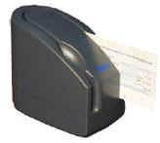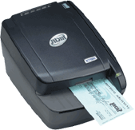
- Baud Rate: 4800-57600 (Should be configured for 57600)
- USB: RDM 5000 Series - Must use Prolific USB-to-Serial converter with serial cable.
- USB: RDM 6000/7000 Series - Use 28AWG/1P+24AWG/2C USB Cable
- Serial: Proprietary RDM serial cable Part#: 5000-40012
  - Note: RDM 6000/7000 WILL work with the Prolific USB-to-Serial Converter if they do not have the USB cable and only the serial cable.

Setup Process for serial cable:
  - Plug the serial cable into the device and the COM port on the back of the PC. Plug in the power supply Part#: DND-2405.
  - Log on www.cross-check.com/logon
  - Click on either MICR Scan Conversion Plus or Business Office Conversion Plus
  - License agreement page will show ¹ and a pop-up window needs to happen. The browser must allow pop-ups. If a pop-up is blocked, a pop-up blocker detector should detect this and give a warning. Refresh the page to make the pop-up window appear again.
  - Do NOT close the popup window. Click on Download CrossCheck RDM Setup Installation and install.
  - Close the popup window.
  - Choose RDM EC5000 Series if using an RDM 5000 Series, or RDM EC6000/7000 Series if using a RDM 6000 or 7000 series under Choose Device
  - Click I Accept
  - The first ActiveX control will install after approving installation: A CrossCheck FS (file system) Utility created by CrossCheck to allow file renaming and deleting of the scanned images on the merchant’s PC.
  - *** SCAN CHECK THROUGH RDM IMAGER NOW *** should show and the device should be ready for scanning.
  - Scan a test check through. Enter any necessary test check information². Verify and click “Approve” to begin processing.
  - “Test Completed Normally” should appear and a new popup window will appear that will upload the image. Install the last ActiveX control: Persits XUpload Control. This will install after approving installation. When the window says “Finished uploading images”, this window can be closed. A support rep should verify the image has been received. An image can take up to a minute to show up on CrossCheck's system for a support rep to pull up.

Setup Process for USB cable:
- Do NOT plug in the device to the PC just yet. (This allows a smooth install)
- Log on www.cross-check.com/logon
- Click on either MICR Scan Conversion Plus or Business Office Conversion Plus
- License agreement page will show ¹ and a pop-up window needs to happen. The browser must allow pop-ups. If a pop-up is blocked, a pop-up blocker detector should detect this and give a warning. Refresh the page to make the pop-up window appear again.
- Within the window, click on Download CrossCheck RDM Setup Installation and install..
- Plug the USB cable into the device and the USB port on the back of the PC. Plug in the power supply. Windows should detect the device being plugged in and a “New Hardware Found” prompt should appear. Finish the driver installation here as it should automatically detect the USB driver you just installed.You will get a notice that the software you are installing has not passed Windows Logo Testing, Click Continue Anyway.
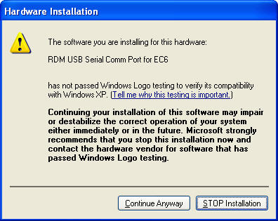
- This can be done by going to Start/Settings/Control Panel, open System, then on the Hardware tab, click Device Manager.
- Look under Ports (COM & LPT) and make sure you see "RDM USB Serial Comm Port for EC6 (COM #)". This Com port needs to be used on the web page.
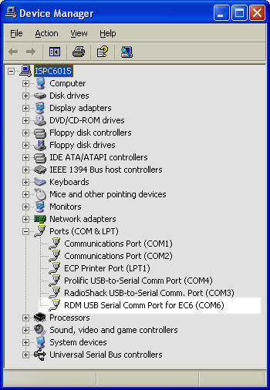
If this is not appearing, try rebooting the PC.
- Back at the “License Agreement” web page, close the pop-up window.
- Choose RDM EC5000 Series if using an RDM 5000 Series, or RDM EC6000/7000 Series if using a RDM 6000 or 7000 series under Choose Device
- Check USB Enabled..
- Click I Accept
- The first ActiveX control will install after approving installation: A CrossCheck FS (file system) Utility created by CrossCheck to allow file renaming and deleting of the scanned images on the merchant’s PC.
- “*** SCAN CHECK THROUGH MICR READER NOW ***” should show when a connection is made successfully.
- Scan a test check through. Enter any necessary test check information². Verify and click “Approve” to begin processing.
- “Test Completed Normally” should appear and a new popup window will appear that will upload the image. Install the last ActiveX control: Persits XUpload Control. This will install after approving installation. When the window says “Finished uploading images”, this window can be closed. A support rep should verify the image has been received. An image can take up to a minute to show up on CrossCheck's system for a support rep to pull up.
Trouble Shooting:
- If receiving an error message communicating with the device, verify the PC meets all system requirements (internet browser, hard drive space, operating system, etc.)
- Verify the user has administrative privileges on their PC as this is required. Script errors being reported by the browser usually means they don’t have adequate privileges.
- Verify COM ports in the device manager of the merchant’s PC and that they have it plugged into appropriate COM port. This can be accessed on XP by right clicking on My Computer in Explore, choosing properties, choosing Hardware tab, then Device Manager.
- Ensure there is a solid green light on the RDM Imager.
- On the Error page click “Manual Configure” and try baud ratings 57600, 38400, & 19200. Click “Save Settings” after setting COM port and baud rate each time. Click “Back to Scan Check” to test each setting. If error still appears, try using “Activate AutoDetect” – this can take several minutes.

¹ If a device is already configured, the license agreement page will not display. Use the Reconfigure Device link at bottom, then click the Change Device button to go back to the license agreement page.
² Business Office Conversion Plus requires the Bank Route # on the check to be “123456780” in order to issue a test approval. MICR Scan Conversion Plus requires ID State “ZZ” and ID Number of “12345” to issue a test approval.

Prolific USB-to Serial Converter
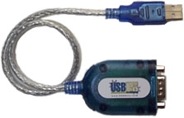
Setup Process:
  - Do not plug the converter cable into the PC just yet.
  - Log on www.cross-check.com/logon
  - Click on either MICR Scan Conversion Plus or Business Office Conversion Plus. Or Approve a Check, then MICR Scan Single Check.
  - License agreement page will show ¹ and a pop-up window needs to happen.
  - Click on Download USB-to-Serial Driver
  - Unzip the downloaded "USB2SerialDriver.zip" and run "PL-2303 Driver Installer.exe" within it.
  - After the installation finishes, plug in the converter cable. The cable should initialize and be ready to use.
  - To verify the COM port assigned, open Device Manager. This can be done by going to Start/Settings/Control Panel, open System, then on the Hardware tab, click Device Manager.
  - Look under Ports (COM & LPT) and make sure you see "Prolific USB-to-Serial Comm Port (COM #)". This Com port needs to be used on the web page.
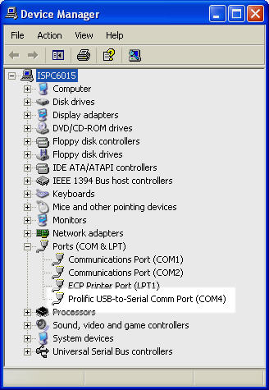

¹ If a device is already configured, the license agreement page will not display. Use the Reconfigure Device link at bottom, then click the Change Device button to go back to the license agreement page.

