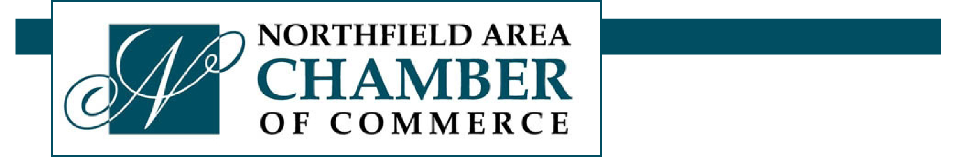
Northfield Area Chamber of Commerce
205 Third Street West, Suite A Wednesday, June 25, 2014
Northfield, MN 55057
Contact: Beth Ayotte Naumann, Board President
612.490.7633 beth@SMbyAyotte.com

NORTHFIELD CHAMBER NAMES NEW EXECUTIVE DIRECTOR
Tourism Manager for Convention & Visitors Bureau Also Hired
NORTHFIELD, MINN. June 25, 2014 -- The Northfield Area Chamber of Commerce board of directors announced today that it has named Brent Burns as executive director of the organization following a national search. Burns, who will be introduced to Chamber membership at the organization’s Golfapalooza event on Thursday, June 26, will begin his new role in July.
The Chamber also announced that it has hired Lisa Havelka as the Northfield Convention & Visitors Bureau (CVB) tourism manager. Havelka joins the Northfield CVB after a highly successful five-year stint with the Owatonna (Minn.) Area Chamber of Commerce & Tourism.
The selection committee for the Chamber was impressed with the breadth of Burns’ experience which included serving as the managing partner of Sylvan Learning Centers in Northwest Iowa, being a branch manager in the mortgage industry and managing sales for a Chevrolet, Nissan and Mercedes Benz dealer, in addition to significant experience in the Chamber of Commerce environment. Most recently he served in a leadership role with the Crystal Lake Chamber of Commerce in Spencer, Iowa.

-more-
Chamber Names New Executive Director
June 25, 2014
Page two of three

Chamber President Beth Ayotte Naumann said, “We are delighted to recruit Brent to join the Northfield business community. We had five or six excellent candidates that made our decision very difficult. In the end we were drawn toward Brent’s wide-ranging experience, his energy and enthusiasm for the Northfield area, his ability to quickly comprehend the importance of Downtown Northfield within the context of the greater community, and his clear ability to balance all of the vital priorities necessary to help Northfield’s area business, commercial and retail organizations flourish.
Burns said, “It is with great enthusiasm that I take on the role of Executive Director for the Northfield Area Chamber of Commerce. I am a natural networker and I understand the ‘big picture.’ I love to build and nurture teams that are focused and moving towards a common goal. My wife and I are eager to relocate to the area and I can’t wait to get going.”
Havelka has more than a decade of experience in the tourism and economic development field including six years as the MainStreet Director in Owatonna. CVB Board Chair Brad Ness explained, “Lisa was our top choice for this position. Her track record in Owatonna is outstanding and her focus on convention and visitors work with such a solid Main-street background makes her an ideal person for this position. We’re blessed to have her join us.”
The appointments of Burns and Havelka come in the midst of discussions between the Chamber and the Northfield Downtown Development Corporation (NDDC) to determine the efficacy of joining forces. Naumann said that all candidates were informed of the possible merger and both Burns and Havelka demonstrated tremendous enthusiasm for making the merger work. Burns said, “This is an extremely exciting opportunity for the Northfield business, commercial and retail community. For the community to thrive, it needs a vibrant downtown. At the same time, it’s not a zero-sum game. If we manage the situation effectively, everyone will win – downtown businesses, surrounding commerce and the community as a whole. I’ll be inviting the entire community to join in.”
-more-
Chamber Names New Executive Director
June 25, 2014
Page three of three

The Northfield Area Chamber of Commerce is a dynamic business organization that promotes the Northfield area and the local business community. The Chamber is comprised of local businesses and business-minded individuals who have banded together with one goal in mind: to advance the commercial, financial, industrial and civic interests of the community.
For more information, please see the Northfield Area Chamber of Commerce website: www.northfieldchamber.com. Businesses and individuals interested in joining the Northfield Area Chamber of Commerce are invited to call 507.645.5604.
# # # #

