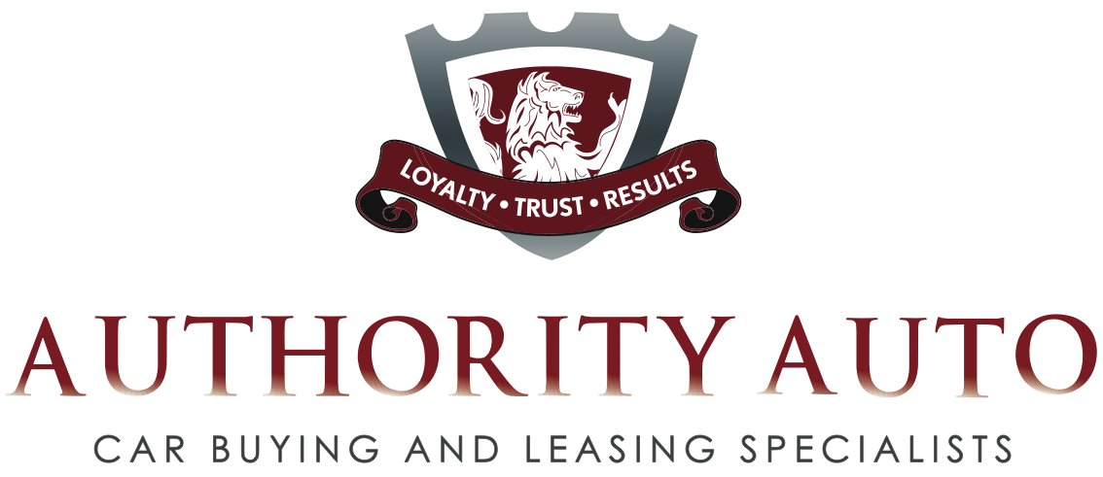

A Q&A with Oren Weintraub
Authority Auto Founder and President

Q. Why did you start Authority Auto?

A. I know the common frustration that most people go through when buying a car on their own. I am very empathetic and if I can spare people the pain, anguish and self-doubt they go through than that is what I am committed to do. I get great satisfaction from using my knowledge and vast experience negotiating great deals to help people save money and take the misery out of the experience.

Q. What makes Authority Auto so unique?

A. There are many aspects of our service that are unique, but the most significant is that we are an advocate for the buyer, not the seller. We don’t receive any compensation from the dealer or a dealer representative, so there are no conflicts of interest. Our ONLY obligation is to our client and we will turn over every stone to ensure that we achieve the best possible deal.

With traditional car brokers, the broker’s income is based on whatever he wants to make on the sale. Thus, both broker and the dealer are looking out for their own best interests. When both the broker’s and salesperson’s income depend on how much profit they can make, it creates a tremendous conflict of interest for the customer. The only way I could truly help people and eliminate that conflict of interest, was to align Authority Auto with our clients by not accepting any dealer commissions.

At Authority Auto, our intention is always to do what is best for our clients.

Q. What else is unique about the company?

A. We stand by our integrity. If we think you’ve got a great deal on your own, we’ll tell you that and give you the comfort of knowing that we couldn’t have done better. However, if we think we can improve your deal, Authority Auto will try to get a better bargain for you, taking a percentage of what we save you, up to $1,495. Our sole commitment is to make the buyer walk away knowing that this is the best deal that could have been secured, and to make it a pleasurable and easy experience.

Q. Many of your customers praise Authority Auto’s customer service. What is it that you do that makes them rave?

A. We want to provide an amazing car buying experience for our customers! We don’t just provide great prices. We streamline the entire process to eliminate the numerous situations that people go through that have made car buying so distasteful.

We do this by facilitating the entire process for our clients from A to Z. Here are just a few examples:
- If they know what model they want, they never have to set foot in a dealership. All they do is give us make, model, color and features.
- We handle getting the best price for their trade-in.
- We communicate with our buyers daily and always in a gracious manner.
- We go at their pace. Nothing is ever forced.
- Most importantly, our clients love the fact that all the information provided is coming from us, not a salesman trying to make a commission. We will present our clients numbers before they go to look at a car, thus eliminating the buyer from going to the dealer, falling in love with the car and later finding out--after much time has been wasted--that the car costs way more than they can afford. We eliminate dealer mistakes before numbers are quoted to our clients.
- We not only get them a great deal, but with our knowledge of the business, we set up our clients to be in the best position possible for when they get their next car.
- If the buyer is based in Southern California where we are headquartered, we will pick up the trade-in and deliver the new vehicle to home or office.

Q. Besides the endorsement of your clients, is there any other independent source that has reviewed your service?

A. Edmunds.com tested our service, finding out that we could indeed improve a deal they had in the works, and now endorses us to the millions of viewers of their website.

Q. What do you say to people who are reluctant to pay your fee upfront?

A. A majority of our clients are happy to pay our upfront fee, and they are relieved and excited that our company exists to help them. There are a few clients who are reluctant to pay our upfront fee and we invite those people to use our Improve Your Deal Service, for which there is no initial fee. Those clients can go through the process of locating the exact car they want and negotiating the best possible deal they can. When they finish their negotiation and FEEL that they have the best deal, they present it to us and we guarantee to beat it. We then charge a percentage of what we save them. If we can't beat their deal, there is no fee after we do the research and the client can complete the deal they negotiated with the confidence that we reviewed and acknowledge it really is the best deal that can be secured.

We have earned many loyal clients after seeing how much we beat their best deal by and realized how much of their own personal time was wasted. Those people end up as repeat customers, paying us the upfront fee on their next deal, and also become a great source of referrals.

Q. How do I know that Authority will get me a better deal than I can get for myself?

We first want to acknowledge that when you are considering hiring us to represent you in this very important transaction, that you have the right to ask that question.

The short answer is that negotiating car deals is our profession and we are very good at what we do. Our experience working inside car dealerships has taught us how dealers make money and the fact that we have been negotiating car deals every day for the last 15 years gives us a level of experience to provide you the upper hand in negotiating your car deal.

In order to be able to intelligently negotiate a car purchase or lease, you need to know the “True Cost” of every item that needs to be negotiated. It’s hard for the average buyer, who negotiates a car deal every three to four years, to know all the facts. Not knowing the facts will always make you wonder if you got the best deal. If you don’t know the specific pricing in negotiating a car deal, you will base your decision on if the deal feels right. Dealerships are experts on making you feel that you are getting a good deal, even if you didn’t. So most people walk away from a deal wondering if they really got the best price.

But there is an inherent conflict of interest between the dealer and buyer. Dealers are in business to maximize their profits and you are trying to save as much money as possible. Without years of experience and all the hard facts, who do you think will come out ahead?

