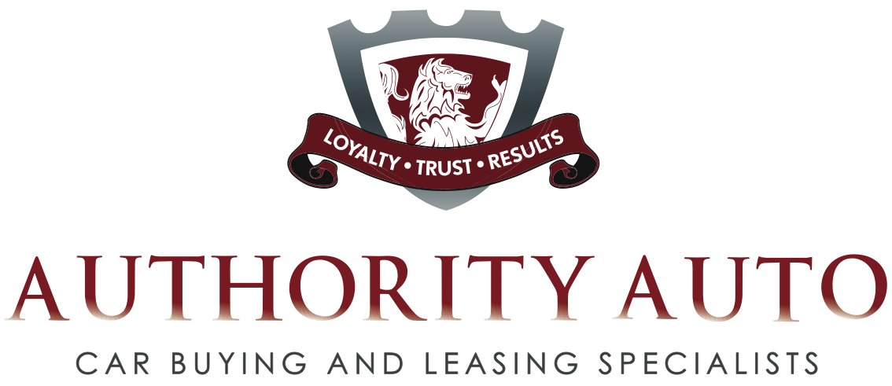

Authority Auto Represents Car Buyers in Auto Negotiations, Securing Optimum Deals With Maximum Peace of Mind &
No Headaches

Former Dealer GSM Switches Side of the Table To Get Insider Prices for Clients

Service Guarantees Best Possible Deals for Car Buying, Car Leasing and Trade-Ins in an Economy Where Every Dollar Counts

SHERMAN OAKS, CA --Tired of feeling squeezed at the auto dealership and wondering if you overpaid for your car or your lease? Wouldn’t it be nice if you had someone with all the insider knowledge to go in and negotiate the very best possible deal for you, and all you have to do is wait for the car to arrive? No headaches, no hassles, no pressure, no discomfort, no lost time of going from agency to agency and no fear of being taken advantage of…

That may sound like a dream, but there really is a company that will handle every aspect of the deal from finding the car to delivering it into your hands—with only a phone call. Authority Auto is the car buyer’s or car leaser’s advocate and concierge—a welcome resource in a time when consumers are feeling the pinch.

Unlike traditional auto brokers that take clients, but get paid by the dealership making them beholden to the auto agency, Authority Auto represents the client exclusively and is bound by the commitment to get the best price for the customer. The Sherman Oaks, CA-based company will not accept any money from a dealer or dealer representative. It takes a fixed fee from the client based on the value of the car desired—new or pre-owned--and guarantees it will secure the lowest price possible. Clients are welcome to try to see how well they can do on their own to validate that it is indeed the lowest price.

“Buying a car is one of the most exciting purchases most people ever make, and unfortunately, it is also among the most stressful,” says Oren Weintraub, President of Authority Auto, and former GSM of one of the nation’s top 100 Ford dealerships. “As car buying consultants, we pride ourselves on exemplary service that makes buying a car a simple and pleasurable experience. Simply tell us the make and model you want, and with our knowledge and clout, we’ll find the exact car, pit dealership against dealership for the best deal, negotiate all the hidden dealer charges out of the transaction, and, in most cases, deliver the car to your door.”

The clients generally save thousands of dollars over what they could have negotiated themselves.

Some examples include:

- Authority Auto had a client interested in a pre-owned BMW. Authority Auto saved her more than $6,000 on the vehicle, plus the equivalent of Authority Auto’s entire service fee when the company negotiated down the price of her extended maintenance plan.
- Authority Auto helped a customer to land a $78,550 2008 Range Rover HSE for $26,100 less than the asking price after the $5,750 rebate.
- For one family buying a 2008 Volvo XC90, Authority Auto was able to get a deal $14,526 lower than the dealer’s $45,942 retail price.
- Another client sought a 2006 Lexus LS430 with a price tag of $68,324. Authority Auto knocked $13,599 off the final bill.

For those buyers who are skeptical or don’t want to pay the upfront fee, Authority Auto’s Improve Your Deal is highly recommended. Authority Auto takes 45% of the amount that it saves the client, not to exceed $1,495. The client must provide a copy of a written quote from a dealer including all fees, taxes, miscellaneous charges and “out-the-door” totals, a complete list of equipment or the vehicle stock number. Always putting the client first, Weintraub has, however, advised some clients to take the initial offer because it is a great price.

Authority Auto also handles car leasing agreements, securing optimal lease mileage allowance and finance terms. Additionally, the company will take on the task of getting maximum value for a client’s trade-in vehicle. With its vast network of dealers and the leverage that comes from knowing what a trade-in’s true value is, Weintraub and his team will shop until they’ve gotten a maximum return.

The range of savings the clients secure over and above Authority Auto’s fee is from $500 to $18,000.

As a result of the savings and the company’s white-glove service philosophy, Weintraub receives dozens of letters per month from customers such as the following:

- “When my previous car was totaled in a flash flood, I contacted Authority and in two days there was a new car in my driveway! I could never have believed that buying a car was so easy and satisfying,” said Tam of St. Louis, MO. “Your knowledge, negotiating skills, personal attention and follow-through made me feel so comfortable and confident in trusting you with such an important financial decision. I never had to worry about all the details and haggling that normally takes place when buying a car. I have been recommending you to all my friends and I will never sit in a car dealership with a headache again!”

- “I didn't want to spend any time haggling with dealers, trying to hunt down cars and get offers from several places, so I put my feet up and let Authority do all the work,” said A.P of Sherman Oaks, CA. “That was the smartest decision about cars that I've made in a long time.”

- "Authority saved me more money than I thought was humanly possible (let alone the emotional expense of having to hassle with car dealers.) When combined with its first class service, such savings makes using Authority a total no-brainer," said Ian J. of Sherman Oaks, CA.

Not only does Authority Auto garner rave reviews from its clients, but it earns the respect of the dealership salesmen because Weintraub and his team have such solid credentials from their days in the business. Observed one customer in a letter to the company: “The salesman who delivered the car from the agency made a special point of telling me how much he enjoyed working with Authority, as compared to brokers he'd dealt with in the past.”

Noted Weintraub, “I’m pleased that we have gained the respect of the dealerships that we negotiate with, but I’m even prouder of the reputation we’ve developed with our clients for being trustworthy, reliable, customer-centric and a great value.”

In additional to proven savings and the stress-free process, one of the company’s greatest assets is the quality of consumer service. Authority Auto communicates constantly with clients so that they are apprised of developments. Each transaction is personalized, not formulaic. The staff has a casual, friendly and efficient approach to customer relationships. In some cases, the consultancy will pick up the trade-in for the client, and deliver the purchased car at home or office based on client preference. Clients receive a confirmation of the deal in writing before a final contract is submitted to them for approval and signature—and there is no pressure to sign.

“But most people are so thrilled with the savings, they can’t wait to sign the sales contract and take delivery of their new car!” says Weintraub.

The whole process can take from two days to two weeks at most, but the timing is often determined more by when the client needs his or her car than how quickly the company works to secure the deal.

Authority Auto was founded when Weintraub walked away from his job after 12 years as a leading negotiator, salesman and general sales manager at a dealership. “Even if you are pretty savvy, when you buy a car on your own, the decks are stacked against you. It’s like playing a slot machine in a Las Vegas casino—the house always wins. There are just so many complexities and ways to pad the deal,” he says. “While I love negotiating, I always felt uncomfortable that my negotiating came at the expense of my clients. In creating Authority Auto, I can now employ my talents, experience, honesty and integrity on behalf of my clients.”

For more information, go to www.authorityauto.com or call (818) 788 -1900 or toll free (866) 62 MYCAR, (866-626-9227)

