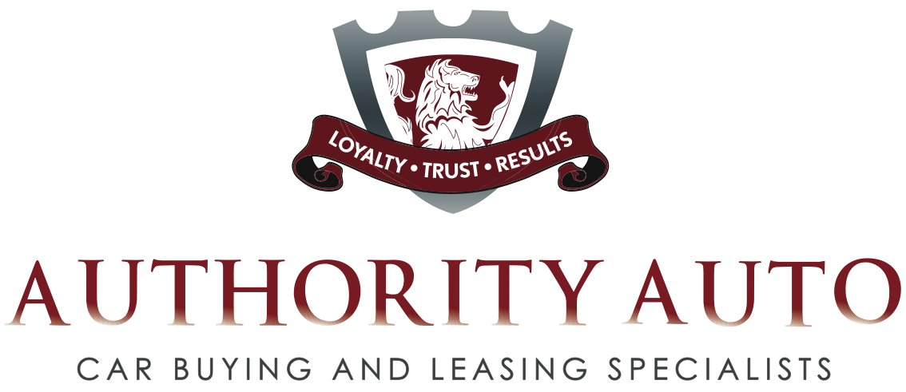

Authority Auto Completed Car Purchases and Leases

Here is a sampling of deals that Authority Auto has secured on behalf of the company’s clients:

Deal 1: Authority Auto had a client interested in a pre-owned BMW. She went to a dealer and found the car she wanted. The dealer quoted her a price, but she was not comfortable with the person she was dealing with, the price he offered her, and the overall experience. She gave Authority Auto a call and the company saved her more than $6,000 dollars from the price she was quoted. Oren Weintraub, President of Authority Auto, noted that the company also saved her the equivalent of Authority Auto’s entire service fee when the company negotiated down the price of her extended maintenance plan.

Deal 2: Authority Auto aided a family that spent hours negotiating a deal on a 2008 Honda Element, which featured a retail price of approximately $23,825. The best deal the clients were able to negotiate was $200 over invoice--which they thought was fair. The dealer did not have the exact car the buyers wanted, thus requiring the salesman to buy the car from another dealer in order to make the sale. The end result was that the dealer was not able to get the car and the family's entire weekend was wasted. After that frustrating experience the buyers contacted Authority Auto. Not only did the company secure the exact car that they wanted, but delivered it to their doorstep. The price negotiated for them was $1,200 below invoice, a savings of $1,400. Authority Auto also found a buyer for their trade-in that paid more than $1,000 above what the dealer offered. Total savings amounted to nearly $3,000 dollars. That is a significant amount for a car that retailed for such a relatively small amount.

Deal 3: One couple went to a dealership and was close to making a deal with a sales representative that they liked. However, the customers were very payment conscious. They told the dealer that they did not want to have a payment exceeding $400 on a Toyota Prius Package 6 with Leather and Navigation. The dealership quoted the customers $420 on a less expensive Package 5 with Navigation for a four-year lease. Authority Auto stepped in and secured a deal for $395 for a three-year lease on the Loaded Package 6. Extending the term of a lease is one way a dealer can accommodate the customer’s payment range without having to reduce the price of the car.

Authority Auto had another issue with the deal that the dealer presented because it wasn’t disclosed to the customers that they would be exposed out of the bumper-to-bumper warranty for the fourth year of the lease. If something went wrong with certain parts of the car during the fourth year, it could potentially cost a ton of money. When Authority Auto works with its clients, the staff brings this important knowledge to the table to protect the customer. Weintraub notes that he is proud of the fact that his company was able to negotiate a low enough price to accommodate the customers’ wishes and keep them completely under the factory warranty throughout the entire lease.

Deal 4: A customer approached Authority Auto about helping him buy a 2008 Range Rover HSE with a manufacturer’s suggested retail price of $78,550. The company negotiated a price that was $26,100 less after the $5,750 rebate. The customer ended up leasing the car and Authority Auto saved him even more money on the fees associated with leasing a car.

Deal 5: Authority Auto had another client that the company saved from making a costly mistake. His lease was up on a Volvo XC 90, and he was considering purchasing his car at the end of the lease, keeping it for another year or two and then trading it in for another car. The originating dealer which leased him the vehicle negotiated the buyout price of this lease. Authority Auto’s client called the company in to look over the deal he was about to sign. But Authority Auto discovered a plethora of problems with the deal. The first problem was that the negotiated purchase price was much higher than market value. The second problem was that the dealer quoted the client a six-year loan to keep the payments down. When you buy out a lease, you have to pay taxes on the purchase price, notes Weintraub. If the buyer is paying higher than market value on this purchase, PLUS tax on that amount, he immediately is putting himself substantially in the hole. Moreover, taking out a loan for six years compounds the problem because the car will depreciate faster than the owner is paying it off. The customer would also have been exposed financially by driving his car beyond the warranty. If the client had ignored Authority Auto’s advice not to do the deal, he would have found himself owing thousands more than the car’s worth and would be stuck paying on the vehicle for up to six years. Authority Auto ultimately put the customer in a new lease and got him back under the manufacturer’s warranty.

