MATCH DAY 2014 GIVING TUESDAY!
Dear Friends, 
This December 2, 2014 is Giving Tuesday, and (Name of Organization or School) will be participating in The Community Foundation for Crawford County’s Match Day. On that day, the Foundation’s Board of Trustees has agreed to match up to $25,000 raised on that date right back to the endowment funds of the agencies and schools for whom the dollars are being collected!
Our community is fortunate to have The Community Foundation for Crawford County. This past year, they have contributed some $450,000 in grants and scholarships right here in Crawford County. You probably see the good work of the Foundation on a regular basis and don’t even realize it. Every time you see children laughing on one of several playscapes, visit our area’s historical societies, or admire the beauty that the murals bring to downtown Bucyrus, you are seeing just a small example of the projects the Foundation helps fund. As a result, the Foundation enriches the lives of us all.
Please support me and (Name of Organization or School) by visiting the website below and making a contribution. You might even consider donating $30 in honor of the Foundation’s 30th anniversary this year! I am just one of many Crawford County residents participating in this Giving Tuesday “virtual party” by taking 10 minutes at 10:00 am to reach out and solicit at least 10 others on behalf of The Community Foundation for Crawford County and (Name of Organization or School). You may even forward my message and send it with the link below to 10 or more of your friends! Remember, it is important that the donations be made on December 2nd to qualify for the match. (Please tell any check writers to date their checks for Dec. 2nd and mail them to 254 E. Mansfield St., Bucyrus, OH 44820).
We all participate in Black Friday and Cyber Monday; now let’s ignite The Community Foundation for Crawford County and get fired up on Match Day/Giving Tuesday!
http://cfcrawford.org/your-donation-supports-bucyrus-and-crawford-county-ohio-non-profits
Thank You,
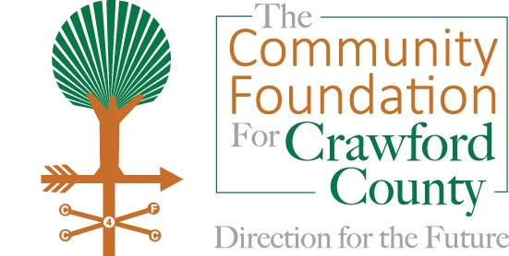
(Your Name)

