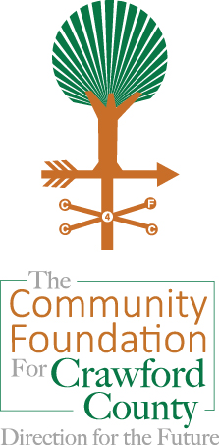 Endowment Summary

***September 30, 2013***

**Asset Allocation**

As 3rd quarter 2013 came to a close, the Foundation’s Endowment remained broadly diversified across equity, fixed income, and alternative investments. Nearly 70% was invested in mutual funds containing equities (i.e., stocks) with exposure to international markets and various investment styles. Approximately 16% of the Endowment was positioned in mutual funds containing fixed income (i.e., bond) securities and cash, and the remainder of the portfolio was invested in mutual funds containing alternative assets, such as energy, natural resources and commodities.

**Performance**

Performance of the Endowment year-to-date 2013 was 13.33%, outperforming the benchmark (10.14%). Most equity asset classes had double digit returns in 2013. Domestic equities well outperformed international equities year-to-date. The Foundation remains confident it is investing to both preserve and grow the Endowment for the long-term.

*Endowment returns as reported by the Consultant, Mason Investment Advisory Services, using the time-weighted return method of calculation

**Benchmark represents average return of all community foundations between $5 mm and $24.9 mm in assets that participated in COF survey

**Endowment Value**

Despite the slight dip in the second quarter, the total value of the Endowment grew year-to-date 2013. Endowed assets increased by nearly $1.3 million due mostly to the positive returns of equities.



**Investment Policy Summary**

The Endowment is invested according to guidelines established by the Board of Trustees in the Investment Policy Statement. This policy is reviewed regularly with an external consultant so that the investment strategies used for the Endowment are kept in compliance with the policy statement.

**Distribution Policy**

The Foundation executes a grant-making program designed to support the immediate and long-term needs of the community, while preserving the value of the Endowment. Please contact the Foundation if you wish to receive more information about the distribution process and how grant amounts are determined.

**Questions?**

If you have any questions or would like to receive more information, please contact the Foundation at (419) 562-3958. We would be very happy to assist you.