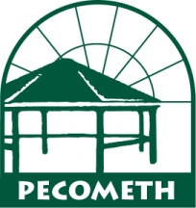
Pecometh Dietary Needs

Group Name: ____________________________________ Retreat Dates: ________________
This form helps us to provide your group with a satisfying dining experience. Please return this completed form to us at least two weeks prior to your event to ensure that we are able to meet your needs.
Food Allergies:
Guest Name Allergy

Other dietary needs: Example: vegetarian, pork-free diet, etc.
Guest Name Dietary Needs

136 Bookers Wharf Road * Centreville, MD 21617 * (410) 556-6900 * Fax (410) 556-6901

