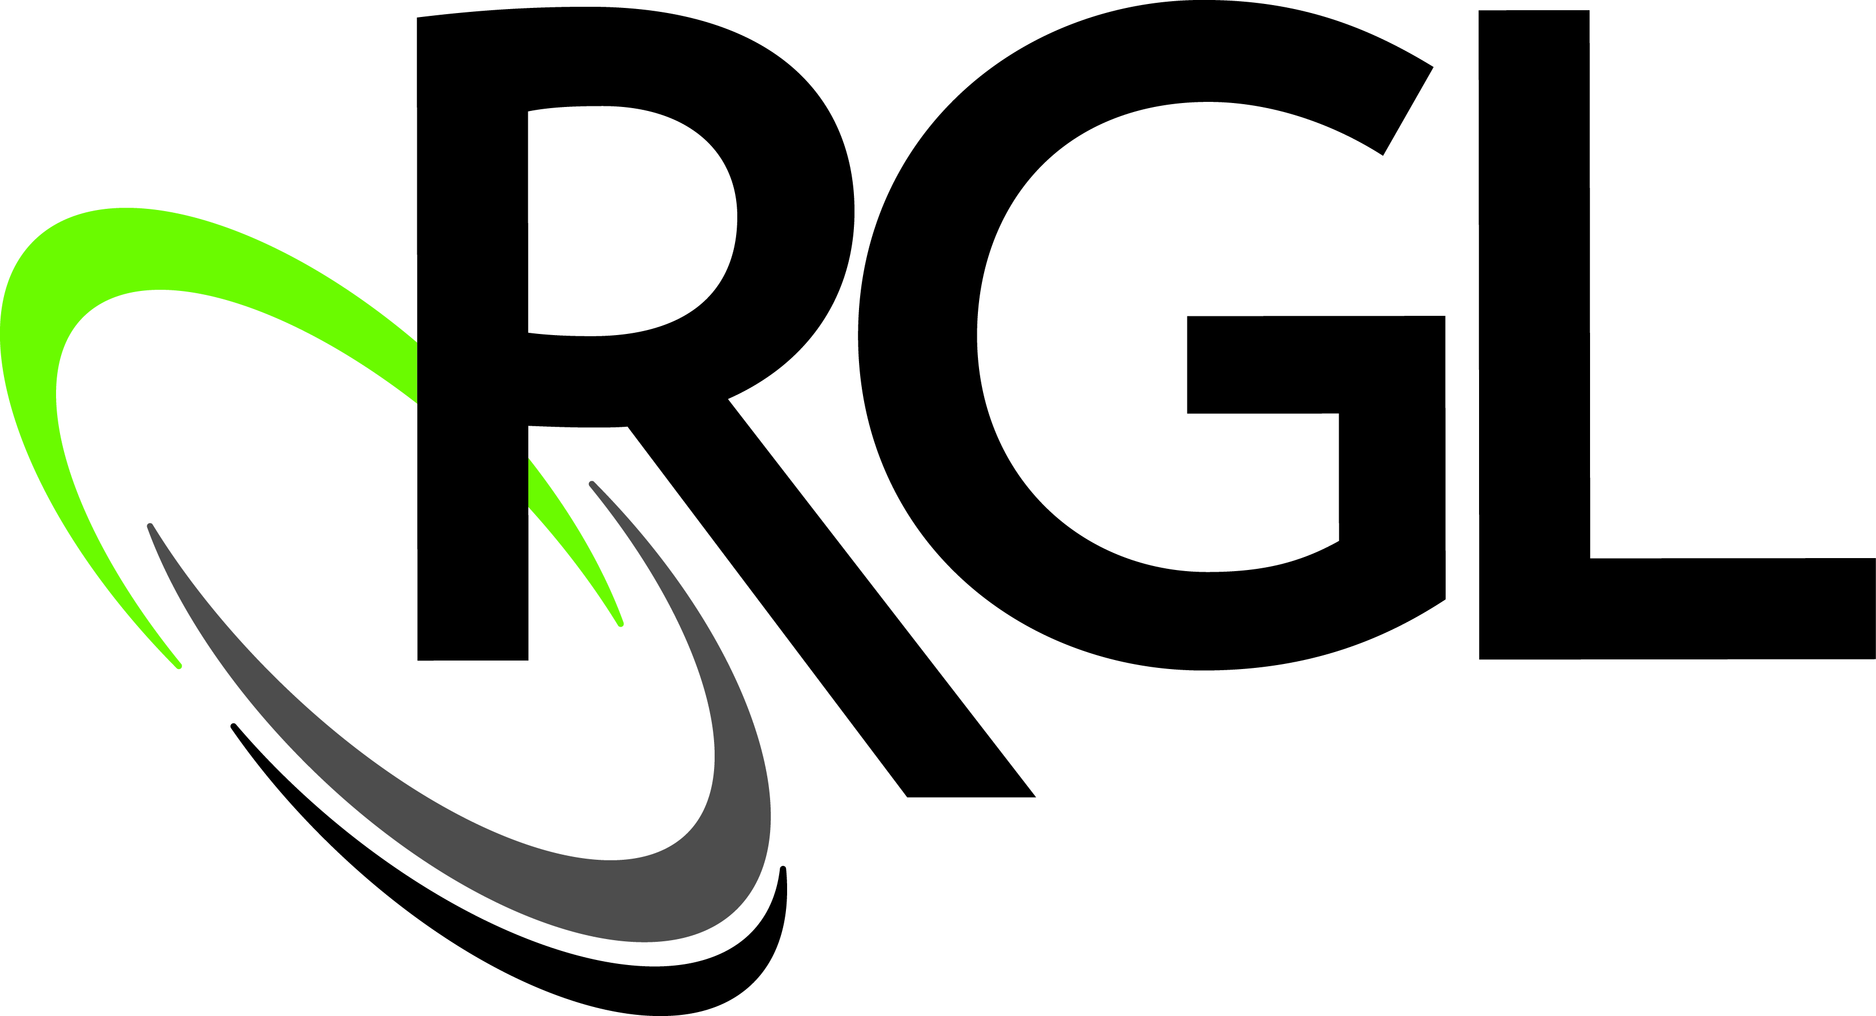
FOR IMMEDIATE RELEASE: For more information:
May 10, 2013 Ashley Christophersen (414) 390-5500
achristophersen@muellercommunications.com

RGL Announces Plans For “What If” Logistics,
Implements New Vision and Rebranding
RGL unifies its operations, provides employee opportunities and implements a new vision and brand

Green Bay, Wis. (May 10, 2013) – RGL announced today strategic plans for a new corporate vision, people vision and a rebranding of each of its member companies, which are designed to support aggressive growth goals.

These changes are intended to help RGL take advantage of significant changes in the logistics industry. The company’s “WHAT IF” approach to logistics will create an opportunity for RGL to grow by providing innovative services that reduce time, waste and expense for clients facing common supply chain challenges such as capacity shortages, cost pressures and the need to integrate new technology.

“RGL’s plan to capitalize on this unique environment begins with the RGL vision: Inspired people creating unparalleled customer value by leading a revolution changing how logistics is done,” said Bob Johnson, CEO of RGL. “Logistics is changing, and RGL is changing logistics.”

RGL’s people vision recognizes the critical role played by each employee. As part of the new people vision, RGL plans to continue developing and implementing its award-winning safety, wellness and training programs to promote employee satisfaction and well-being.

“It is vital that our employees feel ownership of the work they do, and that they go home every day feeling safe, healthy and fulfilled,” said Johnson.

The new RGL brand represents the coming together of three companies with a long legacy of changing the game in logistics: Leicht, Checker Logistics and RGL Specialty Services. All three will now operate as RGL, The “WHAT IF” Logistics Company. The name RGL is in dedication to the company’s former leader Russell G. Leicht.

RGL helps customers reinvent logistics by asking “WHAT IF” to come up with creative solutions that simplify, improve and reduce waste in their supply chain. RGL analyzes customer’s current state to see what is and then asks “WHAT IF” to work towards the customer’s desired outcomes to see what could be.

“This brand message emphasizes what RGL does best,” said Johnson. “Every day, we ask our customers ‘WHAT IF’ to challenge the status quo and find new solutions for the supply chain. The ‘WHAT IF’ challenge also applies internally: all RGL employees are expected to contribute to a continuous improvement environment.”

While some companies search for a purpose, RGL had their customers help identify their purpose. When researching the RGL brand, customers shared that applying the “WHAT IF” concept is at the heart of what RGL does differently than most in the industry.

For more information on RGL, please visit www.rgllogistics.com.

About RGL
Based in Northeast Wisconsin, RGL serves innovative, on the move, companies across the country. Core expertise is in transportation, distribution and handling. A sampling of specific services provided include: brokerage, trucking, intermodal, distribution center operations, order fulfillment, warehousing, co-packing, in-plant services, crating and more. RGL ensures that the customer receives the right product, at the right time, in the right configuration, in the right condition, with the right information, and exists to continuously improve its business, service to customers, development of employees and to make contributions to the community.
###

