Pool Size | Cover Size | List Price | SALE price
12 x 24 | 14 x 26 | $749 | $674
14 x 28 | 16 x 30 | $1399 | $1259
16 x 32 | 18 x 34 | $1299 | $1169
18 x 36 | 20 x 38  Call us today!  Port Elgin  371 Goderich St.  519-832-5858  Owen Sound  689 10th St. W  519-376-5858 | $1599 | $1439
20 x 40 | 22 x 42 | $1849 | $1664
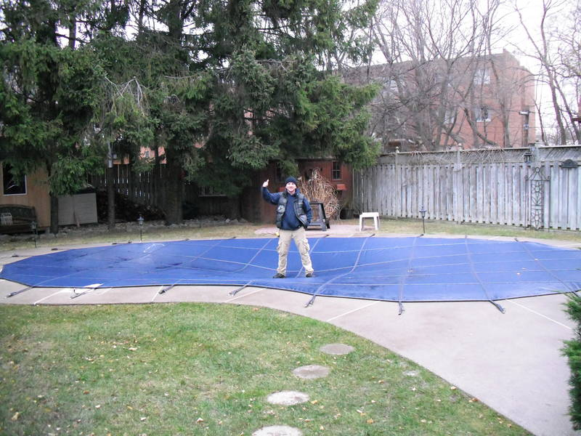

12 year warranty
Rintoul's
We will install it for
$399
or
Do it yourself
And SAVE
Safety Covers
Mesh Deck-Loc System

No More Tarp & Water Bags

Keep Pool Clean & Protected

Book your safety cover by May 17th 2014 and SAVE 10%
Please call for a quote on custom shaped covers.

Owen Sound 519-376-5858
www.rintouls.ca or “LIKE” us on Facebook

Green mesh 5 x5 (includes brass anchors, stainless steel springs, vinyl spring covers, installation rod, anchor key and storage bags.

