Gustav Klingbiel Nature Reserve, Mpumalanga
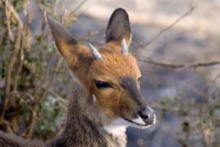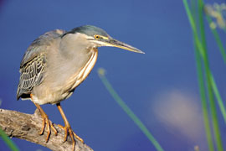

The Gustav Klingbiel Nature Reserve is situated on the eastern side of Lydenburg along the scenic Long Tom Pass to Sabie and is one of the most beautiful holiday destinations in the world. One of the main attractions in Gustav Klingbiel Reserve is its fascinating bird watching opportunities. About 276 bird species have been recorded in the reserve and its vicinity and several game species such as Bushbuck, Kudu, Impala, Zebra, Eland, Grey Rhebuck and Steenbok also occur in reserve to add an extra bit of excitement to your trip.
The reserve is 2200 hectares and the Klipgatspruit cuts the mountainous area into a deep valley. The main habitats include thornveld and bushveld on the low-lying areas, and montane grassland on hillsides and plateaus with protea woodland on the higher altitudes. Small isolated pockets of forest are present in the ravines that are tributaries of the Klipgatspruit.
Along the Long Tom Pass, scenic views of montane grassland with mountainous gorges and cliffs can be seen while small sprouting areas of Silver protea can be seen along the road and large concentrations of common Sugarbush can be spotted on mountain plateaus.
At the entrance to the reserve there is a museum displaying a very interesting exhibit about the town's history and history of the archaeological Stone Age sites.
The Gustav Klingbiel Reserve has marvelous views, fantastic sights and is well worth a visit.

Stonecutters Lodge is a short 15 minute drive from the Gustav Klingbiel reserve.

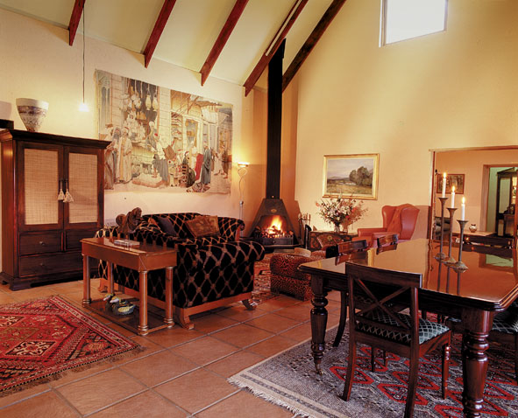

To Book at Stonecutters Lodge:
Call +27 (0) 13 235 4225
+27 (0) 13 235 8921
+27 (0) 83 375 0132

or visit our website:
www.stonecutters.co.za
Email: cobbles@mweb.co.za

