

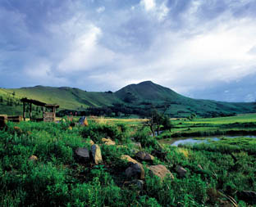

Stonecutters Lodge is situated in the Mpumalanga Highlands between Dullstroom and
Lydenburg (Mashishing) and is only 3 hours from Gauteng and 1.5 hours from
Nelspruit (Mbombela) Middleburg and Witbank (eMalahleni)

As a conference venue for groups of up to twenty delegates (sharing) or 11 delegates (single) there is no better choice than Stonecutters Lodge. This upmarket, 4 Star lodge on a scenic 60 hectare property, is an ideal setting for a conference group to focus on the task at hand away from the frenetic distractions of the city. Stonecutters is owner managed and prides itself on excellent personal service. The friendly reservations office assists in planning and facilitating events which can be tailored to a budget. Flexibilty is key – don’t want a three course dinner but prefer a braai or potjie? Running over time and need a working lunch? No request is too much trouble for the Stonecutters team. Meals at Stonecutters are exceptional. Sumptuous lunch buffets and 3 course plated dinners with the best ingredients and classic cooking methods ensure that delegates enjoy fabulous cuisine.

An important feature of planning a conference at Stonecutters Lodge is the fact that delegates take over the entire lodge and enjoy exclusivity as guests at this elegant county manor. Stonecutters Lodge has achieved a BEE status of Level 4 and has qualified as a member of Proudly South African. (Certificates available on request).

Stone Manor is the central gathering point for the group; here the large veranda overlooks a cascade of water tumbling into an indigenous pond. The Manor consists of a beautifully appointed lounge/dining area with huge fireplace, which conveniently leads onto the conference/function room and the Cats’ Whiskers pub. A generator powers the manor house in the case of power-failure so that disruption to a conference is not a possibility.

The Conference Room is modern with state of the art equipment: Flexible boardroom table arrangements, laptop and telephone facilities, aircon, big screen, DSTV and a ceiling mounted data projector. Office facilities are available to take care of delegates’ secretarial needs.

The Cats’ Whiskers Pub is cosy and quaint. With original stone walls, a roaring log fire and TV for sports channels, the atmosphere ensures a great evening! Stonecutters is fully licensed and the well-stocked bar caters for all tastes from shooters to single malt whiskeys.

Both the conference room and the pub open onto a walled garden which is a great break-away area for delegates, facilitating tea breaks and smoke breaks! With flag-stones underfoot, built-in braai and umbrellas shading the tables and chairs, there is a wonderful café terrace ambience in this sheltered terrace garden.

The luxurious Accommodation is clustered around Stone Manor, all within walking distance: Cobbles Studios, Trout House and Stone Cottage. There are a total of 10 double rooms (twin or king beds) all en-suite. Two bathrooms in Trout House are wheel-chair friendly. Under-carpet heating, bar fridges (stocked on request) quality beds and bedding – no detail has been overlooked.

CONFERENCE RATES:
Every effort has been made to keep conference rates as low as possible and consequently the 24 hour Conference Package rate represents excellent value for money. Package rates vary from R1050 to R1450 per delegate depending on single or shared accommodation, midweek or weekend booking. As every conference has different requirements the tariffs below are merely a guideline- please discuss your requirements with Madelien or Lesley and they will get back to you with a written quotation.

CONFERENCE TARIFF 2011 | 1ST JAN - 31ST DEC | 24 HOUR PACKAGE
 | MID WEEK SHARING | WEEKEND SHARING
ACCOMMODATION | R 540 | R 685
BREAKFAST | R 100 | R 100
LUNCH | R 110 | R 110
DINNER | R 200 | R 200
MORNING & AFTERNOON TEA | R 40 | R 40
CONFERENCE FACILITY | R 60 (8 Hours) | R 115 (8 hours)
TOTAL PER PERSON SHARING | R 1 050 | R 1 250

.
 | MID WEEK SINGLE | WEEKEND SINGLE
ACCOMMODATION | R 650 | R 885
BREAKFAST | R 100 | R 100
LUNCH | R 110 | R 110
DINNER | R 200 | R 200
MORNING & AFTERNOON TEA | R 40 | R 40
CONFERENCE FACILITY | R 100 (8 Hours) | R 115 (8 Hours)
TOTAL PER PERSON SINGLE | R 1 200 | R 1 450
OFFICES SERVICES EXTRA | Prices include VAT | Prices include VAT

Day Conference Rate 2011
R395 per person (snacks on arrival) or R440 p.p. (Continental plus full English breakfast on arrival)
Rates are broken down as follows:
- Tea/coffee/ snacks on arrival R 55.00
Or Continental plus full English breakfast R 100.00
- Two tea/coffee breaks R 40.00
- Buffet Lunch R 110.00 p.p.
- Conference Room and all equipment (8 hours) R 190.00 p.p.
- Use of office services will be charged for. Prices include VAT
Terms:
50% payable on confirmation of booking.
50% payable 15 days prior to event
Bar bill and sundries payable within 7 days of presentation of invoice.

Cancellation Fees:
50 % of total cost if cancelled 15 days prior to arrival.
100 % of total cost if cancelled 7 days prior to arrival.

Banking Details:
Stonecutters Guest Farm (Pty) Ltd, Standard Bank, Lydenburg
(Branch code 05265141)
Account Number 033 277 842:
Fax deposit slip to 086 608 4232 or e-mail cobbles@mweb.co.za
PLEASE USE THE INVOICE NUMBER AS THE REFERENCE FOR INTERNET PAYMENTS

Website:
http://www.stonecutters.co.za
Reservations: 013 235 4225 Fax: 086 608 4232 Cell: 083 375 0132
e-mail: cobbles@mweb.co.za

Boardroom Dimensions:
Length: 9 metres, Width: 5 metres; Maximum Seating: Boardroom 16; U-shape 22

Equipment:
- 3 Electrical ports recessed in flooring beneath the boardroom table
- (One port connects the laptop to the ceiling mounted data projector)
- Fixed Overhead Projector for Data, DVD or DSTV projection
- Fixed big screen 2.0 metres x 1.5 metres
- 2 x White Boards
- 4 x flip chart
- 1 x 2.0m x 1.2 m pin board
- UPS with 1 hour battery back-up for laptops
- A generator in case of an ESKOM power-failure
- Stereo sound system with surround sound
- Fully air-conditioned with reverse cycle heating

Among the many companies who have had successful conferences at Stonecutters: Roche Pharmaceuticals, Sanofi - Synthelabo Pharmaceuticals, Waste Tech, Enviro-Serve, Xstrata Mining, Anglo-Plats Mining, Glenrand MIB, Topsport etc.

From the Guest Book:
“A truly amazing place, with top-drawer service and excellent food” John Murray, Sales Manager, Ebsco Sub Saharan Africa
“Thank you for a wonderful stay at Stonecutters Lodge…. personal touch…. professional….outstanding service and food.”
Vic Macdonald, Company Secretary, African Rainbow Minerals.

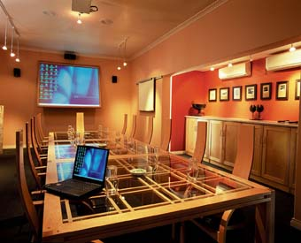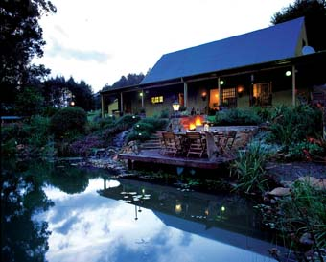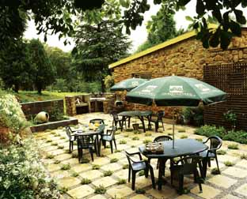

TEAM BUILDING ACTIVITIES

Fly-fishing Clinic
As Stonecutters is a trout lodge offering 2 dams and three kilometres of river fishing, many conference groups choose a fly-fishing clinic as a team event. Under the tuition of an expert the group will be taught casting techniques and some of the basic science of the fascinating world of fly-fishing. A competition can be organized and some great prizes or team gifts relative to this sport can be suggested.
Price: From R285 p/p using a local guide for 1.5 hours including rod hire.
From R320 p/p using an expert guide from Dullstroom. (excluding prizes)

Clay-Pigeon Shooting
This popular event is held on the lawns at Stonecutters and under the supervision of an expert, delegates shoot competitively at flying ‘clays’. A group minimum of 8 delegates is required.
Price: R325per person for 25 shots.

Photo-Chase
A Fun team event while exploring the venue………Delegates are divided into teams.
Each team is issued with
- A digital camera
- A copy of the Photo-Chase guide book
- A site plan of the property to assist in route planning.
The guide books contain photographs taken around the property: each with a cryptic clue in the form of a four line poem. Working against the clock the teams must then proceed to take photographs identical to those in their respective guide books. Their routes will take them around the lodge property, meandering through scenic river, forest and hill locations. Photos may include members of the team or any part of their anatomy!

The team that takes the most photos in the quickest time wins the ‘Shutter Speed’ Award. Other awards will be for ‘The Funniest photo’ ‘Technically the Best’, etc.
Each team hands in their camera and the shots are judged by Stonecutters staff. During the evening prizes are awarded: this will be a fun event!
R300.00 per delegate- Prizes extra.

Bird of Prey Display
This renowned raptor display is a daily event at the Dullstroom Bird of Prey Centre. Entertaining and informative, this stunning show can be brought to the Stonecutters property. Price: At Dullstroom centre: R40p/p.
At Stonecutters: R1500 for a display lasting about one hour.

Horse Riding
Just 20 kilometres from the lodge, outrides on up to 10 well-schooled horses in a beautiful mountain setting.
Price R140p/p p/hour.

I-Create
Get crafty at this Dullstroom centre with mosaics, painting, sand art or fabric painting. Courses set according to clients’ budget.

Spa and Wellness
Serenity Spa in Dullstroom offers rejuvenating treatments for utter relaxation. Price list available on request.

PHOTO-CHASE

ARCHERY

CLAY PIGEON SHOOTING

GOLF:

