Ohrigstad Dam Nature Reserve, Mpumalanga
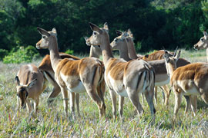
Lying between the town of Ohrigstad and the historical village of Pilgrim’s Rest in Mpumalanga, Ohrigstad Dam Nature Reserve is situated on the edge of the Greater Drakensberg Escarpment-
2 500 hectares of beautiful mountain scenery that surrounds the Ohrigstad dam and makes for a tranquil getaway.
For day visitors there is a pretty, shady picnic site at the far end of the dam that makes lazy lunches, surrounded by mountains possible. The dam offers outstanding fishing opportunities, and yellowtail, carp, tilapia and catfish are numerous, and canoeing and rowing are also popular pastimes.
The Nature Reserve lies roughly 10 kilometres from the turnoff onto the R533 en route to Pilgrim’s Rest. There is prolific bird life, and there are a number of large mammals in the reserve. Sightings of mountain reedbuck, bushbuck, grey rhebok, brown hyena and the little South Africa hedgehog are not uncommon.

Ohrigstad Dam & Nature Reserve is 57km from Stonecutters Lodge and makes a great day trip. Pilgrim’s Rest could also be included on your day trip just a further 16kms along the R533.

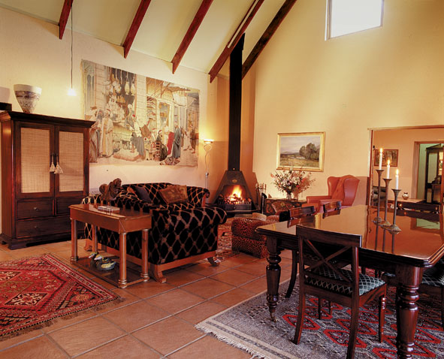

To Book at Stonecutters Lodge:
Call +27 (0) 13 235 4225
+27 (0) 13 235 8921
+27 (0) 83 375 0132

or visit our website:
www.stonecutters.co.za
Email: cobbles@mweb.co.za

