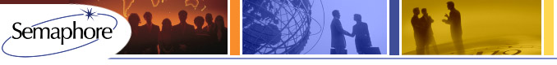

Semaphore’s 2014 Confidence Survey
Semaphore's Annual Confidence Survey
Do you expect to make more personal compensation next year than this year? Feeling more confident or less confident in the President’s Economic team as we left government shutdown and the most recent Fiscal Cliff behind? Thoughts on your boss and competitors? Annually we ask our readers to weigh in and share their level of confidence in themselves, the economy and their businesses. Last year we heard mixed levels of confidence – did it prove to be so? Especially as the stock market soared and reported PE values were up – albeit not as high as the Dow.
Semaphore is conducting its sixth annual survey of Private Equity and Venture Capital partners, principals and professionals supporting the industry. The purpose of this survey is to gather anonymous input from our industry friends and clients with the results fully reported to all. It will stay live until mid-January.
By participating you'll get to gauge your expectations with your peers, competitors and industry colleagues. The survey will take 2-3 minutes and respondent identity will not be reported to us. Results will be published in Term Sheet and on our websitewww.sema4usa.com. Dive in.
Click here to take the survey.
Click here to see last year's results.
Semaphore (www.sema4usa.com), is a leading global professional services provider of Private Equity and Venture Capital funds under management and diligence services. Semaphore currently holds fiduciary obligations as General Partner for six Private Equity and Venture Capital funds, is a New Markets Tax Credit lender and advises General and Limited Partners as well as corporations around the world. Semaphore's corporate offices are in Boston with principal offices in New York, London and Dallas.

