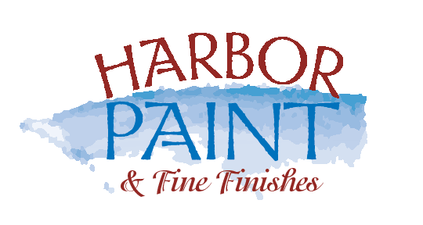

Client “To Do” List info@harborpaints.com 631-385-4405
Harbor Painting offers the following guidelines to assist you in preparing for your upcoming project.
Please review the “To Do” checklist and feel free to contact us with any questions or concerns. One
Week prior to the start of your project, please select your colors for each room. We are here to help.
Please see the color selection sheet.

“To Do” Prior to our arrival:
- Disconnect wiring form computers, video, TV and stereos. Identify your wires so you can reconnect them correctly.
- Remove and store any items on the walls in the areas we are painting.
- Clear off all counters, tables, dressers and shelves of all items.
- Rooms should be clear of all clothing, papers, towels, throw rugs, etc.
- If closets are to be painted, please have them emptied prior to our arrival.
- If any pictures, hanging items etc., are staying in their current locations, please leave the hardware in place. If they are being moved, please let us know and we will pull the hardware and we will patch the holes.
- Remove contents of kitchen cabinets if they are to refinished
- Grandfather clocks should be secured or removed from area
- If Harbor Painting moves a piano, it may need to be re-tuned. (Harbor Painting is not responsible for piano tuning)
- Take down curtains and draperies (Harbor painting is not responsible for any damaged to window treatments)
- Alarm system should be disabled (Harbor Painting is not responsible for alarm company service fees)
- Make any necessary arrangements for pets.
- For your safety and comfort –advise us if you are sensitive to odors. We prefer “Green” low VOC paints.
- If anyone is pregnant or you have infant or asthmatic children, you should make arrangements to stay away from the jobsite for the duration of the job.
- Please leave phone numbers where you may be reached during the day.
- If you are unable to do any of the items on the checklist, please contact us and we will be happy to make arrangements with you.
- Please relax; you have hired professionals who do this every day. We understand the disruption caused by having workers in your home and we will do everything possible to exceed your expectations.

Harbor Painting will perform the following services:
- Move all large furniture and group in the center of the room
- All floors and carpeting will be covered with drop cloths
- All furniture will be covered with plastic sheeting
- Each room area will be vacuumed and furniture will be put back in place upon completion of the job.
- Rubbish and empty paint containers with be removed from the job
- Left over paint cans will be marked and left for the customer
- Our trained crew leader will carefully inspect all surfaces to insure our quality standard has been met.

Harbor Painting takes pride in our professionalism and craftsmanship. Time is taken to prepare and protect your property as if it were our own and to provide the best possible service to complete your project in an efficient and timely manner.

