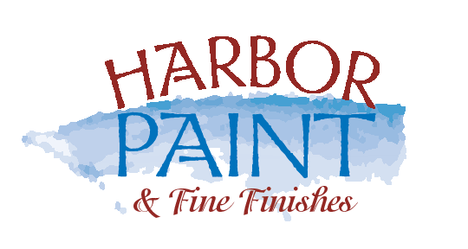

Touch Up/ Spruce Up Request * info@harborpaints.com 631-385-4405

Please let us know of any areas of concern you may have during your project. We will take care of it immediately. You may use this form as part of our “Service” and” Spruce Up” programs. Please visit www.harborpaints.com for more information. If attention is needed to any areas after the job is complete and covered under our Warranty, please complete this form and we will schedule a convenient time to meet with you.
Client Name: ________________________________________Date:_____________________________
Daytime phone: ______________________________________Cell: _____________________________
Email:________________________________________________________________________________
Address: _____________________________________________________________________________________
Areas needing attention | Color | Sheen | Complete

The above areas have been completed to my satisfaction.

Client____________________________________Forman______________________________________

