FOR IMMEDIATE RELEASE
Contact: | Heidi Johnson McAllister  Downtown Congregations to End Homelessness  heidi@dceh.org  612-242-4670

Minneapolis Residents Being Priced Out of Housing

Minneapolis, MN (September 29, 2014) –

Living in a 3 bedroom, 1,000 square feet apartment unit can be challenging for Minneapolis residents Kenkeisha Warren and Tommy Stafford and their four children. With their rent at $950 per month and both earning minimum wage, they spend more than 30% of their income on rent. Finding an affordable place with enough room for their family is becoming more and more of a challenge.
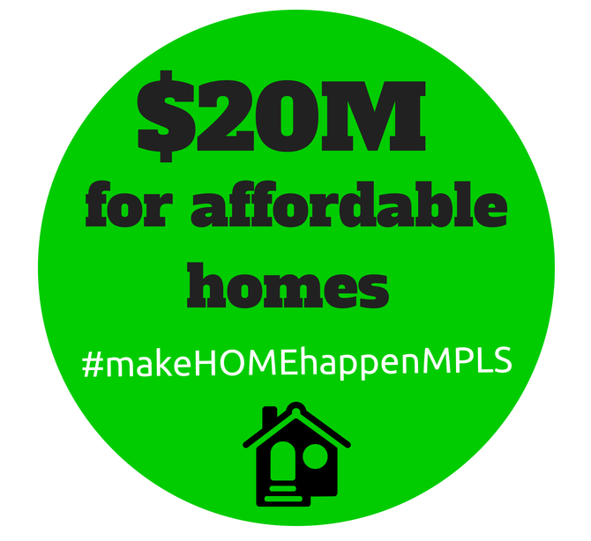

Minneapolis is seeing a strong building boom yet it’s leaving our lower income residents behind. Searching for housing can be a challenge for people making less than the area median income of $70,000. So far in 2014, the housing boom has created almost 2,000 rental units, most of them expensive luxury apartments. With all the high-end housing being built, the cost of housing, both rental and homeownership, is rising and pricing people out of the places they live.

Mayor Betsy Hodges’ proposed budget funds the Affordable Housing Trust Fund below the $10million requirement set by the City Council and cuts the total funding for affordable housing by over $2 million. Meeting the city’s strategic goals rely on both housing equity and an adequate supply of affordable housing, yet the investment in these areas as proposed by Mayor Hodges is woefully inadequate.

We need our city council to make investments in housing that will meet the demand for parents and their children, like Kenkeisha and Tommy. “It is hard to find a decent place to live when rents are so high. We want to live in Minneapolis, but we have seen it get harder to find a place that we can afford.”

Over the next few months, City Council Members will consider the Mayor’s budget proposal. Housing is a fundamental aspect of many of the city’s approved strategic goals, which include creating and maintaining affordable housing, growing Minneapolis, and addressing equity. With the challenges people in Minneapolis are facing to find an affordable place to live, more funding is needed.

“An economic boom like the present should help the whole city – not just those with granite counter tops and organic fruit in the fridge”, said Council Member Jacob Frey. “Our neighborhoods should include a variety of housing options and socio-economic classes. These goals are not possible if every apartment is going for $1,500 a month. If we are serious about narrowing the opportunity gap we need to put our money where our mouth is, and that means making affordable housing a priority in our budget.”

A group of organizations will be working to ensure that Minneapolis invests $20 Million for Housing, including Twin Cities Habitat for Humanity, the Alliance for Metropolitan Stability, the Metropolitan Consortium of Community Developers, The League of Women Voters Minneapolis, Downtown Congregations to End Homelessness, and Beacon Interfaith Housing Collaborative. This funding would go toward the Affordable Housing Trust Fund, the Senior Housing Initiative, and Homeownership Initiatives. This $20 million will begin to address the strategic goals of the city of Minneapolis.

