Massage Therapy Confidential Health History Form

The information request below will assist us in treating you safely. Feel free to ask any questions about the information being requested. Please note that all information provided below will be kept confidential unless allowed or required by law. Your written permission will be required to release information,

Name: __________________________________ Date of Birth___________________________

Address: ________________________ City: _____________________Postal Code: _______________

Phone: Home: ___________________

Cell: _______________ _____ Email address: ________________________________

Work:___________________ Occupation: ____________________________

Preferred contact: _________________ Referred by: ____________________________
Please indicate conditions you are experiencing or have experienced.

Soft Tissue/Joints Respiratory Skin
- Tendonitis/bursitis | - Chronic cough | - Skin condition
- Weakness___________ | - Shortness of breath | - Bruise easily
- Sprains/strains | - bronchitis | - herpes
- Arthritis-OA/RA/other | - asthma | - varicose veins
Location: | - emphysema | - athletes foot
- herniated discs | - pneumonia | - warts/planter warts
 | - sinus problems | - loss of sensation

Headaches Infectious Disease Accident/Injury
- tension headaches | - hepatitis | - car accident
- migraines | - tuberculosis | - whiplash
- tooth/jaw/ear pain(circle) | - HIV/AIDS | - fractures
- head trauma-date:__________ | - other:_______________ | Date:__________________________  Symptoms:_____________________  Physical limitations:______________  ______________________________

Cardiovascular Other Conditions Other Conditions
- high blood pressure | - neurological conditions | - insomnia/poor sleeping patterns
- low blood pressure | - epilepsy | - kidney/bladder problems
- heart attach | - diabetes-onset:__________ | - haemophilia
- phlebitis | - allergies-anaphylaxis y/n | - fibromyalgia
- stroke/CVA | - cancer: _______________ | - osteoporosis
- pacemaker | - vision problems | - surgical implants (pins, plates, etc.)
- heart disease | - hearing loss or tinitis
- angina | - constipation
- chronic congestive heart failure | - other digestive conditions:  __________________________

Women
- pregnant-due date:_________
- gynaecological conditions

What is your general health status? _________________________________________________________________

Current Medications_____________________________________________________________________________

Condition it treats______________________________________________________________________________

Previous surgery, injury__________________________________________________________________________
(ie: dislocation, fracture, car accident)

Of special note (presence of internal pins, wires, metal plates) ___________________________________________

Other healthcare (ie chiropractor, naturopath, physiotherapy) ____________________________________________

Do you have any other medical conditions? (digestive conditions, mental illness, hemophilia)__________________

_____________________________________________________________________________________________

Main Complaint
Location of the pain:

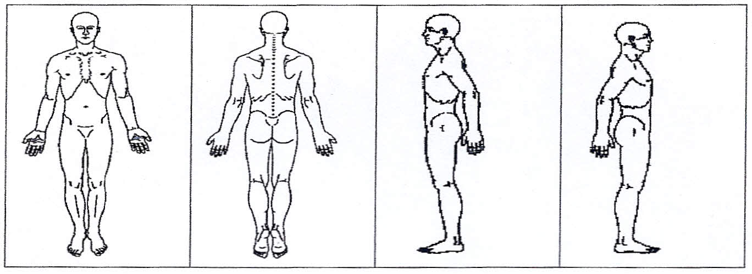
Please use the diagrams. Try to be as specific as you can.
Cause of the pain: _______________________________________________________
How long have you had the pain? ___________________________________________
How frequent is the pain? (all night/day/only when you get up) ___________________
______________________________________________________________________
How intense is the pain? ( scale of 1-10) ______________________________________
How would you describe the pain? (achy,throbbing,burning)______________________
What makes the pain increase? _____________________________________________
What makes the pain decrease? _____________________________________________

What medications are you presently taking for the condition (muscle relaxants,
painkillers)? ____________________________________________________________
Is there a history of this condition? __________________________________________
Have you received any other treatment for this condition? If yes, please describe
and comment on its success.________________________________________________
What results do you desire from your treatment? _______________________________

Informed Consent to Treatment
Massage Therapy involves the manipulation of the soft tissues of the body, skin, muscle, ligaments
and connective tissues, using techniques to produce therapeutic results.
With Massage Therapy, the client disrobes to their comfort level, and lies on a table between two sheets.
Only the areas of the body being directly treated are uncovered at one time.
If at any time you are uncomfortable with the pressure or technique being used, you can tell the therapist
(i.e to decrease or increase pressure, irritating, etc). You can aslo stop the treatment at any time.

I have read the above and give consent for treatment.

24 hours notice is required for cancellation of an appointment to avoid charges.

Signature: ___________________________________

Date: __________________

