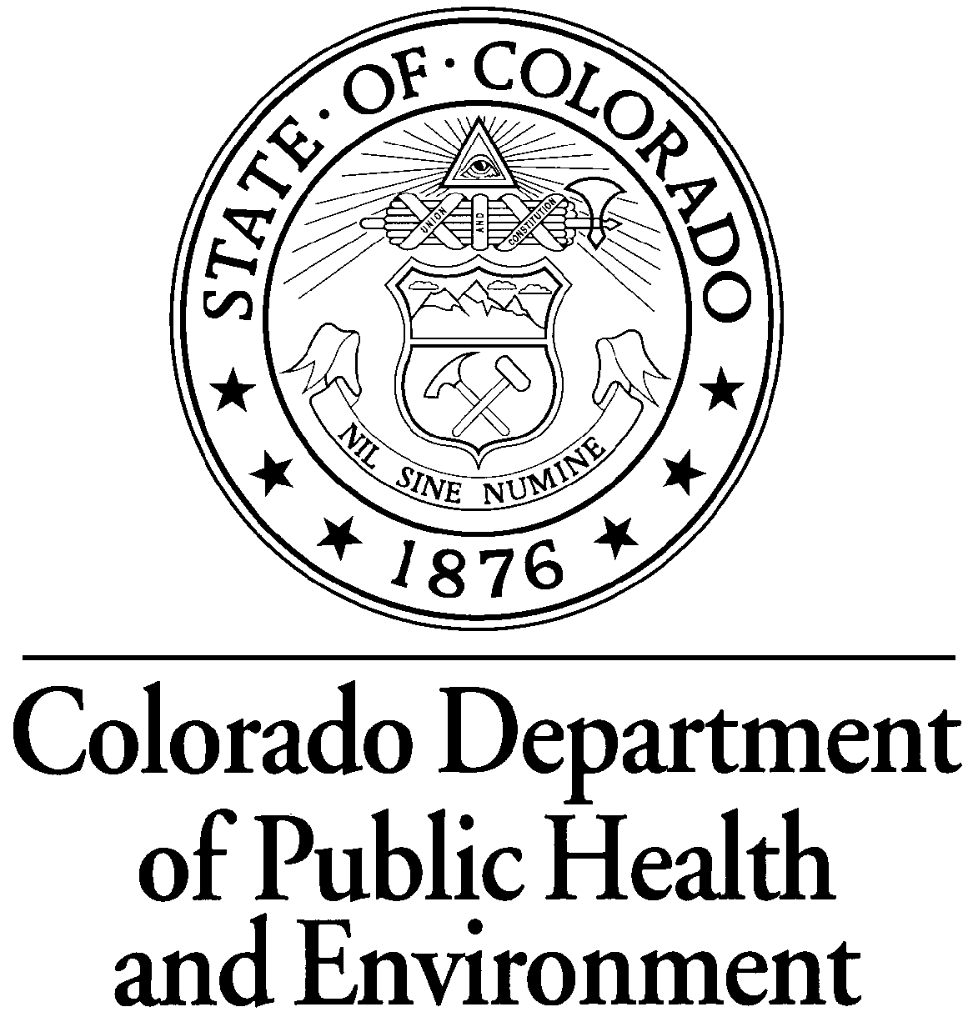 | NEWS RELEASE  Office of Communications  Colorado Department of Public Health and Environment  4300 Cherry Creek Dr. S. | Denver, CO 80246  303-692-2021 | cdpheofficeofcommunications@cdphe.state.co.us
FOR IMMEDIATE RELEASE:  Wednesday, Aug. 3, 2011  FOLLOW US ON: |  | CONTACT:  Warren Smith  Community Involvement Manager  Hazardous Materials and Waste Management Division  303-693-3373  warren.smith@state.co.us
Survey shows nearly 75 percent of Coloradans aware of radon dangers,
but less than 35 percent test their homes

DENVER – A study recently released by the Colorado Department of Public Health and Environment shows that 73 percent of Coloradans surveyed know about radon, an odorless, colorless radioactive gas that is the leading cause of lung cancer in non-smokers and the No. 2 cause of lung cancer overall. The survey also showed that only 34 percent of respondents had tested their homes for the gas, which originates from the decay of naturally occurring uranium in the soil. Harmless when it disperses in the air, radon is dangerous when it collects in homes.

“It’s encouraging that so many people are aware of radon, because most Colorado counties are at high risk for it,” said Chrystine Kelley, radon program manager in the Hazardous Materials and Waste Management Division of the Colorado Department of Public Health and Environment. “The best way to protect your family is to test your home, and we recommend that every Colorado home be tested.”

Radon testing data collected by the state shows that approximately 50 percent of Colorado homes have radon levels above the recommended action limit of 4 picocuries per liter of air (PCi/L). The good news, Kelley says, is that a properly installed mitigation system can greatly reduce indoor radon concentrations.

This is the first year that questions about radon awareness were added to the annual Colorado Behavioral Risk Factor Surveillance System, a series of telephone surveys monitoring how health factors such as smoking, excess weight, sedentary lifestyles and the nonuse of seat belts contribute to injury, illness and death.

Other radon awareness findings include:

- Respondents ages 18-29 were least likely to know what radon is, and the 30-49 year-old age group was less likely to know what radon is compared to people ages 50-69 and older than 70.
- Approximately 64 percent of black respondents and 58 percent of Hispanic respondents did not know what radon is, compared to slightly less than 20 percent of white respondents.
- In general, radon knowledge increased with education level and income.
- Respondents ages 18-29 were the least likely to have had their homes tested for radon; and black and Hispanic respondents were less likely to have tested their homes than white respondents.
- Seventy-five percent of Coloradans whose homes tested above 4 PCi/L had installed mitigation systems.

“The only way to know if radon is present in your home is to test for it, and the only way to get rid of it is to install a mitigation system,” Kelley said. The Study of Radon Awareness and Behavior in Colorado, additional radon information and discount coupons for short- and long-term radon test kits are available at www.coloradoradon.info.

-- # --

