FULL SPEED AHEAD Keynote Series

To Thrive in a More, Faster, Now World
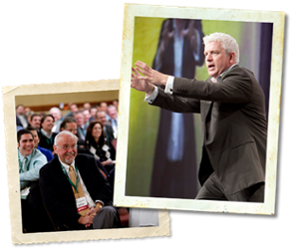
Vince Poscente, one of the most in-demand speakers today, is an expert on Resiliency—the ability to overcome challenges and bounce back even stronger than ever before. His client list includes top organizations with one thing in common: they understand that success is not just about reaching your goals and getting what you want. There also has to be an intent to handle set-backs and overcome obstacles and end of smarter, stronger and more focused than ever before, Vince knows first-hand the power that attitude, determination and innovation play in your future success--especially when life doesn’t go as planned.
A recreational skier, Vince rose to the ranks of an Olympic skier in just four short years. Next goal. Win the gold. But it didn’t happen. Things got in the way. But not in the way of him becoming successful. He just had to bounce back and find another path. Another solution. Another way to achieve his goals and GRAB THE GOLD another way. Landing him a spot as a Times Best Selling author. Hall of Fame Speaker. Award winning business owner.
So what are your teams’ obstacles? The economy? Competition? Negative attitudes? Lower productivity? And the list goes on.
Vince is the #1 go-to guy for taking a team and teaching them how to lead better. Produce more. Sell more. And move past the obstacles and into a mental space that creates the kind of success you and your team want and deserve.
This is NOT Vince just telling his story. Because everybody has a story. This is about Vince sharing strategies and solutions that will definitely change how your team handles crisis. Problems. Competition. And change. Without understanding resiliency and the absolute importance it plays on everything and everyone—your team will not have the skills they need to overcome the things that will inevitably stand in their way.

