FULL SPEED AHEAD Keynote Series

To Thrive in a More, Faster, Now World
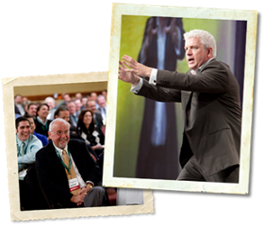
Vince Poscente, one of the most in-demand speakers today, is an expert on Resiliency—the ability to overcome challenges and bounce back even stronger than ever before. His client list includes top organizations with one thing in common: they understand that success is not just about reaching your goals and getting what you want. There also has to be an intent to handle set-backs and overcome obstacles and end of smarter, stronger and more focused than ever before, Vince knows first-hand the power that attitude, determination and innovation play in your future success--especially when life doesn’t go as planned.
A recreational skier, Vince rose to the ranks of an Olympic skier in just four short years. Next goal. Win the gold. But it didn’t happen. Things got in the way. But not in the way of him becoming successful. He just had to bounce back and find another path. Another solution. Another way to achieve his goals and GRAB THE GOLD another way. Landing him a spot as a Times Best Selling author. Hall of Fame Speaker. Award winning business owner.
So what are your teams’ obstacles? The economy? Competition? Negative attitudes? Lower productivity? And the list goes on.
Vince is the #1 go-to guy for taking a team and teaching them how to lead better. Produce more. Sell more. And move past the obstacles and into a mental space that creates the kind of success you and your team want and deserve.
This is NOT Vince just telling his story. Because everybody has a story. This is about Vince sharing strategies and solutions that will definitely change how your team handles crisis. Problems. Competition. And change. Without understanding resiliency and the absolute importance it plays on everything and everyone—your team will not have the skills they need to overcome the things that will inevitably stand in their way.

Keynote Speech Topics

Full Speed Ahead Sales

Sales people are a unique collection of high performing individuals, with considerable expectations, facing a cascade of opportunity. This is coupled with a world of More – Faster - Now realities of overwhelm and life balance. New York Times bestselling author of The Age of Speed, Olympian and award winning salesperson, Vince Poscente, delivers a wildly entertaining, thought provoking and substantive insight on how to thrive with our unique sales groups. Vince went from recreational skier to the Olympic games in just four years. Skiing at 135 mph on skis, he shares a remarkable formula about:
- Clarity of Purpose
- The Process of Commitment
- Consistent Effort in a Competitive Environment
- Building Confidence
- Routines for Controlling Peak Performance
Giving executives and their sales people a collective experience allows a conference fulcrum for better sales execution and higher profits. Full Speed Ahead has profoundly affected countless sales teams explore internal motivation and future potential.

Full Speed Ahead Leadership
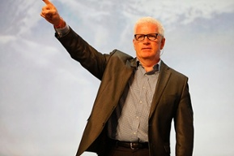
The Olympic movement is pervasive in our society on many levels. Primarily, we can all relate to the pursuit of excellence. We can also appreciate the three core principles of the pursuit of excellence, international understanding and fair play alongside the motto of Citius, Altius, Fortius (Swifter, Higher, Stronger).
But the unwritten motto for high performing leaders is “Smartius.” Inevitable obstacles spring from basic human nature. In the personal and corporate landscape, real life issues and the realities of competition pervade. The solutions to roadblocks for leaders of corporations are explored in this entertaining and thought-provoking message.
Building Teams with the Urgent WHY?

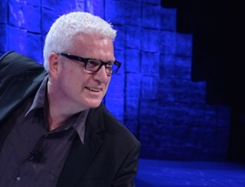
LeBron James used Vince Poscente's strategies in his transitions from Cleveland to Miami and back to his hometown. The Dallas Cowboys coaching staff used the
principles with their team in their recent turnaround season. FedEx and EvolvHealth use Vince Poscente's tools in their leadership team training keeping them out front in a competitive landscape. Vince Poscente helps teams target their emotion-drivers towards simplicity, synergy and life balance.
The underpinning of Vince Poscente's "Urgent Why" approach is from his international bestseller, The Ant and the Elephant. It is a based on the combination of finding your WHY and the emotional quotient that fuels internal motivation. Vince Poscente combines the concepts of finding each team member's emotional buzz, a simple path towards clarity, commitment, consistency, confidence and control in concert with the team's overall objectives. This is a transformational keynote for teams determined to progress full speed ahead.

Find Your Buzz
This motivational keynote speech has been delivered around the world for Direct Sales audiences wanting a high energy, humor and an inspiring message around accelerated goal setting. This "recreational skier to Olympics in four years story" has been Vince's most requested speech over the last twenty years. It revolves around the three key elements of "big goals fast":
- Alignment starts with each of us having an "emotional buzz" surrounding the goals in front of us.
- Agility is facilitated when we "do what the competition is not willing to do."
- Aerodynamics is all about efficiency and eliminating things that cause drag (such as fear and interruptions).

Instant Impact and Lasting Influence
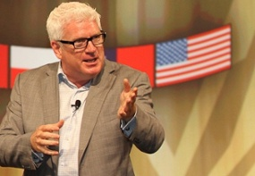
The skills and art of impactful and influential communication are necessary for leaders on the platform or digital media. Reading off a teleprompter is the ultimate contrived message resulting in an invisible barrier between leaders and followers. Using Power Point slides as a crutch for messaging is also an energy killer. But leaders who expertly command the stage or screen can have instant impact and lasting influence. Vince Poscente leads an interactive and transformational session on how leaders can deliver a profound message anywhere from a room full of their employees, an audience of stakeholders or in a brief video message.
Vince has coached the Chief of Protocol of the White House, Harvard Business Book authors, CEO’s of multimillion & billion-dollar companies and entrepreneurs intent on designing a killer keynote. Vince’s acumen for speaking had him inducted into the Speaker Hall of Fame with the likes of Ronald Reagan, Zig Ziglar, Og Mandino and Jack Canfield. Vince Poscente is in-demand for his Instant Impact and Lasting Influence keynotes at corporate events around the world. This rare opportunity to learn from a master communicator, at the top of his game of speaking and training.This powerhouse keynote will help you have instant impact and lasting influence when you are in front of a demanding client or called to deliver an important presentation.
Vince Poscente is a New York Times bestselling author of six books and has been an in-demand keynote speaker for over two decades. He is an Olympian and inductee into the Speaker Halls of Fame in Canada and USA. His FULL SPEED AHEAD keynotes deliver energy, humor and practical, take-home tools. He was rated by MPI/eSpeakers as the top ten motivational speakers in North America and Meetings & Conventions "Meeting Planners' favorite speaker."

