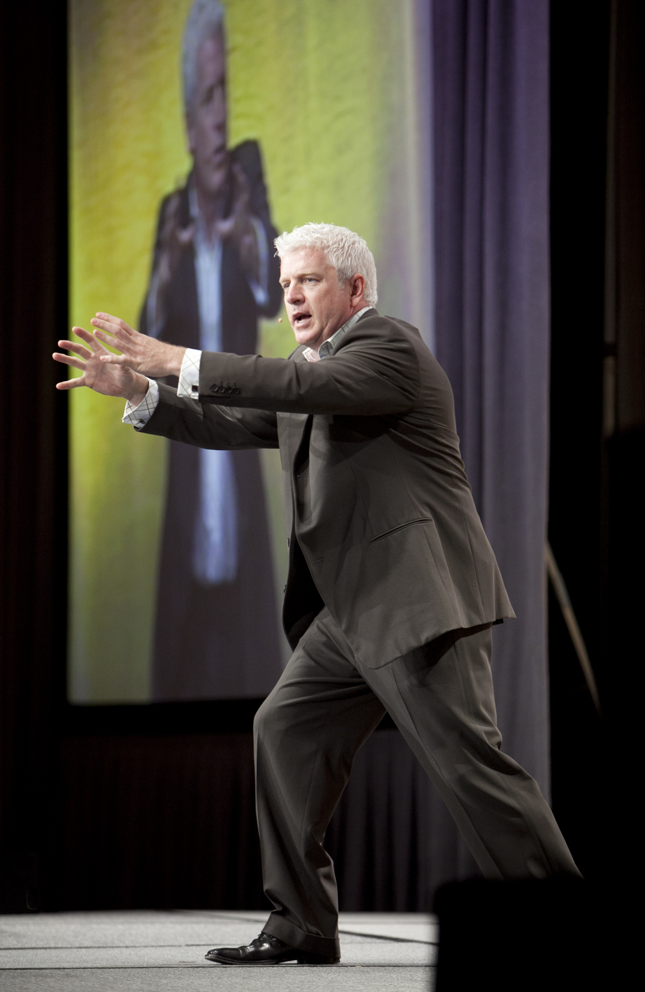
VINCE POSCENTE
Lead Research Analyst
ELEPHantPOWER Systems

Since 1992 Vince Poscente has been researching, writing and speaking about life mastery. This New York Times bestselling author wrote the international phenomenon, The Ant and the Elephant - Leadership for the Self. His background as an Olympian with a masters in Organizational Management - alongside his corporate experience - culminate into an invigorating perspective on accelerating past problems towards sustained improvement.

- Inductee into the USA and Canada’s Speaker Halls of Fame
- Authored over 450 pop-psychology articles on thriving in today’s fast paced world
- #1 Wall Street Journal, USA Today and NY Times bestseller
- Masters in Organizational Management
- Leadership on four Himalayan expeditions
- Weekend skier to Olympian in four years

Contact Vince Poscente to help you accelerate towards mastery in the business of life.

www.vinceposcente.com 214.752.7400 info@vinceposcente.com

