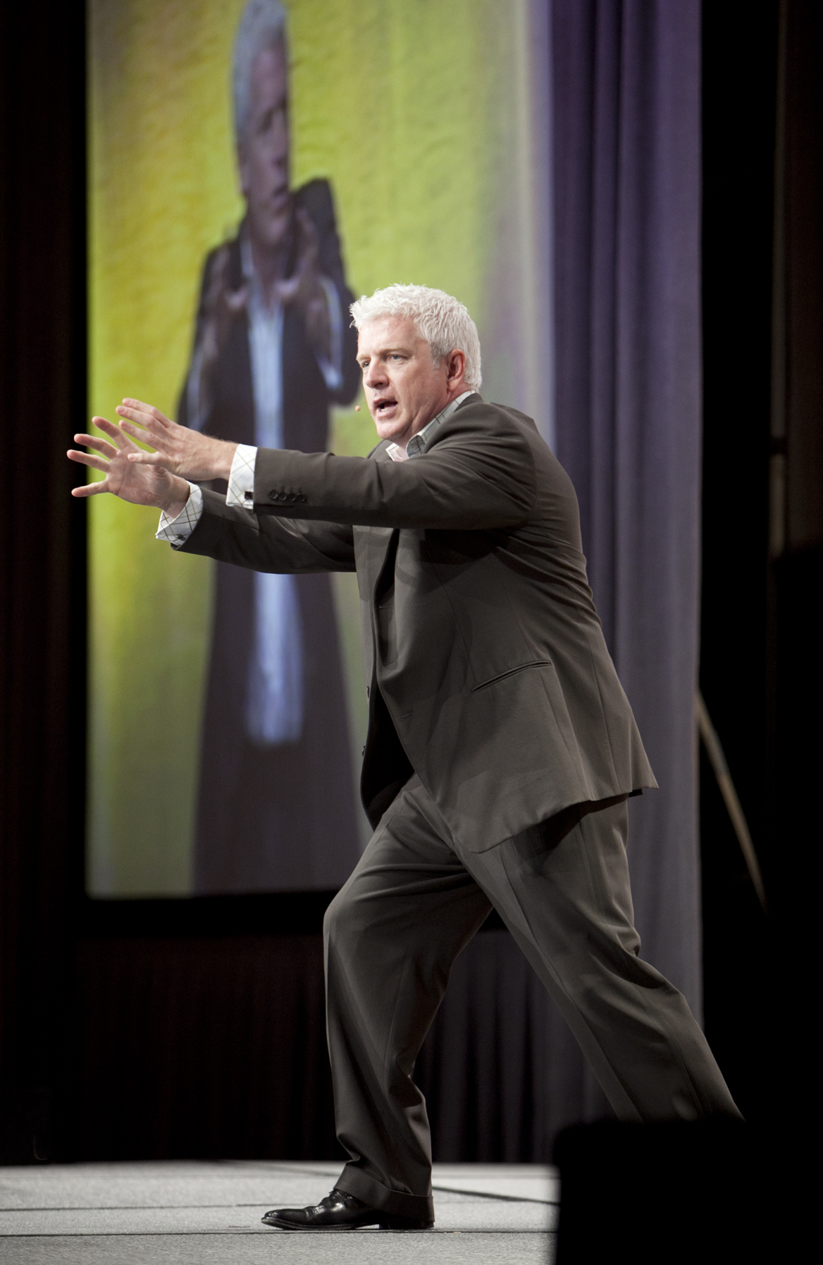
VINCE POSCENTE
Lead Research Analyst
ELEPHantPOWER Systems

“We will not thrive by ‘coping’ with challenges. Driving profits and developing cultures are accelerated through our ELEPHantPOWER Systems. When individuals align their elephantine subconscious agendas with the uncanny power of ant-like intentions - magic happens. Life gets easier. Market share grows. Organizations thrive in a peak performance culture.”

Vince Poscente is the Lead Research Analyst for ELEPHantPOWER Systems. His team analyzes why leaders hit roadblocks and sales people bump up against self-limiting beliefs. They study the dynamics of peak performance in the business of life and challenge the norms for influential communication.

About Vince Poscente: Since 1992 he has been researching, writing and speaking about life mastery. This New York Times bestselling author wrote the international phenomenon, The Ant and the Elephant - Leadership for the Self. His background as an Olympian with a masters in Organizational Management - alongside his corporate experience - culminate into an invigorating perspective on accelerating past problems towards sustained results.

The fact that Vince Poscente could be a stand-up comedian with his signature insights translate into instant impact and lasting influence.

Poscente illustrates how each team member can sustain an excellence advantage. Through insightful research and edge of your seat stories, your audience will be energized and ready to tackle the tough challenges ahead of them.

“Sophisticated audiences want more than ‘simple motivation.’ My job is to illuminate a direct path for reducing overwhelm, eliminating obstacles and engaging customers; all in an entertaining way.”

- Meetings & Conventions - Planners’ Favorite Speaker 2014 & 2015
- MPI’s eSpeaker selection for “Top 10 Speaker” 2015
- Inductee into the USA and Canada’s Speaker Halls of Fame
- Authored over 450 pop-psychology articles on thriving in today’s fast paced world
- #1 Wall Street Journal, USA Today and NY Times bestseller
- Masters in Organizational Management
- Leadership on four Himalayan expeditions
- Weekend skier to Olympian in four years

Contact Vince Poscente to help you accelerate towards mastery in the business of life.

www.vinceposcente.com 214.752.7400 info@vinceposcente.com

