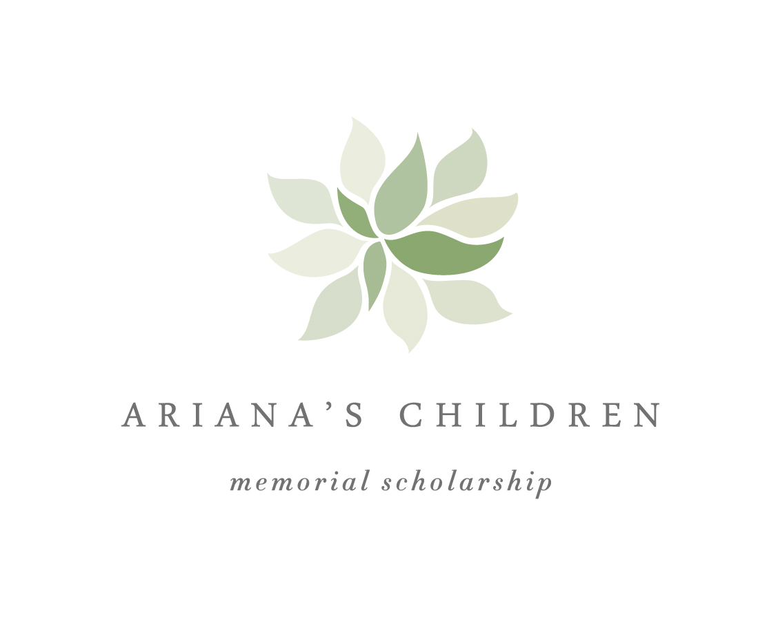

Description
The Ariana's Children Memorial Scholarships are intended to support PHC students with a vision and commitment to work on the international level and who are preparing themselves to do well, seek judgment, and relieve the oppressed (Isaiah 1.17) throughout their academic and professional careers.

Award: Two awards, $3,000-4,000 each.
Duration: Awarded once annually.
Renewal Requirements: These scholarships are not automatically renewable.
Description: Provides financial support for international academic opportunities.
These Scholarships are merit-based. The award recipients are selected through a competitive application process. Applications should be submitted to the PHC Office of Admissions by 28 February of the spring term. The Scholarship Board will select a pool of finalists in March and the award recipients will be notified by the beginning of April.
Applicant Parameters and Process

- Applicants must be at least a rising sophomore; at most, a graduating senior.
- A cumulative 3.0 GPA is required at the time of the application.
- Application is open to students from any academic major.
- Applicants must be in good standing with Patrick Henry College. Ongoing disciplinary procedures or financial deficiencies (late/insufficient payments of tuition or room and board) are grounds for disqualifying applicants.
- All applicants must complete and submit an application to the PHC Office of Financial Aid by 28 February 2015. The award recipient will be notified by the beginning of April.
- The Scholarship application comprises the following elements, all found in the Application document below:
  - Personal information form
  - Study proposal
  - Personal statement
  - Essay responses
Upon completion of the program/project, the Scholarship recipients are expected to summarize their experience and observations in an essay or narrative, ideally to appear in a PHC print publication. The Scholarship Board will host a dinner for the recipients after the completion of the program/project to discuss their experience with the Board and other interested donors.

International Academic Opportunities

The fundamental criteria for qualifying study proposals are simple: they must be academic in nature and involve travel outside the continental United States. Potential programs/projects include, but are not limited to:

- Language immersion programs
- International internships
- Study-abroad programs
- International field trips led by PHC faculty
- Field research (sponsored)
- Field research (independent)

Note: The Scholarship Board does not require students to only propose programs/projects that will receive approval from the PHC Registrar for academic credit. If, however, the student would like to ensure academic credit from PHC for completing their program/project, they are responsible to apply for and receive the necessary approval from the PHC Registrar before undertaking the program/project. Being awarded the Scholarship does not constitute approval from the PHC Registrar’s office for PHC academic credit.

Application Forms

Application Forms

Please complete and submit your Application to Christine Guenard, Associate Director of Financial Aid (cwguenard@phc.edu), by 28 February 2015.

