How to Build Reliable Mobile Displays
Petri Savolainen

Thinner, lighter, larger
From the early days of mobile phones to the present, manufacturers have fiercely competed on who is able to make the smallest, the lightest, and the thinnest device. Although size has hit a plateau for some years, it is still relevant factor. The device must be small enough to be stashed in a pocket and light weight is an advantage. Internet and social media are the drivers for expanding usage of smart phones although the user still can make phone calls and text with his or her device. The focus on media drives the industry to put displays as big as they can into the devices, with sizes being in the range 3.5” to 5”.

A new, but rapidly growing market segment is the tablet market. These devices offer larger displays (7-10”) and have the same connectivity as smart phones. For many the tablet is replacing the laptop as the computer on the go. As compared with the smart phones, the larger display makes the usage of content, including video, games, photos, and internet, easier. The tablet manufacturers are also moving toward high definition displays.

The touch screen has become an industry standard user interface. Hence, display and touch are the user’s communication channels with the device. This requirement puts pressure on the reliability of the display module and the touch screen as the user’s expectation of the robustness is in the same range as with “old” displays safely surrounded by robust mechanics and thick windows, as shown in Figure 1. Thinness is key driver for displays both in smart phones and tablets. For example, Apple’s new iPhone 5 utilizes an in-cell screen technology, which combines the display and the touch sensor into a single part, requiring a thin profile to function reliably. Combined with the touch screen, the challenge for the device manufacturer is to ensure that the display and touch will be reliable, defined as the measure of a products ability to perform a required function under stated conditions for an expected duration.

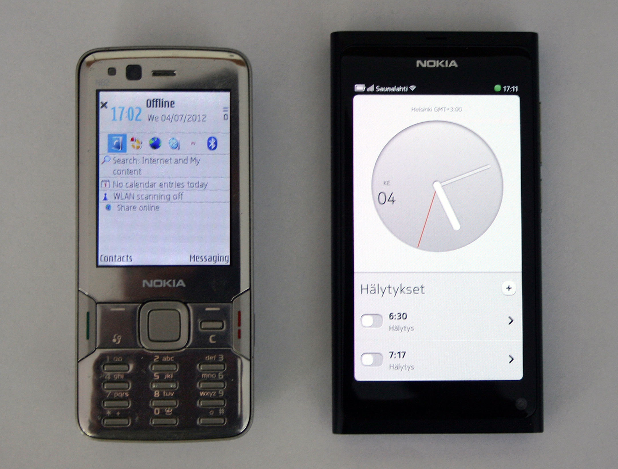
Figure 1. “Traditional” phone design vs. smart phone.
The reliability challenge
As shown in Figure 2, a display and touch module will take an increasingly larger proportion of the volume of the device, both in the case of smart phones and tablets. At the same time the mechanical structures supporting and protecting the module have decreased in size and stiffness, presenting a tremendous challenge for the reliability of the device. In addition, the touch user interface means that the module is constantly under mechanical stress when the device is being used. The icing on the cake is that the devices are under constant risk of being dropped, facing high shock loads at impact.

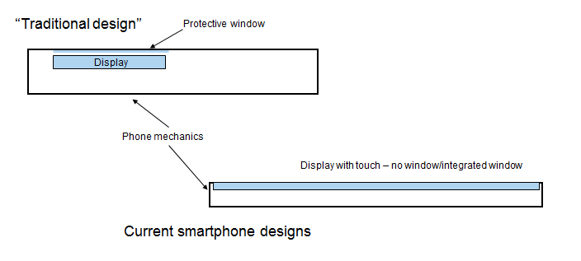
Figure 2. Current displays occupy much larger proportion of the phone and may be part of the cover.

Due to higher pixel densities, the driver integrated circuits (ICs) are becoming more complex. To enable an increasing number of outputs and save real estate on glass, the drivers tend to grow in length. Bending of the display module might stress the driver IC beyond its strength. This is possible because the glass is thinner and transfers a higher load to the driver than with thicker glass. In addition, the driver IC’s connection to the glass must be robust. The connection is in most cases a chip on glass (COG) type using anisotropic conductive adhesive (ACF).

Typical route in and out to the display and touch module is accomplished using flexible printed circuit. They too are getting thinner, yet the number of tracks is increasing. In addition, the transmission speeds are higher to enable high definition (HD) video, increasing the likelihood of cross talk and other issues. The flex circuit is usually folded and connected to the main board with a board-to-board connector. The connection to the module is typically flex-on-glass with ACF. The folds in the flex may cause tracks to break with vibration or shock impact. Finally, the connections may experience excessive loads, for example in the case that the flex is slightly too short, stressing the connector and the ACF.

Moisture may cause problems in the ACF connections. The polymer matrix of the ACF swells because of the water and conductive particles lose contact to the glass tracks and driver IC bumps. This problem is possible with the flex on glass side as well. Furthermore, the moisture may drive corrosion of the tracks on the glass if there is sweat, fingerprints, or other ionic contaminants on the tracks.

Minimizing reliability risks
We will now discuss the means to build reliable display modules in the following paragraphs.

Glass
Glass is a brittle material and stress is amplified by flaws, e.g. cracks. Ductile materials yield before they break, but brittle materials break before they yield. This means that glass breaks instantly when the stress exceeds the level defined by the material parameters and the number and size of flaws. This also implies that the “strength” of glass is a statistical parameter.

K-criterion defines that glass breaks when the stress intensity factor, defined by the flaw size and stress level, exceeds the fracture toughness¹:

K_{I} = Y σ √a ≥ K_{IC} (1)

Where: K_{I} stress intensity factor, K_{IC} is the fracture toughness, Y is numerical parameter (for example, 2 for surface flaws), a is the depth of the flaw, and σ is the nominal stress, that is the stress without any flaws. Hence, minimizing the size and number of flaws is critical for minimizing glass breakage in displays.

Building robust display and touch module starts with glass cutting where the modules are separated from the mother glass by mechanical cutting. The target is to achieve as smooth a cut surface (glass edge) as possible since the stress needed to break the glass is proportional to the crack size. Conversely, the smaller the crack, the higher the stress needed to break the glass. This issue is even more important with thinner glasses. Therefore, the display manufacturer must pay attention to their glass cutting processes to achieve as smooth glass edges as possible. This may require the use of a Design of Experiments (DOE) to find the parameters and tools (cutting wheel) to find out the best possible solution in terms of edge quality and productivity.

Glass cutting process monitoring can be performed with four-point bending test and microscopic inspection of the edge quality. The glass frit may have to be analyzed using optical microscopy to locate the failure site and characterize the cracking. Similarly, nano-indentation may have to be performed on the frit to ascertain the hardness of the samples. Additionally, handling of the glass modules in subsequent process steps must be as delicate as possible – no glass clinging sounds should be heard in the display factory.

Module assembly
Delicate handling of the module in all phases of the process is important here as well. Another matter to be addressed is the electrostatic discharge (ESD) protection of the module through the assembly line. Transport equipment, working stations, and any material in touch with the module must be carefully selected to provide proper ESD protection. DfR recommends that the level of ESD protection be in accordance with IEC-61000-4-2 for Class 4 devices, which is 8K volts from a Charged Device Model (CDM) as ESD from a Charged Device is the most prevalent failure mode attributable to ESD. In addition, all the workers in line should wear proper garments and footwear and use wristbands where needed. Regular training for ESD practicalities is essential to avoid issues.

For all processes involving polymers, the manufacturer shall develop the process according to the polymer supplier’s recommendation in order to achieve the best possible results. A DOE will be a helpful tool here, too. The processes involved are ACF bonding for the driver IC and flex circuit, curing the optically clear adhesive for the touch panel, as well as silicone or UV coatings to protect the contact ledge of the module. Useful process controls are shear testing for the driver IC and peel testing for the flex circuit. It is also essential to prevent any particle or other contamination at these phases to avoid open circuits (ACF) or corrosion.

Attaching optical films (polarizer, etc.) requires a particle free environment and adequate pressure to eliminate air bubbles. The pressure should not, however, produce too high a stress on the panel. The same goes for inserting the module in its frame: the module should go into the frame with as little force as possible.

Module and product design
Panel fixing points to its mechanical frame should keep the panel fixed to the frame despite any impact or other loads and to protect the sensitive areas, especially the contact ledge with driver IC from excessive loads. Glass thickness, composition, and tempering can be varied along with adhesive thickness to ascertain the optimum bond line thickness for reliable attachment and should be evaluated. The mechanical frame also provides the connection between the module and the device.

Key in designing the device around the module is that no object (components, sharp corners, mounting towers, etc.) will press the module nor will hit the module in impact. Such occasions might deliver stress levels high enough to break the glass. A very effective way to design for low stress levels is to use Finite Element Analysis (FEA) to simulate different load conditions (both intrinsic and extrinsic) and check the stress peaks. Redesign can be done based on the simulation results to lower the stress. Statistical information on glass strength in each case should be acquired through four-point bend testing.

References
- Kurt Nattermann, “Strength of glass”, Schott Glass, Mainz, Germany, May 2003.

