Open School

How to Access the IHI Open School Online Courses

Step 1: Login to IHI.org.
- Go to www.IHI.org/Login. If you are not yet registered, please click the “Register Now” button to do so.

Step 2: Enter your group’s passcode.
- After you have successfully logged in, go to www.IHI.org/EnterPasscode.
- Enter your group’s 8-digit passcode [abcd1234] and click the “Get Access” button.
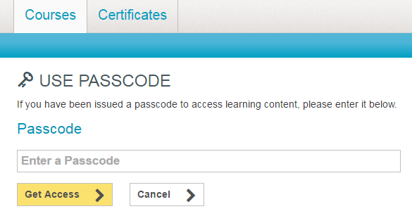

abcd1234

- A confirmation message will appear, indicating you have joined your group and inviting you into the courses.

Step 3: Take courses.
- Now that you are registered for the courses, return directly to your learning using the following link: www.IHI.org/ProfessionalCourses. Bookmark the link for easy access.

