**IDP is a process you direct, in partnership with your supervisor, to review performance and enhance your professional performance and growth by:**

*• Identifying and pursuing your goals for professional development in alignment with institutional goals.*

*• Setting goals to learn or improve in important competencies you will need now or in the future*

*• Identifying your strengths, talents and passions and planning ways to use them on the job*

As a part of your IDP, you will identify the professional goals that matter to you and align with the institutional goals, determine what experiences, skills and behaviors will help you achieve those goals and then create a plan of action to achieve your goals. You will work with your supervisor to evaluate areas that have the greatest potential to pay off for you, and for the organization, in the short term and longer term.

In this way, you and the college can succeed together.

This booklet explains your role in creating and directing your professional development and provides you with tools to create and launch your Individual Development Plan

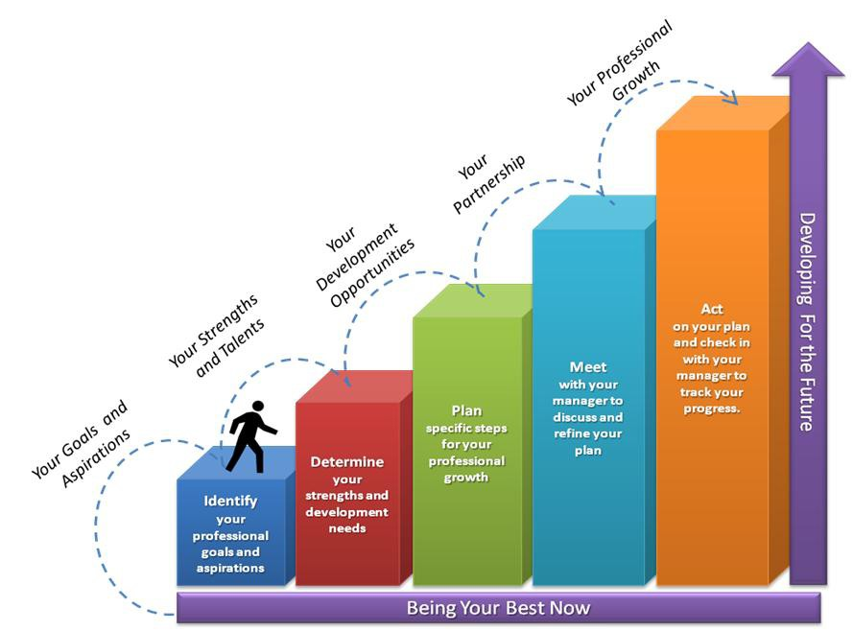

**Review current performance**

**Meet with your supervisor to discuss and refine your plan**

**Act on your plan and check in with your supervisor to track your progress**

***Three Key Ingredients for Professional Development***

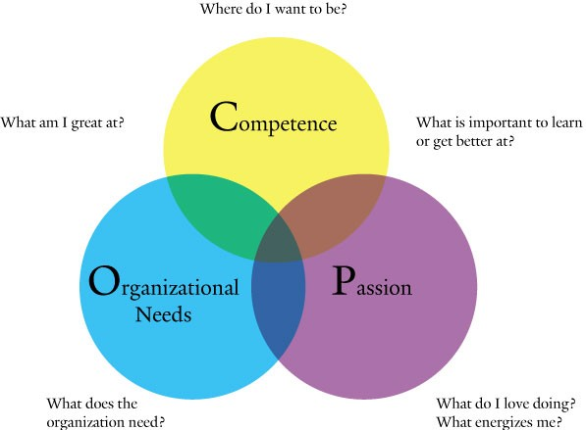

What are my current challenges / areas for improvement?

**Getting Started *– A Step-By-Step Guide to the IDP Process***

❶ ***IDENTIFY*** *Your Professional Goals and Motivations*

• What motivates and energizes you at work?

• What kinds of opportunities do you want in the future?

* What are my current challenges / areas for improvement?

• What opportunities exist in your current role that will help you develop and grow?

• Where do your motivations and the needs of the organization strongly align?

• What do you want to learn…prepare for?

• Note your goals and motivations on the IDP Conversation Tool which follows.

❷ ***DETERMINE*** *Your Talents/Strengths and Development Opportunities*

• What are your talents/strengths?

• What are your passions, what do you love doing?

• What are your areas to improve, or new areas to learn?

• Review your recent and past reviews, any performance-related feedback you have received from your supervisor(s), co-workers, students and others, and any self-assessments you have taken (DiSC, MBTI, others) - are they consistent with your assessment of your talents, strengths & development needs?

• Note your talents/strengths and development opportunities on the IDP Conversation Tool.

❸ ***PLAN*** *Your Focused IDP Objectives and Action Steps*

• Considering your current career situation and future aspirations, where should you focus your development? What will your objectives be for this IDP?

• Will your IDP include building capabilities, preparing for new opportunities, both?

• Which of your strengths/talents will you use more often, or expand?

• What development opportunities are important for you to focus on?

• What action steps will you take to achieve your IDP?

• Note your ideas for development activities on the IDP Conversation Tool.

❹ ***MEET*** *With Your Supervisor*

• Schedule a one-hour meeting with your supervisor to discuss your draft IDP.

• You will be responsible for running the meeting with your supervisor.

• Prepare by reading through the “Meet With Your Supervisor” section of this guide.

• Bring the notes you created in Step 3 to the meeting.

• Use the “How to Conduct an IDP Meeting With Your Supervisor” steps to run the meeting.

• Meet with your supervisor to discuss and refine your individual development plan.

❺ ***ACT*** *On Your Plan*

• Complete an IDP form to finalize your plan and give a copy to your supervisor.

• Plan your IDP deadlines into your calendar.

• Partner with your supervisor to make the plan work.

• Schedule quarterly follow up meetings to check on your progress.

• Act on the plan and assume ownership.

**IDP Conversation Tool**

**Employee Supervisor**

Where I see myself in the future (my career and/or professional growth goals)

Where you see me in the future (growing in current job or taking on new responsibilities)

What I see as my strengths and talents

What you see as my strengths and talents

What I see as my development opportunities

What you see as my development opportunities

Development Plan I will commit to and you will support for this year

What I see as possible development actions for me

DD

What you see as possible development actions for me

***The IDP Meeting***

Individual Development Planning is a partnership, a joint effort, led by the employee and supported by the supervisor. The plan begins to come alive during the IDP meeting. In this meeting the employee and supervisor discuss and refine the ideas they have prepared before the meeting, and talk about development within the current job, and possibilities for future career development in alignment with college needs.

The output from the discussion is a refined IDP with goals and activities spelled out that will allow the employee to grow in directions of interest, while contributing to the needs of the college. Together, the employee and supervisor create a plan the employee can act on and the supervisor can support.

The process for getting ready and having the meeting is described below.

*Employee Role Supervisor Role*

**Prepare for the meeting Prepare for the meeting**

- Review your most recent IDP and any performance documents for this year. Think about what skills are needed for your current work and future positions, along with your interests and Hocking’s needs.

- Self reflect on areas of needed improvement.

- Make notes in the Employee sections of the IDP Conversation Tool, and bring it to your meeting.

- Prepare to lead the discussion – this is *your*

development plan.

- Use the meeting steps in the next section to plan and stay on track during the meeting.

- Review the employee's most recent IDP and any performance documents.

- Think about resources and opportunities that might provide development for your employee.

- Write any performance concerns and prepare to discuss them.

- Think about how your employee’s talents and strengths can be best utilized.

- Make notes in the Supervisor sections on the IDP Conversation Tool and bring your ideas to the meeting.

- Your employee will use the meeting steps in the next section to walk you through their ideas and goals for professional development.

**Meet**

- Your role is to provide an overview of your thoughts for each section of the IDP Conversation Tool, and share how you arrived at your ideas.

- Invite your supervisor to share his or her perspective as you move through each section and come to agreement about what will be incorporated into the plan.

- Set a time to get the refined IDP back to your supervisor and calendar a time for your first check-in.

**Meet**

- Your role is to provide honest feedback on performance and help the employee think through the plan based on what you know about the department’s direction and goals, the College’s goals and the employee’s skills.

- Make sure you’re clear about what will be included in the IDP, and how you will support it.

- Calendar the first check-in when your employee will meet with you to check progress.

How to Conduct an IDP Meeting with Your Supervisor

❶ **State the purpose and process** for IDP discussion. “I would like to talk about my performance, ideas for my development and get your feedback so that we can agree on some next steps.”





❷ **Give your supervisor an overview** of each of the sections of the

IDP form and share how you arrived at your conclusions for each.

❸ **Ask and Listen –** Invite your supervisor to share his or her perspective on each of the sections as you move through them,

and *listen* carefully to understand his or her perspective and reactions.

❹ **Decide** with your supervisor which ideas to incorporate into your plan, and agree when you will send him or her the finalized IDP form.

❺ **Thank** your supervisor for his or her support and set a time during the next quarter when you will meet to check-in on progress.

Act on Your Plan

*Employee Role*

**Follow-up on the plan**

*Supervisor Role*

**Follow-up on the plan**

- Send your supervisor and HR a copy of the finalized plan.

*- Act on the plan.* Implement the plan – this is your career, your future and only you can take the steps required to develop and grow your skills and capabilities.

- Hold to your scheduled meetings with your supervisor to track progress and make adjustments as necessary.

- Help your employee secure resources or opportunities to accomplish their goals (training, new assignments, people to contact).

- Check-in informally on a regular basis to find out how much progress has been made.

- Hold to your scheduled meetings with your employee to track progress and coach as necessary.

IDP Quick Tool – Development Activities

**Potential Development Activities**

Most people learn most effectively, and long-lasting by doing. Research tells us that activities most likely to be effective in developing people have many of these qualities:

1. They target building on strengths, or developing skills, that have been selected based on accurate self-assessment combined with candid feedback from as wide a range of sources and relevant perspectives as possible.

2. They provide an opportunity to engage in real work activities that are challenging, visible and have some risk, but also have support to allow for acceptance of mistakes as skills and competencies are learned.

3. They are not limited to one or two types of “good” development activities, but can be drawn from a variety of types of activities – as long as they do not target too many different skills or abilities at once, and are practical and doable.

4. They resonate with the individual, so the individual knows these are the right areas to target, and genuinely cares about developing them.

Working or work related activities do not generally offer development in only one or another skill or competency areas. This means *you* will bring *your focus area* to the activity to make sure you use it well to provide the growth you are looking for. For example, skills of organizing a group, speaking effectively and inspirationally, engaging diverse individuals in an activity, problem solving, innovating, etc., could all be potential target areas within some of the activities below. Different people will use these activities differently to target the areas that matter to

them.

On the next page is a “Short List” (not by any means all inclusive) of activities that can be used to target specific competencies for development.

“Short List” of Potential Development Activities

1. Present at or lead a meeting(s) you do not normally run.

2. Take on a significant role for a task/project/activity that crosses departmental boundaries.

3. Develop and present ideas for improvements at work.

4. Put yourself in someone else’s shoes (shadow, or job swap for a predetermined time).

5. Mentor someone in the organization.

6. Volunteer, and take a lead role.

7. Join a professional organization, and sign up for a committee of interest, or role on the board.

8. Network to meet at least 6 new people at Hocking College.

9. Do an information interview(s) with someone(s) whose role interests you, and discuss what you learned with your supervisor.

10. Build a business case for a change in your department, and present it to your supervisor.

11. Sign up to take part in a Hocking community event or activity (Day of Service, United Way, Sustainability, etc.)

12. Do research on a topic that interests you and is related to your department, or Hocking, and present your findings at a staff meeting, or to your supervisor.

13. Create a process map for a service you provide to your customer groups, and analyze it for potential improvements.

14. Form and lead a team to improve hand-offs between your department and one of your

customer groups or departments.

15. Teach someone a skill or area of expertise you possess.

16. Become a member of a Hocking community group and take on a leadership role in the group.

17. Participate in student activities including as a spectator, club leader or other role.

18. Participate in Hocking College Foundation activities.

|  |  |  |  |  |
| --- | --- | --- | --- | --- |
| **NAME:** | Jane Doe | | **DATE:** | 2/22/2019 |
|  | | | | |
| What are my professional growth and career aspirations?  How do I think these aspirations can be best met at Hocking College? | | | | |
| I’d like to be using my knowledge of accounting in a more senior role-maybe in 3-5 years. This could be at the supervisor level, where I could influence decision-making and contribute to better financial planning and budgeting process across the College. | | | | |
|  | | | | |
| **TALENTS OR STRENGTHS TO USE MORE (3-5)**  **What are my talents and strengths?** | | **DEVELOPMENT OPPORTUNITIES (1-2)**  **What knowledge, or areas I can improve?** | | |
| * **Accounting Knowledge** * **Ability to explain finance info to non-finance people** * **Strong analytics** * **Skilled at presenting data visually in a clear-compelling manner** | | * Need experience managing people * Learn how to effectively delegate | | |
|  | | | | |
| **FOCUSED IDP OBJECTIVES AND ACTIONS STEPS**  **What development goals do I have for the next 12 months? The next five years? What specific actions can I take to achieve these goals?** | | | | |
| * Present @ 2 or 3 key financial meetings – explain finance data or new processes to senior client supervisors or finance managers. I.D. these opportunities w/my supervisor @ start of each semester.   First Semester meeting to be held by 3/31/19.   * By April 30-create plan to delegate ongoing analysis of mine to more junior staff-set up   Schedule for before and after delegation meetings (plan ahead-then self-critique)   * By June 30-I.D. and study research delegation (book, article, course) * Ongoing thru fiscal year-meet monthly w/my supervisor to review delegation challenges/   Progress-get coaching | | | | |
| **NEXT REVIEW MEETING DATE: March 14, 2019** | | | | |

Notes: