MEDIA ALERT
CONTACT: Cheryl J. Lightholder, Manager of Communications
414-847-4165 or Cell: 414-750-0603

FOR IMMEDIATE RELEASE
GOODWILL ELECTS MICHAEL BEST PARTNER,
BRAD KALSCHEUR, TO BOARD
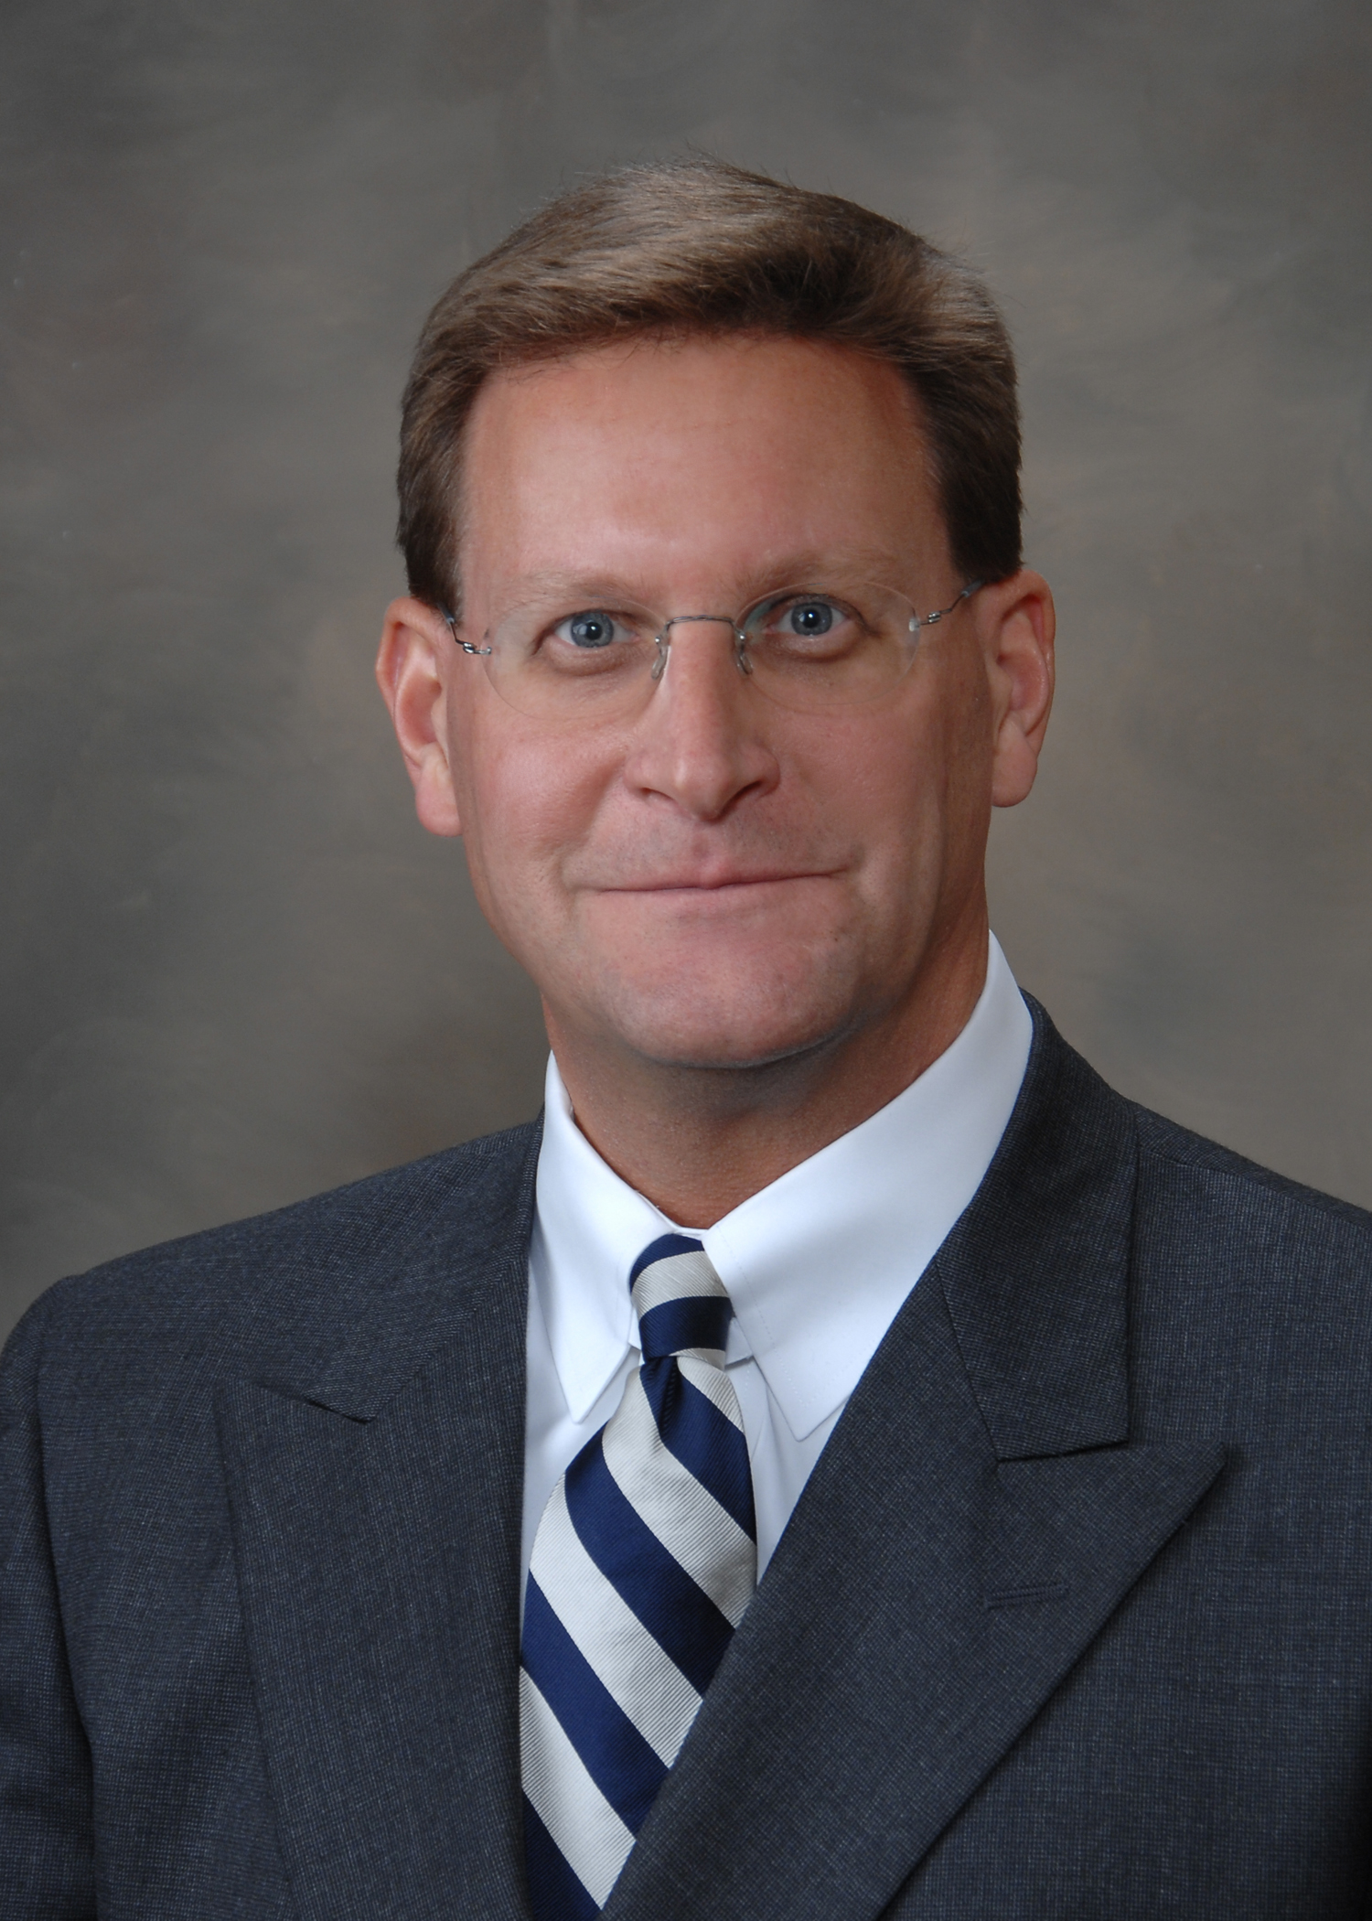
June 17, 2015…Goodwill Industries of Southeastern Wisconsin, Inc. recently named Brad Kalscheur, partner in the Wealth Planning Services Practice Group at Michael Best & Friedrich LLP to its Board of Directors.
Kalscheur’s practice includes all areas of estate and business succession planning, as well as the structuring and taxation of partnerships and limited liability companies. In addition to being a certified public accountant, he received his law degree and was admitted to the Wisconsin Bar in 1995.
Prior to attending law school at Marquette University, he was a tax specialist in the Washington D.C. operating office of KPMG Peat Marwick. He sits on the boards of Real Property Probate and Trust Law and the AIDS Resource Center of Wisconsin. Is very involved with Marquette University in their Business Administration Alumni Association, Accounting Department and the Jesuit Partnership (WI Province), and is President of the Planned Giving Council of Eastern Wisconsin.
Kalscheur will help oversee the largest Goodwill organization among 165 agencies in North America. Goodwill Industries of Southeastern Wisconsin employs more people with disabilities than any other private-sector business in the area. In 2014, Goodwill provided services to 72,152 men and women with disabilities and disadvantages. Visit www.goodwillew.com for more information.
###

