Performance Profile: What I Value as an Athlete and Person
What core values do you need to become the athlete you want to be?
Brainstorm core values you think are most important to be the best athlete and person you can become and write those values along the outside of the Performance Profile (PP). Next, honestly rate where you feel your abilities are in each, on a scale of 1 (not skilled) – 10 (highly skilled). The middle of the PP is 0 and each line is 1, with 10 being the outermost line.
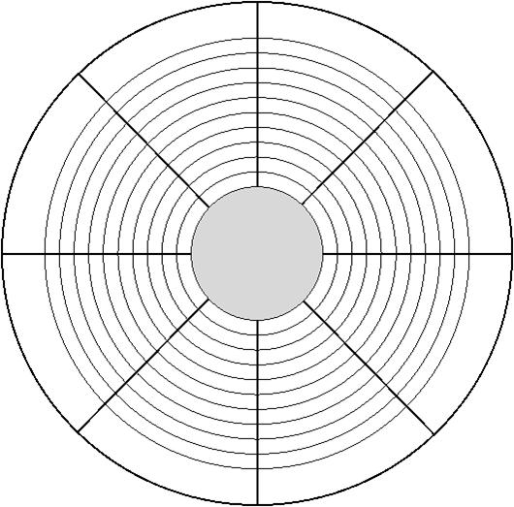

Define your values and explain what they mean to you:

