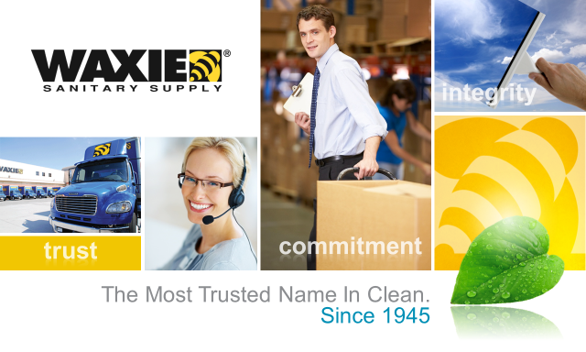

KCDA
RFP #16-261 Maintenance Machines
June 29, 2016

KCDA
Maintenance Machines

RFP #16-261

Table of Contents

- Cover Letter p. 2
- Exhibit A: Certification of Debarment (KCDA’s Attachment A) p.
- Exhibit B: Terms by Manufacturer (KCDA’s Attachment B) p.
- Exhibit C: Exceptions to Terms and Conditions p.
- Exhibit D: Price Sheet p.

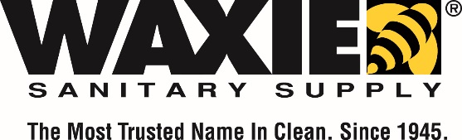
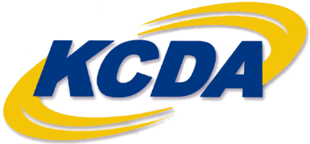

June 29, 2016

Michele Ortiz
Contract Supervisor
King County Director’s Association
18639 80th Avenue South
Kent, WA 98032
Re: RFP #16-261
Dear Michele,
WAXIE Sanitary Supply is pleased to respond to KCDA’s RFP #16-261 for Maintenance Machines. WAXIE has a long history of providing Cleaning, Janitorial, and Maintenance Supplies in the Public Sector.
WAXIE Sanitary Supply services over 2500 public sector clients throughout the western United States. WAXIE brings excellence in distribution and service as well as excellence in manufacturing from the products we distribute. WAXIE currently enjoys a substantial volume of business through our existing contracts with KCDA.
The scope of work, as WAXIE understands it, is to provide maintenance equipment to KCDA members necessary to maintain the existing condition of current member facilities. WAXIE acknowledges and accepts all Terms and Conditions outlined in both the T&C and Special Provision (KCDA’s Attachment C) documents except as noted in our attached narrative, and is pleased to be able to exceed KCDA’s expectations with regard to providing and maintaining your required machines.
Attached please find our pricing, required attachments and a brief narrative explaining WAXIE’s offer pursuant to RFP #16-261. Additionally, you’ll find all information requested in the IFB’s Scope of Work section as well as all documents listed on the Submittal Checklist attached to WAXIE’s response.
We look forward to the opportunity to supply KCDA should we be selected as the winning bidder. If you have any questions regarding our submitted information please contact me at mmuscara@waxie.com or (480) 213-1709.
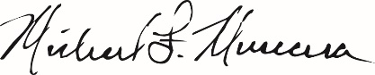
Sincerely,

Mike Muscara
Corporate Accounts Director

Exhibit C Company History and Exceptions to terms and conditions.

About WAXIE and our Capabilities
Founded in 1945, WAXIE Sanitary Supply is a 71-year-old, privately held, family owned company with a proud history of honoring our clients, communities, and family values. This attitude is embodied in our company motto: The Most Trusted Name In Clean. Since 1945. WAXIE has long been focused on our customers and prides ourselves on helping businesses keep their facilities cleaner, healthier, greener and safer. We are passionate about what we do and are committed to delivering that passion to our customers.

WAXIE is among the largest distributors of sanitary supplies and equipment in the Western USA and is one of the largest family owned distributors in the nation. We differentiate ourselves by having orders delivered on time, at the right price, with exceptional customer service. We are here to listen to our clients and respond to their needs. Our average fill rate on orders is 97%.

Our scale allows WAXIE to boast the infrastructure and logistical flexibility of a national distributor without sacrificing our family owned history which drives the ability to focus on customer needs. For the past 7 decades, WAXIE has remained the industry leader in the distribution of quality institutional supplies to the Public Sector, commercial, industrial, and contractor markets in our geographic footprint.
Please see Exhibit A for our Capabilities Brochure.

WAXIE is an industry leader in green and sustainable solutions for our partners. WAXIE is committed to being an industry leader in promoting responsible business practices that support sustainable communities that are secure, economically prosperous, environmentally responsible and healthy places in which to live and work. Sustainability has emerged as a global theme of the 21st century – it is a concept which balances the interconnectedness of the environment, the economy and our quality of life. Please see Exhibit B for our Commitment to Sustainability brochure.

Exceptions to Terms and Conditions.

Section 3 Part B Preparation of Bids

FOB Destination – WAXIE is offering FOB destination at the prices offered in Oregon and Washington. The following shipping terms apply to the states below.

Alaska – Offered price plus shipping from Seattle at $.30/pound for all customers that receive shipments on a WAXIE delivery truck working from our Anchorage and Fairbanks Inventory Centers. Outside our normal delivery area additional freight charges will be charged as they are incurred. A list of zip codes WAXIE normally delivers on a company owned truck is included.

Idaho – FOB destination to all locations WAXIE normally delivers to. Outside WAXIE’s normal delivery area actual freight charges will apply.

Montana – All shipments to Montana will be at the price given plus applicable freight charges.

For orders that meet the manufacturers minimum dollar amount for freight free shipping directly to the customer there will be no delivery charges.

Repair Services

WAXIE will provide repair services based on the following program price schedule.

In Shop Repair Service Fee $72.00 per hour billed in ¼ hour increments.
Parts used in machine repair – 10% off list price.
Pick up and return of equipment on WAXIE truck no fee.
Pick up and return of equipment via common carrier actual freight charges.
Onsite labor rate $75.00 per hour.
Portal to portal charges for onsite $75.00 per hour.

Training Services

The following training program is available for KCDA customers purchasing equipment through WAXIE. Onsite training by WAXIE Equipment Specialist, or Manufacturers Representative upon purchase of any piece of equipment. WAXIE will train all personnel in the correct operation, cleaning and daily maintenance of the equipment.

Customers may request additional training as necessary to make certain all personnel are trained appropriately. Training programs are available based on the customers employee work schedule excluding weekends and holidays.

