 |  | 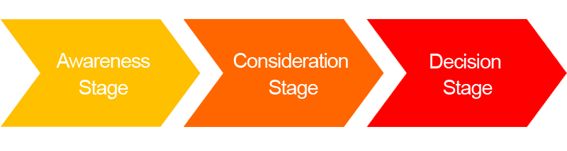
 | Persona 1: | % | % | %
 | Persona 2: | % | % | %
Topics | 1:
 | 2:
 | 3:
 | 4:
 | 5:
Content Type | 1:
 | 2:
 | 3:
 | 4:
 | 5:

