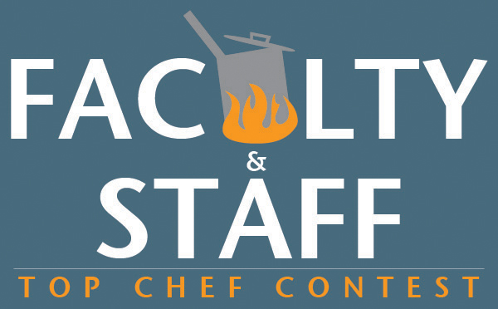
Watch your professors get graded for a change at the
[InsertStoreName]'s Top Chef Competition!

Faculty and staff will cook a dish of their choice for a panel of local celebrity judges, while you sit back and sample free snacks!

DATE: Tuesday, August 30, 2011

TIME: 2 p.m.

PLACE: The Quad

Come join the fun!

