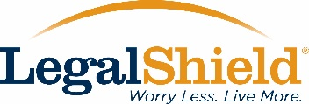
Subject Line: Attention: Identity Theft Myths and Realities, join a webinar to learn more!
Audience: Existing group HR managers, HR administrators, Existing Small Business owners, prospective new customers
Purpose: To be an Identity Theft resource to your existing customer base, that currently offer our voluntary benefits to their employees
(Body of the Email below)
Dear (Insert Customer name here)
Each new data breach and phishing scam alert is accompanied by a wave of cyber security articles and commentary. The tone of these stories can range from panicked to apathetic. But the facts can't be ignored: So let’s get the facts straight.
We are offering a webinar, Identity Theft Myths and Realities. There are many misunderstandings concerning identity theft. We will explore theories about why there are so many myths, and look at some of those myths and debunk them.
The webinar will be held Wednesday, June 22nd, 2016, at 1 pm Central Time.
http://event.on24.com/wcc/r/1185156/98C2140DA4E1290B56825F18F9E46C16
This webinar is presented by Effrin Reeder, Senior Manager at Kroll Inc., a global security firm. Click the link below to find out more about the webinar and to register.
LegalShield, along with our partner Kroll, offer the IDShield guarantee. Every day. Every Hour. Every Second. We do whatever it takes for as long as it takes to restore your identity to its pre-theft status. You have our $5 million service guarantee.
We value you as a client, and think you will find these identity theft resources useful. We also look forward to seeing you at the webinar!
Sincerely,

