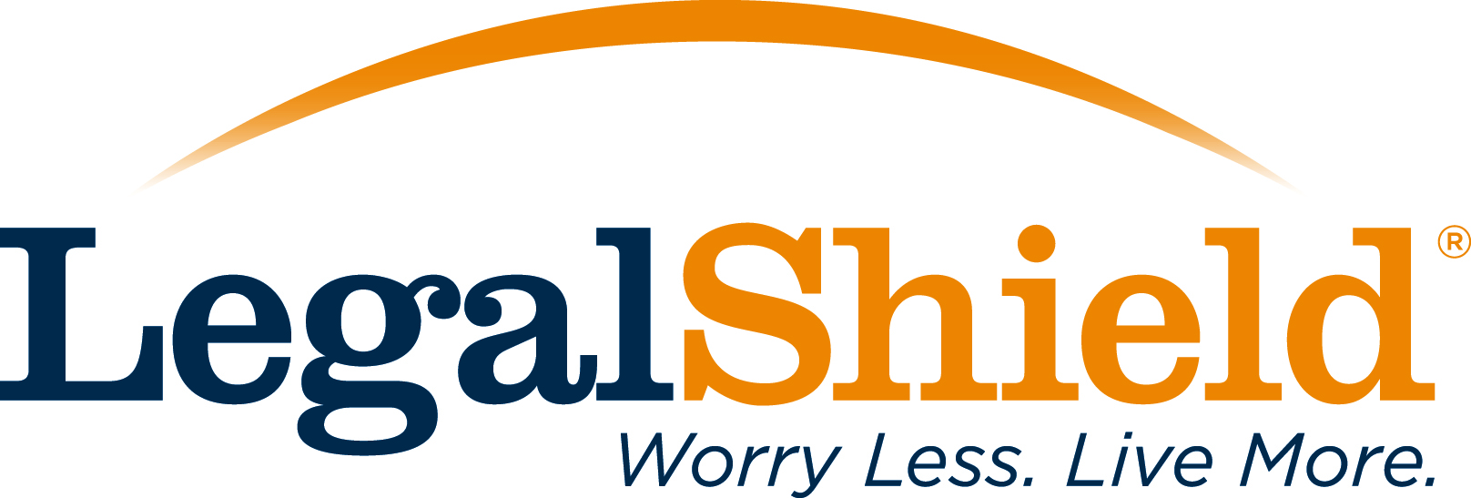
Subject Line: Help Your employees recognize Tax ID Theft
Audience: Existing group HR managers, HR administrators, Existing Small Business owners, prospective new customers
Purpose: To be an Identity Theft resource to your existing customer base, that currently offer our voluntary benefits to their employees
(Body of the Email below)
Dear (Insert Customer name here)
Did you know the Internal Revenue Service has paid out $5.8 billion in fraudulently filed income tax returns?* January 25-29 is Tax Identity Theft Awareness Week. As leaders in the legal and identity theft services industry, we are offering complimentary educational resources for you and your employees.
The first resource is information to help your employees recognize Tax ID Theft.
Learn about Tax Identity Theft: http://connect.legalshield.com/tax-id-theft
The second resource is a webinar about tax identity theft especially for managers who want to learn more about how they can help their employees protect themselves against tax fraud. This webinar will be presented by Effrin Reeder, Senior Manager at Kroll Inc., a global security firm, and will be held Wednesday, January 27, 2016 at 1 p.m. CST. Click the link below to find out more about the webinar and to register.
Register for Tax ID Theft Webinar: http://event.on24.com/wcc/r/1115304/5BFB58C061A06697AC360A72A9CBCB47
LegalShield, along with our partner Kroll, offer the IDShield guarantee. Every day. Every Hour. Every Second. We do whatever it takes for as long as it takes to restore your identity to its pre-theft status. You have our $5 million service guarantee.
We value you as a client, and think you will find these tax identity theft resources useful. We also look forward to seeing you at the webinar!
Sincerely,
(Insert your name, title and contact information here)
* Source: GAO-15-119 Identity Theft

