**TECHNOLOGY:**

**Tesla's solar roof — gimmick or game-changer?**

[Christa Marshall](http://www.eenews.net/staff/Christa_Marshall), E&E reporter

Published: Monday, October 31, 2016 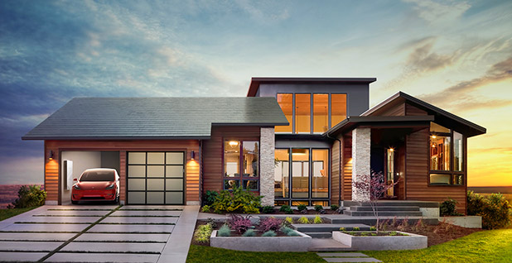

One of the four varieties of Tesla's new solar roof product. Photo courtesy of Tesla.

Tesla Motors Inc. CEO Elon Musk unveiled a much-anticipated "solar roof" Friday as part of his company's quest to be at the forefront in fighting climate change.

At an event at Universal Studios in Los Angeles, Musk said the new product fits into a three-part approach to cutting emissions through electric cars, home batteries and clean power. He also unveiled a more powerful version of Tesla's existing Powerwall home battery with about twice the energy storage capacity of the current model.

The solar roof, which comes in four varieties, targets the 5 million Americans who install new roofs every year. It also targets shareholders who will be voting on Tesla's planned $2.2 billion merger with SolarCity Corp. later this month.

The idea propelling Tesla's solar roof is that over time, everyone will shift to solar roofs as new houses are built via a cheaper and cleaner option.

"The whole point of Tesla is to accelerate the advent of sustainable energy," Musk said.

Tyler Ogden, an analyst at Lux Research, said Tesla's solar roof is potentially significant because of the company's size and SolarCity's reach. In theory, that could boost the integrated solar market, which has struggled so far. Aesthetics of solar are an important driver for customers, he noted.

According to Musk, the product will be more durable than typical roofs.

The goal is to have "solar roofs that look better than a normal roof, generate electricity, last longer, have better insulation and have ... an installed cost that is less than a normal roof plus the cost of electricity. Why would you buy anything else?" Musk said, standing on the old Hollywood set of the show "Desperate Housewives."

He stood in front of a video showing how a heavy weight can smash many traditional roof materials but not the durable Tesla product, which is tailored to buyers looking for a sleek roof that blends in with architecture. The new tiles consist of textured glass that is opaque but allows light to pass through to flat solar cells. The roofs come in four styles: textured glass tile, slate glass tile, Tuscan glass tile and smooth glass.

"What remains to be seen is whether Tesla's 'sexy' brand will attract enough early adopters to drive broader appeal," said Timothy Fox, a vice president and research analyst at ClearView Energy Partners.

However, Musk did not set a price for the solar roof and left out details such as product performance. He told reporters the tiles are comparable to "competing high-efficiency solar panels," according to Bloomberg.

**Lingering questions**

The lack of details left several analysts questioning whether the product would gain traction or, worse, would fail like earlier generations of proposed solar-roof-style products from other companies.

Dow Chemical Co., for example, abandoned plans earlier this year to sell a solar shingle line.

What will be key, Ogden said, is whether Tesla and SolarCity announce partnerships with the construction industry. The product is different from earlier models, too, in not just swapping tiles for solar modules and instead envisioning a distinct manufactured roof.

At the same time, he called the announcement "underwhelming" and more of a concept than a product, considering the list of questions about pricing and other issues.

Hugh Bromley, an analyst at Bloomberg New Energy Finance, said the flashy announcement will be viewed as positive for an industry accustomed to news reports of bankruptcies and regulatory disputes. The lack of pricing information risks triggering a "wait and see" mentality, though, he said.

He also questioned whether the product would be another "architectural gimmick" of building-integrated photovoltaic solar that would not be easily scalable, just like earlier failed attempts.

"Tesla's solar roof is no different. It is the metaphoric 'super-car' of residential solar. It portrays cutting-edge technology with broad appeal but a minute addressable market. It competes in a utilitarian solar market where most customers are comfortable in a 'family sedan'" he said.

Another challenge is that the advanced "mono-crystalline" wafer from Panasonic that would be used in the solar roof is still a "boutique" product that could dilute the economies of scale, according to Bromley.

Tesla also has faced criticism about its plans to acquire SolarCity, with some analysts saying the company should focus on its core car business (*[Greenwire](http://www.eenews.net/stories/1060039235/)*, June 22).

Musk provided more details about the new version of Powerwall, which will be priced at $5,500 and able to produce double the power of the original. Tesla introduced its Powerwall last year as an energy storage option for residences that go solar.

It also announced Friday that a more powerful version of its utility-scale battery, the Powerpack, started shipping in September. Powerpack systems tied to utility projects in Hawaii and California are expected to be the largest lithium-ion battery storage installations in the world.

Musk compared the current situation with solar roofs to initial doubt about electric cars, back when many initial models "looked like a golf cart." Visually appealing, low-cost solar roofs could do for solar power what Teslas did for electric cars, he said.

"Something similar needs to happen to solar. We really need to make solar panels as appealing as electric cars have become," Musk said.

Tesla is just one of several companies making a play in tying residential solar to energy storage.

Last week, LG Chem Ltd. — the world's largest supplier of vehicle batteries — teamed up with Sunrun Inc. to offer a solar and lithium-ion package to customers.

While currently available only in Hawaii, the deal is viewed as competition with Tesla's Powerwall systems. The partnership adds LG Chem's products to Sunrun's offering, after the company forged a deal with Tesla last year.

Twitter: [@christa_mars](https://twitter.com/christa_mars) Email: [cmarshall@eenews.net](mailto:cmarshall@eenews.net)