

# Auto Industry’s Ranks of Electric-Car Battery Suppliers Narrow

## Three big Asian makers emerge as favorite suppliers amid turn from in-house and startups

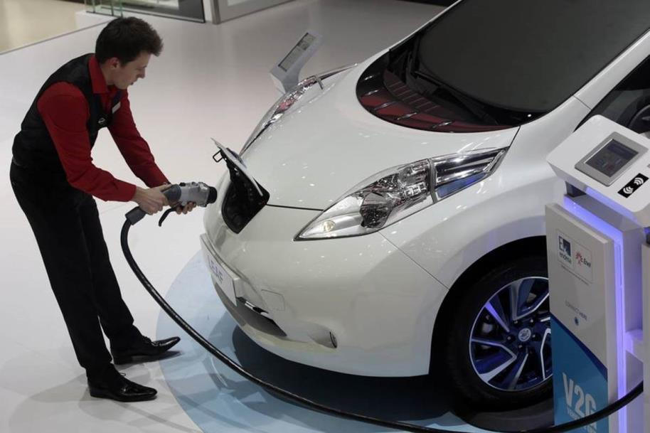

An employee prepares to install a charging plug in the socket of a Nissan Leaf electric automobile at the Geneva International Motor Show in Geneva, Switzerland, earlier this year. Photo: Matthew Lloyd/Bloomberg News

By Mike Ramsey

August 20, 2015

Luxury car maker [Audi](http://quotes.wsj.com/XE/XETR/NSU) AGon Wednesday revealed its first all-electric car would go 310 miles on a charge using an advanced battery developed by South Korea’s [LG Chem](http://quotes.wsj.com/KR/XKRX/051910) Ltd.and [Samsung SDI](http://quotes.wsj.com/SSDIY) Co., two of three Asian suppliers increasingly favored by car makers.

Failed technology gambles and a half-decade of jockeying among suppliers have top auto makers increasingly choosing LG, Samsung SDI and [Panasonic](http://quotes.wsj.com/PCRFY) Corp.The three are emerging as the early winners amid a shift by car companies away from in-house efforts, traditional battery makers and startup ventures.

Their quick rise as key suppliers to European, Asian and U.S. car makers is remarkable for an industry that typically insists on reducing risks by building key components such as engines in-house—or using lots of suppliers for less-critical parts.

In part, experts say few companies so far have shown they can meet the challenge of building advanced batteries with the quality, weight and cost expectations that auto makers demand. And the technology is moving so fast that few auto makers have tried to master the exotic chemistry required.

Of course, electric cars remain a niche market amid a lack of charging and other infrastructure, high development costs and low gas prices. But coming exhaust emissions regulations have encouraged Audi and others to bring all-electric vehicles to market. And they largely are picking the same three Asian companies to supply batteries.

Advertisement

This week, Boston-based emerging technology researcher Lux Research Inc. forecast the market for electric-vehicle batteries will grow to $30 billion by 2020, from $5 billion this year, and predicted the three suppliers will split most of that pie.

“If we look out in a five-year time frame, we are looking at Panasonic, LG and Samsung SDI making up about 80% of the market” said Cosmin Laslau, a battery expert with Lux Research.

Companies that once vied for electric-vehicle contracts, including [Johnson Controls](http://quotes.wsj.com/JCI) Inc.and A123 Systems LLC, changed course after losing out to the larger rivals. They now supply smaller batteries for hybrid cars that combine battery power with an internal combustion engine.

Japan’s [NEC](http://quotes.wsj.com/NIPNF) Corp.remains the No. 2 battery provider for electric-vehicles from its contract supplying [Nissan Motor](http://quotes.wsj.com/NSANY) Co.’s Leaf car. That contract appears to be at risk based on recent statements by Nissan Chief Executive [Carlos Ghosn](http://topics.wsj.com/person/G/Carlos-Ghosn/66), who indicated the next-generation Leaf could use LG batteries.

“We have opened to competition our battery business in order to make sure we have the best batteries,” Mr. Ghosn said in a recent interview. “For the moment, we consider that the best battery maker is LG.”

An NEC spokesman declined to comment about the contract.

Panasonic is the top battery maker, supplying [Tesla Motors](http://quotes.wsj.com/TSLA) Inc.,Volkswagen AG and [Ford Motor](http://quotes.wsj.com/F) Co.It supplied 38% of the electric vehicle batteries over the past 12 months, according to Lux and likely will continue to grow if Tesla’s sales go higher.

Tesla, aiming to sell at least 50,000 vehicles this year and 500,000 annually by 2020, is building a battery plant with Panasonic in Nevada.

LG Chem, however, is surging as it has notched contracts with several car companies and could overtake Panasonic by 2020 if it wins the Leaf deal and Tesla falls short of its sales goals.

LG, holding 11% of the market, counts [General Motors](http://quotes.wsj.com/GM) Co., [Renault](http://quotes.wsj.com/FR/XPAR/RNO) SA,Volvo Car Corp., [Daimler](http://quotes.wsj.com/DDAIY) AGand VW as customers. Some of those companies also use smaller LG batteries for plug-in hybrids, and soon will move to more capable versions.

GM currently relies on LG for batteries powering the Chevrolet Volt, which achieves 50 miles of driving on a charge. The Chevrolet Bolt, due in 2017, will be capable of going 200 miles on a charge using a LG battery.

*‘We’ve seen what I would call pharmaceutical levels of quality in [battery] cell production.’*

*—Larry Nitz, GM vice president*

Lux Researcher’s Mr. Laslau said the shrinking and common supply base could stifle innovation, forcing smaller companies to attempt more exotic chemistries to compete.

“The effect will likely be to force the smaller innovators that much further to the bleeding edge of next-generation batteries, since disruptive technology will be their real shot at overcoming the incumbents’ scale advantage,” he said.

Unlike most of its competitors, LG is a materials and chemical supplier, not an electronics company. Its ability to craft very specific chemistry for different applications and cells with low failure rates has made it popular with auto makers.

Larry Nitz, vice president of transmissions and electrification at GM, said a study of Volt customers using LG batteries showed almost no loss of range performance after nearly three years of ownership

“We’ve seen what I would call pharmaceutical levels of quality in cell production. Of the more than 20 million cells that have been produced for the first generation Chevrolet Volt we’ve seen less than two problems per million cells produced,” he said.

Panasonic has said it also has high quality batteries from its long experience as a battery supplier with a broad range of capabilities and customers.

**Corrections & Amplifications**

Samsung SDI, which is 19% owned by Samsung Electronics, is sharing a contract to supply Audi with advanced batteries. An earlier version of this article omitted it as an Audi supplier and incorrectly described it as a unit of Samsung Electronics.

**Write to** Mike Ramsey at [michael.ramsey@wsj.com](mailto:michael.ramsey@wsj.com)