Dear XXXXXXX,

We’re excited to share a unique giving option for you to support [enter your organization name here] and our ability to continue serving fathers and families in the coming year.

[Enter your organization name here] [uses/would like to use] fatherhood skill-building resources from National Fatherhood Initiative, the nation’s leading providing of father-specific resources and skill-building materials. By simply making a donation to NFI in honor of [enter your organization name here], we will receive a credit to purchase fatherhood resources from NFI.

In particular, we are looking to purchase [enter the NFI materials you want to purchase] to use in serving fathers in 2015. These materials will help us accomplish our mission of [insert your mission statement here], and ensure fathers in our community have the skill-building materials they need to be the best dads they can be.

Visit here to donate today. Enter our organization name on the “IN HONOR OF” line. NFI is a 501C3 non-profit, and all donor gifts are tax deductible. Consider how the following donation amounts would help our organization:
$75 | Helps us purchase fatherhood skill-building brochures on a variety of fatherhood topics. | 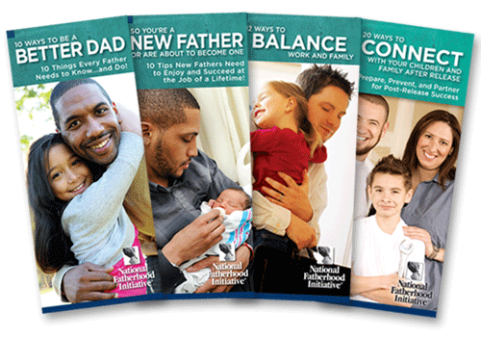
$150 | Helps us purchase a workshop for dads like the Doctor Dad® Workshops for New Dads. | 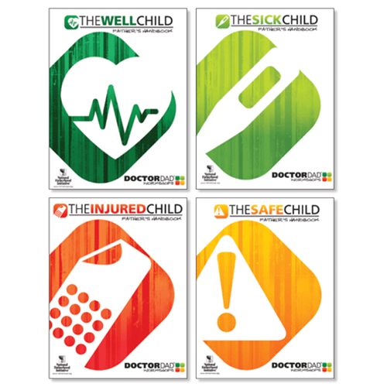
$600 | Allows us to purchase a fatherhood curriculum program like 24/7 Dad®--the most widely used fatherhood program in the country. | 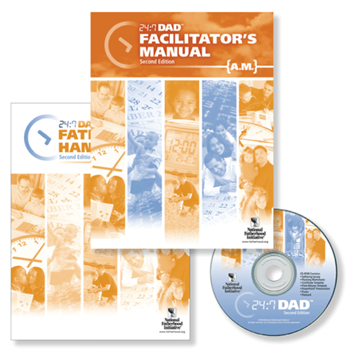
$1,000 | Allows us to purchase the Father-Readiness Training Kit™,  a do-it-yourself training kit that helps us build a foundation  for successfully connecting dads and their children. | 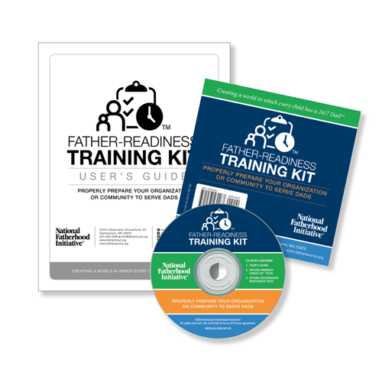
Sincerely,
[enter organization name here]

