Ingenico 2500/2600 series
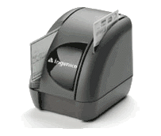
- Baud Rate: 4800-57600 (Should be configured for 38400 for reliability)
- USB: Must use proprietary USB cable Part#: 6035060790100
- Serial: Proprietary RDM serial cable Part#: AC00454
  - Note: Will NOT work with the Prolific USB-to-Serial Converter
Setup Process for serial cable:
  - Plug the 9-pin DIN part of the serial cable into "HOST" on the back of the Ingenico. Plug the other end into a COM port on the PC. Plug the power supply which plugs into the cable Part#: WD1E1500LCP-N .
  - Log on www.cross-check.com/logon
  - Click on either MICR Scan Conversion Plus or Business Office Conversion Plus
  - License agreement page will show ¹ and a pop-up window needs to happen. The browser must allow pop-ups. If a pop-up is blocked, a pop-up blocker detector should detect this and give a warning. Refresh the page to make the pop-up window appear again. The pop-up window must be open for at least 1-2 seconds before closing it.
  - Do NOT close the popup window. Click on Download CrossCheck Ingenico Setup Installation and install.
  - Close the popup window.
  - Choose Ingenico 2500/2600 under Choose Device
  - Click I Accept
  - The first ActiveX control will install after approving installation: A CrossCheck FS (file system) Utility created by CrossCheck to allow file renaming and deleting of the scanned images on the merchant’s PC.
  - *** SCAN CHECK THROUGH INGENICO IMAGER NOW *** should show and the device should be ready for scanning.
  - Scan a test check through. Enter any necessary test check information². Verify and click “Approve” to begin processing.
  - “Test Completed Normally” should appear and a new popup window will appear that will upload the image. Install the last ActiveX control: Persits XUpload Control. This will install after approving installation. When the window says “Finished uploading images”, this window can be closed. A support rep should verify the image has been received. An image can take up to a minute to show up on CrossCheck's system for a support rep to pull up.
Setup Process for USB cable:
  - Do NOT plug in the device to the PC just yet. (This allows a smooth install)
  - Log on www.cross-check.com/logon
  - Click on either MICR Scan Conversion Plus or Business Office Conversion Plus
  - License agreement page will show ¹ and a pop-up window needs to happen. The browser must allow pop-ups. If a pop-up is blocked, a pop-up blocker detector should detect this and give a warning. Refresh the page to make the pop-up window appear again.
  - Within the window, click on “Download Ingenico USB Driver"
  - Unzip the IngenicoUSB.zip to the hard drive.
  - Plug the 9-pin DIN part of the serial cable into "HOST" on the back of the Ingenico. Plug the other end into a COM port on the PC. Plug the power supply which plugs into the cable Part#: WD1E1500LCP-N .
  - Double click on the USB hardware list icon (found in bottom right), you will see the with an unknown device or ACG PC/SC
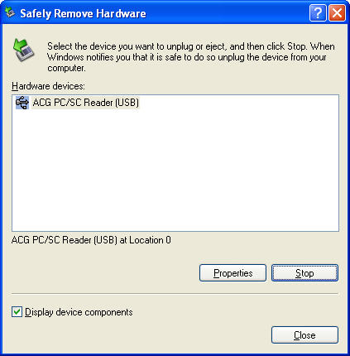
  - Click on Properties
  - Click on Driver Tab
  - Click on "Update Driver" button
  - Choose "Install from a list or specific location"
  - Choose "Don't search. I will choose the driver to install."
  - Click "Have Disk" button
  - Select the location you extracted the zip file and "USB Serial Converter" will appear.
  - Back at the “License Agreement” web page, close the pop-up window.
  - Choose Ingenico 2500/2600 under Choose Device.
  - License agreement page will show ¹ and a pop-up window needs to happen. The browser must allow pop-ups. If a pop-up is blocked, a pop-up blocker detector should detect this and give a warning. Refresh the page to make the pop-up window appear again. The pop-up window must be open for at least 1-2 seconds before closing it.
  - Do NOT close the popup window. Click on Download CrossCheck Ingenico Setup Installation and install.
  - Close the popup window.
  - Choose Ingenico 2500/2600 under Choose Device
  - Click I Accept
  - The first ActiveX control will install after approving installation: A CrossCheck FS (file system) Utility created by CrossCheck to allow file renaming and deleting of the scanned images on the merchant’s PC.
  - *** SCAN CHECK THROUGH INGENICO IMAGER NOW *** should show and the device should be ready for scanning.
  - Scan a test check through. Enter any necessary test check information². Verify and click “Approve” to begin processing.
  - “Test Completed Normally” should appear and a new popup window will appear that will upload the image. Install the last ActiveX control: Persits XUpload Control. This will install after approving installation. When the window says “Finished uploading images”, this window can be closed. A support rep should verify the image has been received. An image can take up to a minute to show up on CrossCheck's system for a support rep to pull up.
Trouble Shooting:
- If receiving an error message communicating with the device, verify the PC meets all system requirements (internet browser, hard drive space, operating system, etc.)
- Verify the user has administrative privileges on their PC as this is required. Script errors being reported by the browser usually means they don’t have adequate privileges.
- Verify COM ports in the device manager of the merchant’s PC and that they have it plugged into appropriate COM port. This can be accessed on XP by right clicking on My Computer in Explore, choosing properties, choosing Hardware tab, then Device Manager.
- Ensure there is a solid green light on the RDM Imager.
- On the Error page click “Manual Configure” and try baud ratings 57600, 38400, & 19200. Click “Save Settings” after setting COM port and baud rate each time. Click “Back to Scan Check” to test each setting. If error still appears, try using “Activate AutoDetect” – this can take several minutes.

¹ If a device is already configured, the license agreement page will not display. Use the Reconfigure Device link at bottom, then click the Change Device button to go back to the license agreement page.
² Business Office Conversion Plus requires the Bank Route # on the check to be “123456780” in order to issue a test approval. MICR Scan Conversion Plus requires ID State “ZZ” and ID Number of “12345” to issue a test approval.

