Golden Streets
Criteria
- You are evaluating the street and neighborhood not just the home!

- “A” Street
  - ¼ Acre-1 Acre
  - 2-15 years old
  - 20 or more houses in development
  - Ease of application
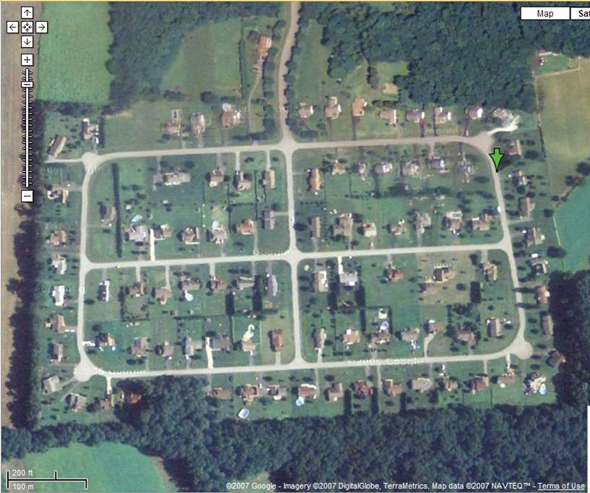

- “B” Street
  - Less than 20 houses
  - 1-3 years old; 10-20 years old
  - Brand new lawn
  - Overgrown landscapes
  - Thinner lawn
  - Still want as a customer - just not our ideal lawn
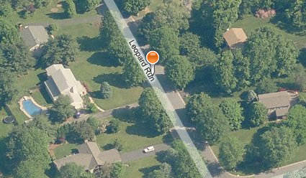

- “C” Street
  - ¼ acre and below
  - Lots of houses but very close together
  - A lot of landscaping beds
  - Very overgrown
  - Small “hometown”

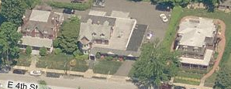

- “X” Street
  - No parking
  - Lots of overgrown landscapes
  - Middle of nowhere
  - Secluded
  - Very large lot

