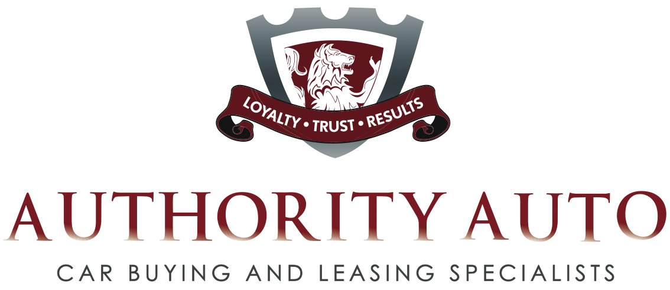

Authority Auto President Offers Consumers
“10 Surefire Tips to Save Money and Have a Better Car Buying Experience”

Sherman Oaks, CA – Oren Weintraub spends his day negotiating unbeatable auto purchase and leasing deals for his clients with car dealerships. And now he wants to offer you “10 Surefire Tips to Save Money and Have a Better Car Buying Experience.”

A former general sales manager of one of the nation’s top 100 Ford dealerships, Weintraub switched sides of the table in 2006. Now his company, Authority Auto, is an advocate and buying consultant for people who want to avoid the emotional pain of car purchase and that feeling of wondering if they really got the best deal.

“I’m happy to share some of my knowledge with the general public,” says Weintraub,
“because I sincerely want to save people money in a financially stressful time.”

And while Weintraub’s “10 Surefire Tips to Save Money and Have a Better Car Buying Experience”” are a great resource for do-it-yourselfers, those folks will still have to deal with the headaches of direct negotiation with savvy car salesman. However, with only one phone call to engage Authority Auto, the company takes all of the pain out of the process for the buyer by handling every aspect of the deal from finding the car to delivering it into his or her hands.

Unlike traditional auto brokers that take clients, but get paid by the dealership and makes them beholden to the auto agency, Authority Auto will not accept any money from a dealer or dealer representative and represents the client exclusively. They are bound by the commitment to get the best price for the customer. The Sherman Oaks, CA-based company takes a fixed fee from the client based on the value of the car desired—new or pre-owned--and guarantees it will secure the lowest price possible. Clients are welcome to try to see how well they can do on their own to validate that it is indeed the lowest price.

“I encourage people to download ‘10 Surefire Tips to Save Money and Have a Better Car Buying Experience’ and if they still aren’t sure if they are being offered the best deal, we’d be happy to see if we can lower if for them,” says Weintraub.

Consumers can secure a copy of “10 Surefire Tips to Save Money and Have a Better Car Buying Experience” by going to Auto Authority’s website: www.authorityauto.com.

