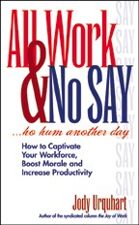
The benefits of Buying books for audience members, (as compared to hats, carry bags or T-shirts, etc.) are many:
- Audience members love to get autographed books (and speakers love to sign them!).
- The meeting chair is a hero for getting them all a book.
- Books build celebrity value for your speakers and audiences listen better.
- The learning continues (for about the same price as the other giveaways).
- Quantity discounts save you a lot of money.
- The speech goes better from the start and the announcement of the free books builds enthusiasm in the audience.
- People keep the book for years and often share them with their family.
- Fewer notes need be taken.
- You can honor your sponsors or host organization with a sticker or custom cover on the book.
You can easily do a special sticker for the book, “Courtesy of (Sponsor’s Name)”, which the author can sign in advance, or even print a special edition if you wish with a foreword from your Chairman or President.
We offer 50% off the cover price if you want to purchase All Work & No SAY for your audience members!

