TCPIP Error 100061 MC75:

This error is related to the Scannabar Terminal Service on the Host PC. This error will appear if the Scannabar service is stopped.

To Start the Service first:

- Log into your Scannabar Menu:
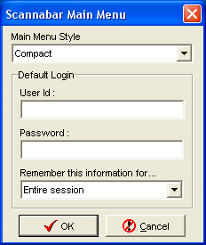

- Go to the System tab:
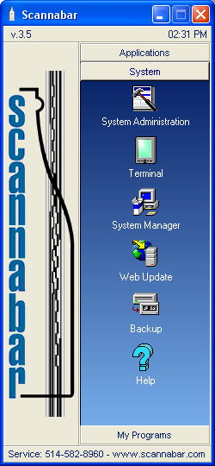

- Click on the Terminal Icon:

- Click the Start Button:
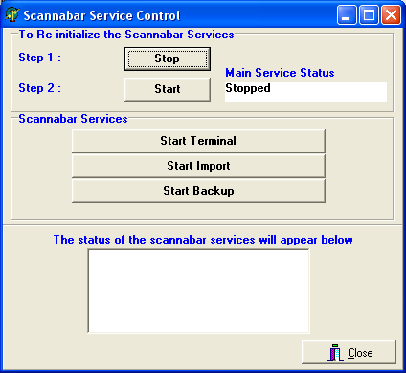

- The Main Service Status will now show that its running:
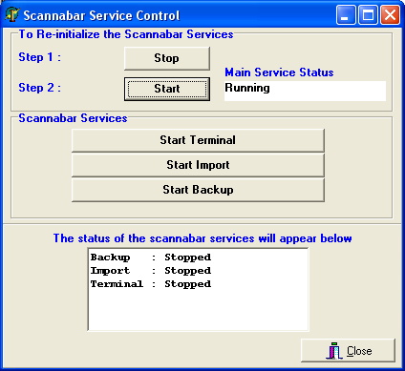

- Click the Start Terminal Button:

- The terminal should now show that it is running:
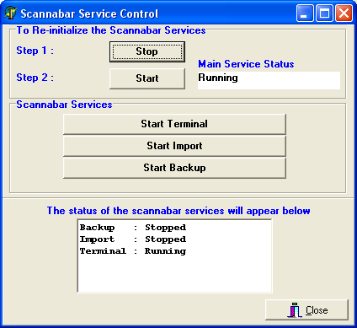

8. You can try logging in again with your Handheld Scanner. Your problem should now be resolved.

If this did not resolve your problem please move onto the next solution.

If restarting the Scannabar service did not help, we will need to delve further into what the problem might be.

The next steps to try are a repair of the Scannabar tables:

- Log into the Scannabar Menu:

2. Click on the System Tab:

3. Click on the System Manager Icon

- Click on the Repair Button
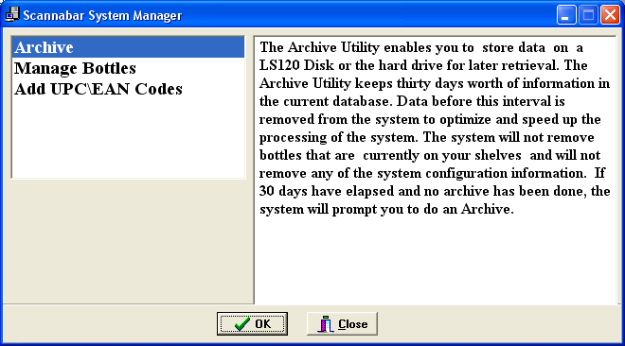

- You can try logging in again with your Handheld Scanner. Your problem should now be resolved.

If this did not resolve your problem please move onto the next solution.

The Last step to try is to verify if the PC’s IP address has changed. Please follow these steps to obtain your IP Address and Verify if it has changed

- Click on the Windows Start Button in the bottom left of your PC.

- Click on the Run button:
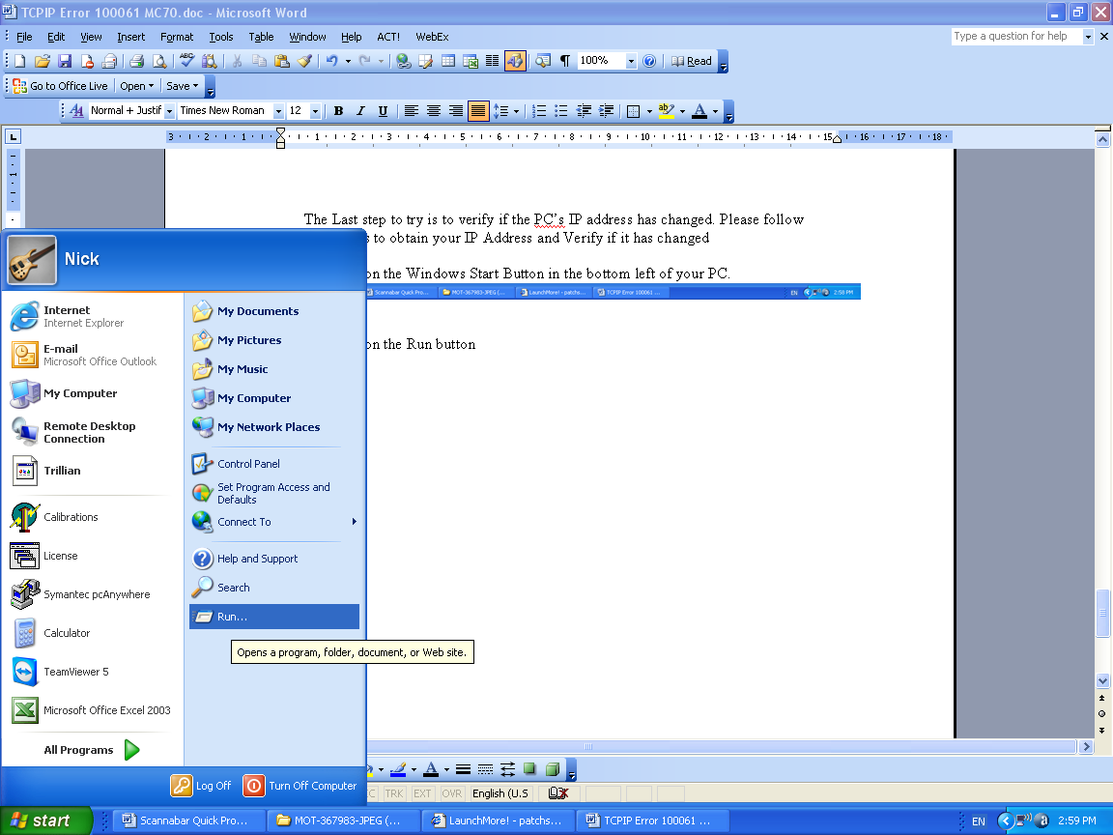

- The Run box should open up. In the Open field type CMD or COMMAND and click OK
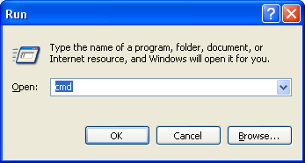

- This will open a Dos screen. In the Dos Screen type the word IPCONFIG and press the ENTER button.
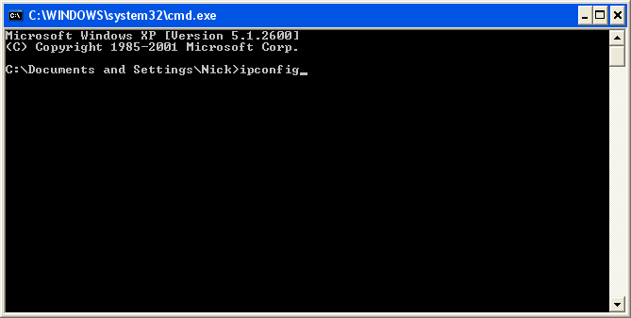
- This will now display the IP address currently assigned to your PC. Write this down. In this example we have an IP of 172.17.1.101
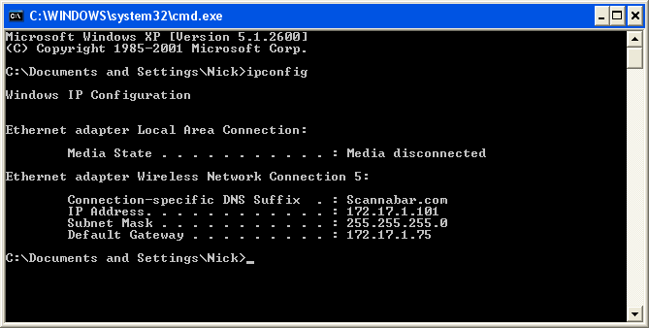

- You must now check on the Handheld software to make sure this number matches up. Go to the Scannabar icon on your Handheld Scanner. Click on the Square with the 3 points next to Terminal
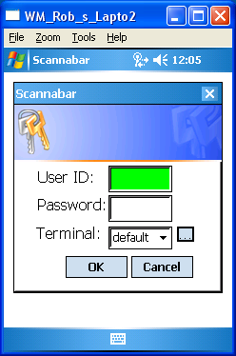

- In the new Screen Highlight your Terminal name and Click the Edit Button.
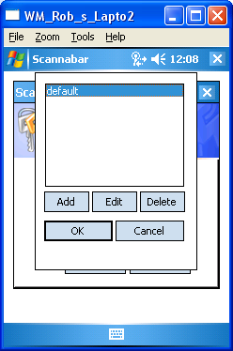

- In this screen the only field you need to verify or change is the Address field. Leave all other settings as they are.
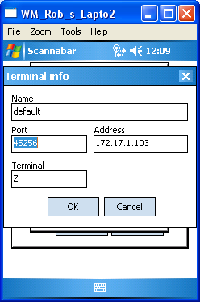

- Make sure the Address field matches the PC IP we obtained earlier. If they do not please make the necessary changes. In this example we see the address as 172.17.1.103 and or PC was 172.17.1.101.

- Once the change has been made. Click Ok, and Ok again.

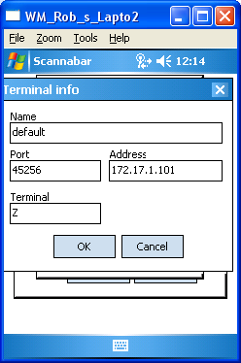

- You should now be able to log into your Handheld Scanner.

If this did not resolve your problem please call one of our Solutions providers@1-800-939-8960 Ext: 2

