Springtime Frittata

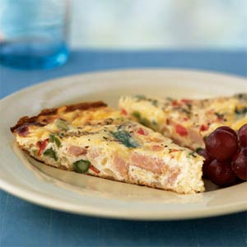

Extend whole eggs with egg whites for a generous serving size. Serve the frittata with fruit & toasted whole grain English muffins or Step Ahead’s signature Passover rolls with apple butter for a delicious light brunch.
2/3 cup chopped 33%-less-sodium ham (about 3 ounces)
1/2 cup (2 ounces) shredded low-fat swiss cheese
1/4 teaspoon black pepper
3 large egg whites
2 large eggs
Cooking spray
1/2 cup finely chopped onion
1/2 cup finely chopped bell pepper
1/2 cup (1-inch) slices asparagus
1/4 teaspoon Italian seasoning
- Preheat broiler. Combine ham, cheese, black pepper, salt, egg whites, and eggs, stirring well with a whisk.
- Heat a 9-inch nonstick skillet coated with cooking spray over medium-high heat. Add onion, bell pepper, and asparagus; sauté 3 minutes. Add egg mixture; reduce heat to medium. Cook, covered, 3 minutes or until almost set. Sprinkle with 1/4 teaspoon Italian seasoning. Wrap handle of pan with foil; broil 3 minutes or until egg is set. Cut into 4 wedges.
Makes 2 servings. Serving size: 2 wedges, 251 calories (183 calories without ham) Adapted from www.cookinglight.com

Passover Rolls
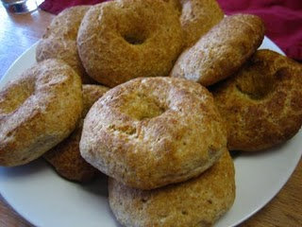
Makes 10 medium rolls or 12 small rolls

5 eggs, separated—beat whites, and then add in yolks.
1/3 cup oil
½ teaspoon salt
1 ½ cups boiled water
2 cups whole wheat matzo meal
¼ cup raisins (optional)

- Preheat over to 350 degrees. Line cookie sheet with aluminum foil and spray with PAM.
- Combine water, oil, and salt in a pot. Bring to a boil, and let cool.
- Add matzo meal to the water & oil blend. Mix well.
- Add eggs into mixture. Add raisins if desired.
- Wet fingertips and shape batter into the shape of a roll. Using your thumb tip or back of teaspoon, make a small indent in the center of each roll (to slightly flatten it).
- Bake rolls for 1 hour. Let cool. Check on rolls after 45 minutes to make sure they don’t burn. Rolls will start to brown on top when they are done.
Hint: When shaping the batter into rolls, a small roll should fit in the palm of your hand. A medium roll should be slightly larger.
Calories per roll:
10 medium rolls: 180 calories ( with raisins: 196 calories)
12 small rolls: 150 calories (with raisins: 160 calories)

