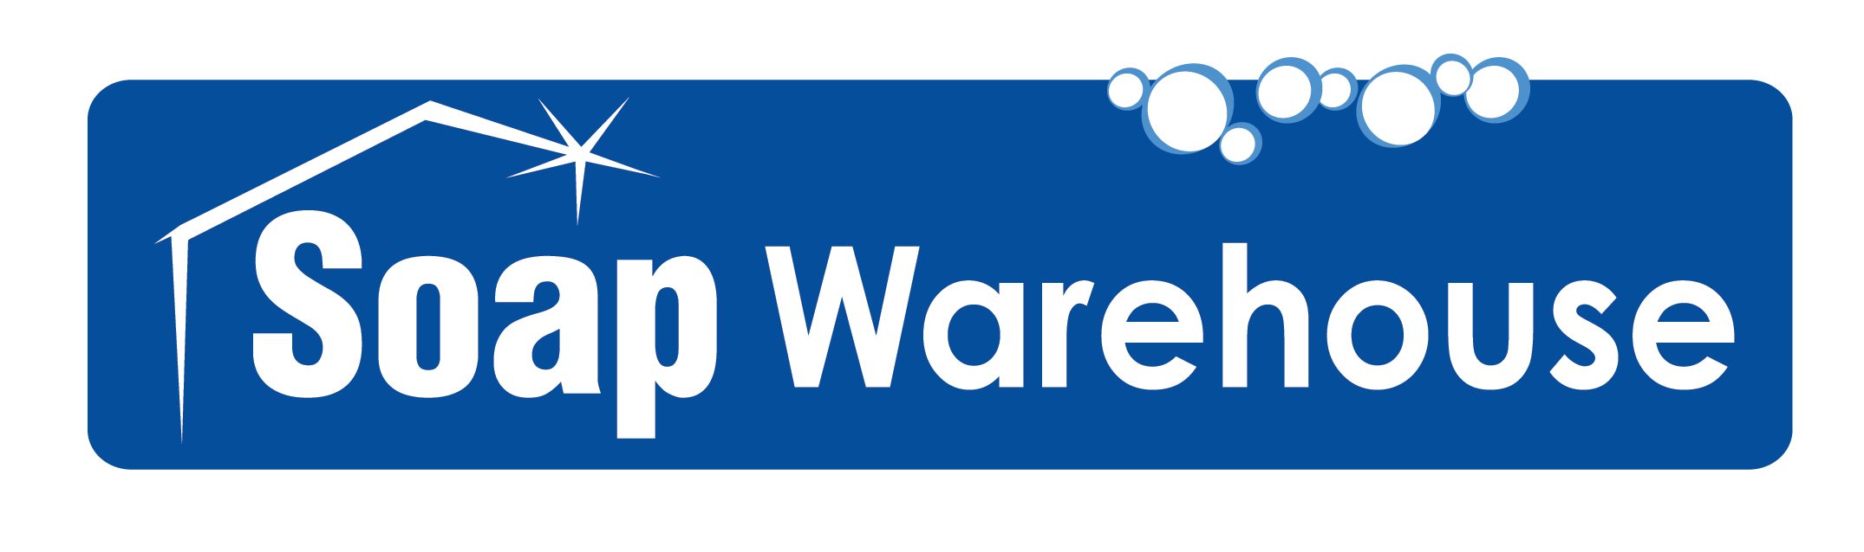

TRUCK WASH * ALUMINUM BRIGHTENERS
CAR WASH * DETAILING * AVIATION
EXTERIOR MAINTENANCE
INDUSTRIAL DEGREASERS
LAUNDRY* SPECIALITY CLEANERS

Products for the pressure washing industry!

We sell concentrated soap, not water!

Soap Warehouse * P.O. Box 392292, Snellville, GA 30039
800-SOAP 911 (762-7911) * 770-939-5488 local * 770-939-5501 fax
E-mail: info@soapwarehouse.biz
Customer Information

Soap Warehouse PRODUCTS

Soap Warehouse concentrates products to the maximum limit of solubility. We don’t like to ship water. When we say “concentrate”, the product is designed to be cut or diluted before it is used. Read the instructions carefully before preparing these products. Labels and MSDS’s for the ready to use products are available from our office.
The phrase “ready to use” indicates that we have diluted the product to a strength that is most easily used. This may be half strength, quarter strength, or less. The choice is yours: “ready to use” for convenience or “concentrate” for economy.

Soap Warehouse COMPANY POLICY

Soap Warehouse CREDIT CARD Customers have the option of using VISA, MASTER CARD, Discover or AMEX Business cards. If not paying by Credit Card and Credit terms have not been established, then we must have (Cash In Advance) by a company check or money order mailed to our P.O. Box prior to the order shipping including shipping costs. C.O.D.: can be arranged but all C.O.D. fees by the carrier chosen is paid by the customer.

Soap Warehouse CREDIT TERMS: All NEW customers or customers that have not ordered in over a year will have to pay by Credit Card or Cash in Advance. For customers that have filled out and have qualified for terms, all invoices are due and payable in 30 days. Any invoices over 30 days will be subject to financing charges calculated at 18% APR. Customers with invoices over 45 days, from the date of invoice, will be notified and any orders placed or received in house will be held until all of the past due accounts are cleared. Any customer abusing their credit terms can have them revoked at management’s discretion. Discounts are given when the customer buys in quantities of 12 or more of the products offered. (See separate price list).

Soap Warehouse CUSTOM BLENDING

Soap Warehouse can facilitate the blending of most water base, liquid cleaning compound you may need. We require only a 220 gallon minimum and 7 day lead time. Call for quotes on your favorite cleaners. Powder products may also be available, please call to discuss your needs.

Soap Warehouse PRIVATE LABELING

Soap Warehouse can facilitate a private label for your company to use for resale for most of our products. There is a $100 set up fee, using an approved logo and/or letter font for your company and product names which includes the choice of one color copy print in either, black or blue and one logo which can be mutli-color. This is a one time fee to use with all of your products unless a change is later made to the label design, then it would be treated as a new label and a new $100 fee would apply.

Truck Wash Detergents:

BROWN DERBY conc. Product No. 11110
This cleaner is one of the most popular truck wash concentrates in the industry. Used as directed, it will clean painted surfaces without damage. It excels at removing carbon stack stain and magnetic road film from tractors/trailers without brushing. It will work in cold water as well as hot water, and rinses free at any temperature. It will clean and brighten aluminum surfaces and is designed for heavy-duty truck washing. As is, this product may be metered at 1:100 for hot water or 1:50 for cold water. Do not use on polished / anodized aluminum or surfaces protected with poly sealers. BROWN DERBY conc. should be effective in hard water to about 20 grains of hardness. Special 5 & 10 kits are available to save you product & freight dollars. Call for pricing.
Contains Sodium Hydroxide. 1 drum makes 2 of Ready-to-Use BROWN DERBY.
USDA approved.

BROWN DERBY Super Concentrate Product No. 11114
This is a SUPER CONCENTRATE, that SAVES YOU FREIGHT DOLLARS! The same BROWN DERBY conc. you have always known, but in a super concentrate. The 5-gallon pail can be added to 50 gallons of water to create 55-gallons of RTU BROWN DERBY or (2) 5 gallon pails can be added to 45 gallons of water to create 55-gallon of BROWN DERBY CONCENTRATE. Easy, convenient, and saving you those freight dollars!

BLUE LIGHTNING Product No. 11210
This is called the "finish safe cleaner". It is designed to clean over the road tractor/trailers and other types of commercial vehicles. It will clean painted surfaces, polished aluminum, anodized aluminum, & chrome without damage. This product will remove most carbon stack stain and magnetic road film from trailers without brushing. It will work in cold water as well as hot water and rinses at any temperature. This product may be metered at 1:70 for hot water or 1:35 for cold water, and should be effective in hard water to about 20 grains of hardness. USDA approved.

WHITE LIGHTNING Product No. 12300
This is also a "finish safe cleaner". It contains 50% more cleaners than the Blue Lightning to clean over the road tractor/trailers and other types of commercial vehicles. It will clean painted surfaces, polished aluminum, anodized aluminum, & chrome without damage. This product will remove most carbon stack stain and magnetic road film from trailers without brushing. It will work in cold water as well as hot water, rinses at any temperature. This product may be metered at 1:70 for hot water or 1:35 for cold water, and should be effective in hard water to about 20 grains of hardness.

BIG RIG BRITE conc. Product No. 11420
This is formulated with fast penetrating surfactants to safely clean polished aluminum and painted surfaces for over the road tractors, trailers, and other types of commercial vehicles. This product will remove magnetic road film from trailers without brushing, leaving the surface with a near wax shine. Do dilute, as one-drum makes two ready-to-use. Use as directed; hot pressure washers apply to the surface at the rate of 1:50 cleaner to water. For use in cold pressure washers and cold water drive through truck wash systems, use at the rate of 1:25.

SW TRUCK WASH POWDER Product No. 18021-10
This is a heavy-duty, caustic alkaline cleaner which effectively removes oils, dirt, and many other soils from most painted vehicle surfaces. Cleans well with hot or cold wash systems. Considered a light to medium duty truck wash. Perfect use for frequently washed equipment.

T -N -T super conc. Product No. 11310
This super concentrate will give you incredible flexibility in your truck wash sales. Truck-N-Tuff super conc. is formulated to safely clean polished aluminum and painted surfaces on over-the-road tractors, trailers, and other types of commercial vehicles without damage when used as directed. This product will remove magnetic road film from trailers without brushing. It works in cold water as well as hot and rinses free at any temperature, designed for use in drive through washes. This 6 gals can be mixed to make 54 gals RTU, the concentrated product can be metered from 1:2 for extreme soils to 1:9 for lightly soiled surfaces. Contains Sodium Metasilicate.

NEUTRA SALT SUPER conc. Product No. 16225
When used as directed this product will quickly and effectively neutralize and remove road salt on the under carriage of vehicles and equipment. Available in super concentrate: 1 drum makes 5 then use at a dilution of 1:10. Contains Hydrofluoric and Phosphoric Acids.

Concrete Truck Cleaner super conc. Product No. 16310
This is designed to remove concrete dust or wet ready-mix splash found on trucks and concrete conveyance equipment. This highly concentrated hydrochloric acid and surfactant blend, also contains 10 % hydrofluoric acid. Five gallons of the concentrate will make 50 gallons of product that is to be used at a metering rate of 1:10 product to water. This product will enhance aluminum surfaces appearance.

TWO STEP PRODUCTS
# 1 conc. Product No. 16410
This system was first popularized by a major equipment manufacturer and field-tested for many years. The first step is a hydrofluoric acid product that sets the magnetic attraction of the soil. Many people in the industry are strong believers in two step washing. This method also leaves you with a near neutral pH waste water. Metered at 1:100 or 1 drum makes 4 and meter 1:25.

# 2 conc. Product No. 16610
This is an alkaline chemical that reverses the attraction and repels the soil from the surface. Step 2 contains Potassium Hydroxide. Metered at 1:100 or 1 drum makes 4 and meter 1:25.

# 1a conc. Product No. 16510
This is a substitute for the #1 or ALUMA BRITE when a non-hydrofluoric acid solution is preferred. In its’ concentrated formula, this product should be metered at 1:100. Or 1 makes 4 and metered at 1:25. #1a contains Phosphoric and Citric Acids and is USDA approved.

SW 503 H.D. Product No. 16096
Non-Etching Aluminum and Stainless Steel cleaner and polish. A ready to use biodegradable liquid Acid Surfactant, formulation designed to effectively remove residual dirt, oils, road film, black welding soot, diesel edge, corrosion and oxide films from polished meal surfaces without etching or pitting, including several levels of inhibition

SW 710 H.D. Product No. 12710
This "BRUSHLESS CONCEPT CLEANER" is a super concentrated green liquid that combines the cleaning ability of biodegradable detergents with a grease cutting, mild alkali that instantly beaks road film, diesel edge and dissolves bug splatter. Can be used after SW 503 H.D. as a two step system.

Aluminum Cleaners:

ALUMA BRITE conc. Product No. 16220
This is a 10% hydrofluoric acid and 10% phosphoric acid solution. It can be used at a 1 to 60 dilution (product to water). This product will leave aluminum with a bright appearance. Suggested to be used with a pump up or low pressure equipment, not with a high pressure washer.

ALUMA BRITE SUPER CONC w/out H2O Product No. 16210
A SUPER CONCENTRATE, SAVES YOUR FREIGHT DOLLARS! The same Aluma Brite conc. you have always known, but in a super concentrate that ships directly in a 55-gallon drum. The drum when filled to the 55-gallon mark with water, creates 55 gallons of ALUMA BRITE conc.

H.D. ALUMA BRITE plus conc. Product No. 16100
This is a 12% hydrofluoric acid and 15% sulfuric acid and 5% phosphoric acid solution. It can be used at a 1 to 60 dilution (product to water). This product will leave aluminum with a soft satin sheen appearance.

TRIPLE DUTY Plus Aluma Clean & Brite Product No. 16270
This contains hydrofluoric acid, phosphoric acid, sulfuric acid and butyl solution. It can be used at a 1 to 60 dilution. This product cleans dirt and oil as it brightens aluminum with a soft satin sheen.

CITRIC ALUMINUM CLEANER Product No. 11660
This will clean and brighten unpainted aluminum without damage when used as directed. It removes dirt and road film from surfaces using cold as well as hot water. Suggest 1 to 10 dilution.

Industrial Degreasers

MIGHTY DOG Product No. 22525
This is a premium, high quality, high concentrated butyl/degreaser that contains an organic solvent to help dissolve grease, oil, mold, mildew, soap scum, etc. It is very effective in cold and hot water, high pressure washing of trucks, trailers, buildings, etc. It is also an excellent for use on extremely difficult cleaning jobs and will clean engines, vinyl, white wall tires, stainless steel, floors, walls and counter tops. The corrosive inhibitors and water softeners in this product help to prevent rusting of ferrous metals and scale build-up in heating coils. Dilution ranges from 1:5 to 1:100 dependent upon application. Contains Sodium Hydroxide.

MIGHTY-O Product No. 27110
This is a 3% butyl degreaser that contains an organic solvent to help dissolve grease, oil, mold, mildew, soap scum, etc. It is very effective in cold or hot water, high pressure washing of painted metal surfaces like gutters. It is also an excellent pre-spray for use on extremely difficult cleaning jobs and will clean engines, tires, floors, walls, etc. Dilution will range from 10:1 to 50:1 dependent upon water hardness, application equipment, and severity of soils. Contains Sodium Hydroxide. USDA approved.

MIGHTY MAX Product No. 22220
This is designed as a 6% butyl, non-caustic cold water degreaser. It is commonly used in house washing, awning cleaning, concrete floor scrubbing and many other applications. It will work exceptionally well as a pre-spray, through a pump-up sprayer, prior to steam cleaning, or hot water washing. This product will remove carbon stain, bugs, grease and oil, when sprayed on the surface of a vehicle, before pressure washing. For use in cold water pressure washers, apply to the surface at the rate of 1:50. As a pre-spray, apply to the surface at the rate of 1:20, but can be used stronger or even straight, when soil load demands. Contains Sodium Metasilcate. USDA approved.

MIGHTY MAX PLUS Product No. 22410
This is a 10% butyl degreaser. It is very effective in cold or hot water, high pressure washing of mobile homes, RV's, trucks, trailers, buildings, etc. It is also an excellent pre-spray for use on extremely difficult cleaning jobs and will clean engines, vinyl, gutters, white wall tires, stainless steel, floors, walls and counter tops. The corrosive inhibitors and water softeners in this product help prevent rusting of ferrous metals and scale build-up in heating coils. Dilution ranges from 1:10 to 1:50 dependent upon application. Contains Sodium Hydroxide. USDA approved.

TKO conc. Product No. 22510
This is a heavy-duty caustic off road cleaner. Optimum dilution of this product ranges from 1:60 to 1:100 depending upon soil and water conditions. It is designed to clean off road equipment, dozers, scrapers, front-end loaders, backhoes, etc. This product will remove carbon, grease, and other stubborn problems. It will work best in hot water or steam, and rinse free at any temperature. Do not use on automobiles, over the road trucks, or aluminum surfaces. Contains Sodium Hydroxide. USDA approved.

RED HOT Product No. 21510
This is a caustic off road cleaner designed for use in steam cleaners and hot water washers. It has special water softening agents and will inhibit scale build-up. This is not a ‘cut-down’ version of TKO. It is formulated specifically for cleaning garbage trucks, dumpsters, and yard equipment. Optimum dilution will range from 1:30 to 1:70 depending upon soil severity and water conditions. Do not use on automobiles, over the road trucks, or aluminum surfaces. Contains Sodium Hydroxide. USDA approved.

CONCRETE CLEANER Product No. 28110
This is a concentrated concrete cleaner that contains an organic solvent to help dissolve and remove grease, oil, black tire marks, etc. Dilution will vary according to application, but average dilution is 1:15. USDA approved.

RITE STUFF Econo Degreaser Product No. 22523
An economical high quality cleaner/degreaser, that contains on organic solvent, to help dissolve grease, oils, mold, mildew, soap scum etc. A high quality cleaner that won’t break the bank, just the dirt. It is very effective in cold or hot water pressure washing of mobile homes, RV’s, trucks, trailers, building, etc. It is also an excellent pre spray for use on extremely difficult cleaning jobs and will clean engines, vinyl, stainless steel and other hard surfaces. It is Biodegradable. For Heavy cleaning dilute 1:5, for general cleaning dilute 1:5 – 1:30.

MIGHTY-GREEN The Green Cleaner Product No. 22270
This Degreaser is Non-Toxic, Non Abrasive, Non-Flammable, Non Corrosive., Biodegradable, Economical and Concentrated. MIGHTY-GREEN is the Green Cleaner that is user friendly but unkind to grease, oil, dirt, mold, mildew, soap scum, etc. With a pleasant, deodorizing scent, MIGHTY-GREEN can be used full strength for heavy duty cleaning and degreasing or diluted for any cleaning need from appliances, laundry pre-soak, to glass and mirrors. Note: Be sure to follow dilution rates. With a foaming agent added, this makes a great kitchen cleaner for areas and equipment you are not able to clean with other chemicals. Great for soaking various filters.

NATURES GREEN APC “Green Formula” Product No. 71162
This “Green cleaner” has a wide variety of uses ranging from an all purpose cleaner to a heavy duty degreaser. It will emulsify heavy grease, soap scum, rubber burns, floor finishes, black heel marks, dirt, printers ink and carbon deposits. It has excellent cleaning capabilities even at high dilution. It is all natural, biodegradable, non flammable and contains no harsh abrasives.
Light duty dilution 1:10, medium duty dilution 1:4 and for heavy duty use undiluted.
Kitchen Cleaners

HOOD CLEANER Product No. 26110
This is a steam cleaner and kitchen degreaser designed to clean stubborn burned-on grease from kitchen and food service equipment, such as hoods, ranges, and ovens. It performs best when used through a steam cleaner at steam temperatures. Dilution ranges from 1:10 to 1:100 dependent upon application. This product has a good performance history in Chinese restaurants. Contains Potassium Hydroxide. USDA approved.

SMOKE HOUSE CLEANER Product No. 23010
SMOKE HOUSE CLEANER is a USDA approved steam cleaner and kitchen degreaser designed for use in Bar-B-Q, Chinese, and other type restaurants where carbon stain, grease, oil, tar and burned-on grease is a problem. Do dilute, as one drum makes two. Dilution rate is 1:100 in hot water pressure washers. Contains Sodium Hydroxide.

OVEN & GRILL CLEANER Product No. 26113
This higher viscosity product is designed to cling to vertical surfaces and degrease commercial kitchens. This product will remove carbon stain, grease, oil, tar, and burnt deposits from most kitchen surfaces. This product has been found to be very effective in removing stains in Chinese restaurants. It is the most effective in hot water and rinses free at any temperature. Dilution rate is 1:100 in hot water pressure washers. Contains Potassium Hydroxide.

BONZI Product No. 21068
This product is designed to cling to vertical surfaces and degrease commercial kitchens. Best applied with a pump up sprayer designed to handle corrosives to clean burned on grease found on and around fryers, ovens, stoves and exhaust systems. Best when rinsed with hot water from a pressure washer or steam cleaner. Contains Potassium Hydroxide and Sodium Hydroxide.

HOOD CLING Product No. 26110
Thicker than Bonzi, this is designed to hold to vertical surfaces to clean and degrease commercial kitchen hood and vent systems. Do not dilute and apply with pump up sprayer that can handle corrosives. Use a hot water pressure washer or steam cleaner to rinse. Potassium Hydroxide.

DRAIN OPENER Product No. 26112
This is a non-acid drain opener designed to dissolve and liquefy hair, paper, and grease found in commercial drains. This is not for home use. DO NOT use on aluminum, if drain has a strainer, remove prior to use of this product.

QWIC ZYME Product No. 25112
This is designed to clean drains using biological action to beak down food wastes, greases, and other organic matter. This will deprive odor causing bacteria of their food source, thus inhibiting their growth and ability to produce obnoxious odors. Use indoors or out. DO NOT allow to come in contact with food products.

Laundry Detergents:

CRESCENT All-in-one Enzyme/Degreaser Product No. 80001
This is a superior powdered enzyme, oxygen enhanced, total laundry detergent. It is a premium product for shirts, uniforms, and table linens to degrease darker colors in the wash. Washing in temps from 110° to 140° for 12-16 minutes eliminates the need for post laundry wash spot treatment or ‘further processing’ to remove insoluble grease stains.
80001-40B $111.00 80001-40P $115.00 80001-400 $894.00

RED Product No. 80007
This is an ultra concentrated powdered All-in-one shirt detergent with built in oxygen bleach, safe for all colors. Excellent for deodorizing restaurant linens with no sour is needed.
80007-40B $90.00 80007-40P $94.00

FLEX Product No. 80003
This is a concentrated powdered All-in-one product with built in oxygen bleach, safe for all colors. Excellent for shirts and general laundering, with great deodorizing power, so No sour is needed.
80003-40B $61.00 80003-40P $65.00

PRESTIGE Product No. 80005
This premium powdered high alkaline detergent is industrial strength, excellent for embedded soils, heavy collar rings, restaurant linens, bar towels and items where dirt has been allowed to remain for a period of time. Prestige is NOT compatible with home style washers.
80005-40B $80.00

CHIEF Product No. 80002
This is concentrated powdered All temperature detergent for general any application use. Very high quality and high concentrated for cost per wash savings.
80002-40B $61.00

RAVE PLUS Product No. 80006
This is fortified powdered, low alkaline, great in cold water detergent is made to be mild, for general laundering use. It is phosphate free and great for blue jeans. Economical yet effective.
80006-40B $45.00 80006-40P $50.00

Spotters:

SCAT Product No. 80026
Our very best, All-in-one pre-spotter and it is all ‘Green’. Color safe for almost any fabric and color while effectively removing stains found in the protein, tannin, and paint-oil-grease classifications. It will emulsify unsightly grease stains from shirts, pants, linens etc. it will even remove butter stains. It can be used full strength for general spotting ‘wet/side and or dry/side’ or cut 2 to 1 to create an effective and economical ‘ring-around-the-collar’ solution. pH neutral.
80026-01 Case of 4 $121.00 80026-05 $144.00 80026-15 $412.00 80026-55 $1,350.00

ALLURE Product No. 80024
A wonderful multi-purpose spotting, pre-spotting, spray-spotting liquid compound to use on paint-oil-grease, food, protein, ink, make-up and ‘mystery’ stains. It is an outstanding leveler to reach all problems in the wash bath.
80024-01 Case of 4 $138.00
ECONOMITE Product No. 80025
Is a safe, premium multi-purpose, liquid spot remover for paint-oil-grease with leveler. Deodorizer.
80025-01 Case of 4 $120.00

SOLV-ALL Product No. 80027
This is an exceptional liquid protein-blood spotting agent. Great to use on Hospital towels, linens and scrubs. Contains no ammonia and is excellent for urine stains & odors.
80027-01 Case of 4 $108.00

STAND-BY Product No. 80028
Is a premium liquid silk spotter & leveling agent to use on the most delicate of items. Color safe.
80028-01 Case of 4 $122.00

TANNAID Product No. 80029
This is an exceptional liquid tannin spotting agent. Removes yellow stains from grass, coffee, tea, mustard, dyes and medicine plus others. Extremely effective when used with Economite.
80029-01 Case of 4 $108.00

Specialty Items:

ATACS Product No. 84812
All temperature and color safe. Reduces or eliminates reprocessing due to fats, oils, grease, no pre-spotting needed, made from vegetable detergents.
84812-01 Case of 4 $180.00 84812-05 5 gal $220.00

FLAIR Wet Clean Detergent Product No. 80032
A superior concentrated liquid, that cleans & conditions while leaving a fresh & clean scent on clothing. This ‘wet/clean’ compound can be used on khakis, shirts, jeans etc., as well as degreases dark clothes, table cloths, napkins and other items. Non- Hazardous & Solvent Free.
80023-01 Case of 4 $126.00 80023-05 $148.00 80032-15 $420.00

SMOKEY Product No. 81278
Laundry cleaner for smoke damaged textiles. Removes incomplete combustion soils.
81278-01 Case of 4 $104.00 81278-05 $115.00

2X LIQUID LAUNDRY DETERGENT Product No. 82132
Laundry cleaner for all types of textiles, low irritation factor when clothes are worn.
82132-01 Case of 4 $33.00 82132-05 $35.00

SW UNIFORM DETERGENT Product No. 80001
This is an oxygen-energized, enzyme-powdered detergent compound blended with balanced surfactants, chelating, anti-redeposition and oxidizing agents. This multi task product can clean, whiten and brighten white shirts, dirty shirt collars, chef jackets, khakis as well as degreasing dark cloths, table cloths, etc. It is solvent free.

Additional products available listed in our Laundry catalog
Car Wash Products:

HIGH FOAM CHERRY conc. Product No. 38810
This is a high foaming car wash product with a cherry scent. Metering of HIGH FOAM CHERRY conc. will range from 1:150 to 1:1800 depending upon equipment. It can be used for hand washing, pressure washing, or drive-thru. "pH" balanced.

FOAMY BRUSH Car Wash conc. Product No. 38910
This is an extremely high foaming red car wash product with an even stronger cherry scent. Metering of FOAMY BRUSH CAR WASH conc. will range from 1:150 to 1:1800. Designed for self-serve brush equipped wash bay and for automatic touchless wash drive-thru. Show your customers you care with MORE color, fragrance, and foam. "pH" balanced.

HIGH PRESSURE CAR WASH Conc. Product No. 38920
This is designed for self-serve equipped wash bays, but it can be used in automatic pressure wash drive-thru or wherever a “pH" balanced moderate foam detergent is desirable. This has a Lemon scent.

TOUCHLESS PRESOAK Product No. 13130
This is a concentrated alkaline liquid detergent for TOUCHLESS PRESOAK tunnels or PRESOAK low pressure, controlled applications. It is designed to safely clean vehicles, painted surfaces, wheels, tires, polished aluminum, chrome, and glass.

WASH & WAX conc. Product No. 31110
This is a highly concentrated, high foaming, acrylic polymer and cleaner concentrate. It quickly penetrates, emulsifies and removes even heavy soil. Dilute at 1 ounce to 4 gallons (1:512). It is designed for hand washing and leaves paint finishes with a high gloss and it will not spot chrome.

SPRAY WAX conc. Product No. 38210
This is a lemon scented, highly concentrated organic filming agent. It is a great "CHEATER WAX" for car washes. Metering instructions are: 1 ounce per five (5) gallons of water (1:640) through a pressure washer. It enhances sheeting, discourages spotting, and speeds drying time. No build up with occur with Spray Wax since it releases with the use of a detergent. Use in rinse water with a regular maintenance program and reduce your time to re-clean the same vehicle.

FOAMY TIRE CLEANER Product No. 33030
This is a concentrated white wall and tire cleaner that is formulated for the automatic applicators in both self-serve and tunnel wash bays. This high foam clings to the tire surface to help dissolve dirt, grease, oil, scuff marks, etc. Dilution will vary according to application.

WHITE WALL TIRE CLEANER Product No. 33010
This is a concentrated white wall tire cleaner that contains an organic solvent to dissolve grease, oil, black marks, etc. Dilution will vary according to application.

BAY WASH conc. Product No. 16230
This will clean and brighten painted brick, tile, vinyl and masonry without damage when used as directed. It will work in cold water as well as hot water. Product can be diluted 1:1 for regularly maintained areas.

QUICK DRY Product No. 38240
This is a highly concentrated drying agent (rinse aid). Applied at the rinse cycle in automatic washing systems; results in sheeting of excess water from the surface with less blower time needed. This must be diluted at a rate ranging from 1:50 up to 1:500, good to start at 1:200.
Detailing Products:

GLIMMER conc. Product No. 68110
This is a super concentrated GLASS CLEANER. One five (5) gallons of concentrate will make one 55-gallon drum of ready-to-use glass cleaner. Or one gallon makes 10, a 1:9 dilution rate. Excellent for plastic and chrome. Does not contain ammonia or alcohols.

TIRE DRESSING Product No. 38960 (Non-silicone)
This NON-SILICONE tire dressing is designed to brighten and enhance the rubber surfaces of cars, pick-ups, and other vehicles and presents a high quality dress to any tire application. This water based formulation, can be sprayed or wiped on and does not contain silicones and is considered to be “paint shop” safe.

VINYL INTERIOR DRESSING Product No. 39810
This silicone emulsion is a very high quality dressing that is designed to brighten, enhance, and preserve vinyl interior surfaces of cars, pick-ups, and other vehicles. It will work on wet or dry surfaces and gives a shine to most vinyl and rubber moldings. It may be sprayed or wiped on.

CARPET & FABRIC CLEANER Product No. 22210
This is formulated with optical brighteners to give colored fibers deeper tone and better contrasts. It is for use on all types of carpet and fabrics. Upon application the emulsified soils are easily flushed to the surface allowing them to be toweled or vacuumed from the fabric or carpets. Excellent for use with extraction equipment.

CAR FRAGRANCES Product No. 41110 Cherry, 41210 Lemon, 41000 Orange
These concentrated fragrances are designed as an odor mask for many odors. They can be diluted with water to achieve the desired strength of scent. Do not allow to come in contact with food or food products. Other fragrances may be available at various times, call for scents and pricing.

CITRUS ORANGE DEGREASER Product No. 90170 Call For Current Pricing
This cleaner has a wide variety of uses ranging from bug and tar removal for the detailing of painted surfaces, general all-purpose cleaning to a heavy-duty industrial degreaser. Not water dilutable, it will emulsify heavy grease, oil, tar, soap scum, rubber burns, floor finishes, black heel marks, dirt, and printer ink from warehouse floors. Do not try to dilute use straight.

ODOR NEUTRALIZER super conc. Product No. 41491
Designed as an odor encapsulation, this product will remove odors, not just mask them. Simply spray into the affected area to effectively remove odor from smoking rooms, laundries and pet areas as well as garbage and trash areas. Super concentrated 1 drum makes 5. Use at a rate of 1:4 parts chemical to water and no less than 24oz/gal of water.

Aircraft Cleaner:

TOP GUN Aircraft Cleaner conc. Product No. 93000
This TOP GUN concentrate will give you incredible flexibility in your aircraft washing. TOP GUN conc. is formulated, tested and approved to safely clean polished aluminum and painted surfaces of the major manufacturers of jet aircraft without damage when used as directed. This product will remove carbon exhaust, grease, oil, and magnetic film without brushing. It works in cold water as well as hot and rinses free at any temperature, designed for use in drive through washes. Copies of certifications are available.
Exterior Maintenance:

CITRUS X-TERIOR House Wash Product No. 29600
This was formulated for exterior cleaning of vinyl, aluminum and wood siding. It is effective in hot or cold water pressure washing of mobile homes, RV's, trucks, trailers and building. It is an excellent pre-spry for extremely difficult cleaning jobs and can clean engines, white wall tires, stainless steel, floors, walls and counter tops. For most applications should be diluted before use at a rate of 1:5-50.

DECK WASH Product No. 41610
This is a high quality cleaner specially designed for cedar wood decks and other exposed wood surfaces. Quickly loosens and removes mold and mildew. For best results, it mixes 1:3 in hot water, allow mixture to penetrate on wood and rinse thoroughly with pressure washer.

DECK STRIPPER Product No. 22521
This is formulated to penetrate and emulsify dirt, grease, oil, paint, and stain. This product is for use on wood and concrete surfaces. It will work in cold water and hot water, and rinses free at any temperature. The optimum cleaning dilution for most surfaces is between 1:2 and 1:4, when stripping paints, stains and sealers use at full strength. This product contains Sodium Hydroxide. Neutralize wood rinsing with WOOD BRIGHTENER See Product No. 60770 for details.

SUPER STRIPPER Product No. 22548
This is designed to clean asphalt, fiber glass shingles, wooden decks and wood fencing. This product should be mixed at a rate of 1:10, but can be mixed stronger if desired and application surface is tested. This product will work in cold water as well as hot water, and rinse free at any temperature. For use in hot pressure washers, apply to the surface at the rate of 1:10. For use in cold pressure wash systems, use at the rate of 1:4. This product contains Sodium Hydroxide. Neutralize wood after rinsing with WOOD BRIGHTENER See Product No. 60770 for details.

SW STRIPPER POWDER Product No. 62400
This is a heavy duty, caustic cleaner. SW STRIPPER can handle the toughest stripping job without the need of agitation. Mix 40 oz per 5 gallons hot water for heavy duty stripping , mix 32 oz per 5 gallons of Hot water for normal stripping, mix 24 oz to 5 gallons for degreasing.

WOOD BRIGHTENER Product No. 60770 aka also RUST STAIN REMOVER
This is a high quality neutralizer, specially designed for all wood decks and other wood surfaces; additionally it can be used to remove rust stains on concrete or other hard surfaces. This product mixes four (4) pounds of cleaner per 5 gallons of water for best results. This product is packaged as (4)-10 pound bags in a 5 gallon pail. Available in 10 lb pails as SW WOOD BRIGHTENER

SW HARD SURFACE POWDER Product No. 62900
This is a general all-purpose powder cleaner used to clean wood, composite wood, concrete walks and driveways. This will remove mold and mildew stains, environmental soils, light grease and oils from most hard home exterior surfaces. Mixed 8 oz per gallon of water.

SO SAFE (Powder) Product No. 62010
This is a non acid, high quality cleaner, specially designed for all wood decks, siding, fences and other wood and hard surfaces exposed to the elements. Mix ¼ cup per 1 gallon of hot water. Mixed solutions should be used within 4 to 6 hours for best results.
PRO BRC (Building Restoration Cleaner) Product No. 16340
This concentrate will clean brick and masonry without damage when used as directed It can be used in hand pump or pressure washers. This product must be diluted before use. Follow label directions carefully and use required safety equipment. Contains Hydrochloric Acid.

BIO BARRIER Product No. 61000
Bio Barrier protects surfaces from harmful microorganisms that cause odor and mold growth. Upon initial contact with the surface, Bio Barrier eliminates odors. Effective protection will last 6-12 months depending on the environment and frequency of exposure to water or moisture. Surface must be cleaned, removing existing mold, and dry prior to application. Do not Dilute.

See the Industrial Degreaser section for our products like Mighty Max & Concrete Cleaner to clean houses, roofs, concrete, gutters, & other exterior applications.

Specialty Items:

NON ACID ALUMIUM Coil Cleaner “Green Formula” Product No. 11161
Non Acid Coil Cleaner has been designed to be safe for the environment and has been tested to clean air conditioner, evaporator and condenser coils with out damage when used as directed. Use at a rate of 1:4 parts chemical to water and no less than 1:40.

CERAMIC TILE AND GROUT Cleaner Product No. 16922
A specially formulated acid cleaner for use on most bathroom fixtures and surfaces including stainless steel, chrome, plastic, tile floors and walls, grout etc. It will remove tough stains including algae, soap scum, rust, hard water stains, oil, grease and oxidation. Use straight on most surfaces or 4-8 oz/gal to clean tile floors.

UNIVERSAL FOAMER Product No. 58760
This high foaming additive is designed to be compatible with both alkaline and acid detergents. It will usually be used at the rate of one gallon per drum of finished product.

DEFOAMER Product No. 50000
This product is an additive for cleaning agents. It will decrease the foaming action of the product and therefore increase its ability to rinse quickly. This Defoamer can be used with water reclaim systems.

DESCALER Product No. 16350
This product is designed to remove lime and sludge build up from process equipment, floors, and walls. Shipped in a ready to use formula for those tough, neglected applications, it can also be diluted up to 10 parts water and 1 part cleaner for maintenance use.

EMULSION BREAKER Product No. 12110
This EMULSION BREAKER is an excellent "oil splitting" truck wash for situations where de-emulsification is required in 30 minutes or less.

SO SOFT CLEANER CONDITIONER Product No. 32000
This promotes spot free cleaning. Reducing your detergent requirements per wash as well as the time spent drying and buffing a surface. It has excellent cleaning capabilities even without using detergents. Add some to your rinse water for spot free finish.

BOOSTER Product No. 55711
This surfactant system for hot water is designed to be added to acid and alkaline cleaning agents. At rations of 1% to 5% by weight, it will increase wetting and bonding of most detergent formulations. It has excellent foaming properties, producing moderate to high foam at 2%.

CONCRETE RESIDUE REMOVER Product No. 16360
This non-fuming product is designed to safely etch concrete surfaces and remove residue from concrete forms, tools, scaffolding, equipment and trucks. Product does not contain Hydrochloric, Hydrofluoric, Phosphoric, or Sulfuric Acids. This organic blend penetrates and dissolves concrete build-up and is formulated with corrosion inhibitors to prolong tool life.

Industrial Equipment Products:

PARTS CLEANER (powder) Product No. 29000
This is a heavy-duty alkaline compound that effectively removes oils, dirt, and other soils from ferrous and non-ferrous metal parts. Use at 110 to 180 degrees for best results. Mixing directions are: one pound of cleaner per 5 gallons of water for non-ferrous metals and two pounds cleaner per 5 gallons of water for ferrous metals. Sold in 25 or 100 lb increments.

PHOS-TIZE HD Product No. 71070
This is a heavy duty, hot phosphatizing degreasing and de-rusting compound for use through hot water high pressure washers, steam cleaners and hot dip tanks. Dilution will vary, but starting dilution is 2%. Phos-tize HD will leave metals rain bowed, blued, and prepared for painting.

DYN-O-COIL Product No. 06141 This is a mineral scale prevention system. When added to water or soap mixtures Dyn-O-Coil changes the normal make up of mineral hardness so that new crystals do not form and will remove those already attached to pump parts and coils. Safe on a machine parts including seals and packing, hoses and wands. 1 quart will treat 1 drum of water or 1 pint to treat 1 drum of mix.

DRAIN OPENER Product No. 26112
This is a non-acid drain opener designed to dissolve and liquefy hair, paper, and grease found in commercial drains. This is not for home use. DO NOT use on aluminum, if drain has a strainer, remove prior to use of this product.

QWIC ZYME Product No. 25112
This is designed to clean drains using biological action to beak down food wastes, greases, and other organic matter. This will deprive odor causing bacteria of their food source, thus inhibiting their growth and ability to produce obnoxious odors. Use indoors or out. DO NOT allow to come in contact with food products.

For Pricing please see enclosed price list or visit our web site.
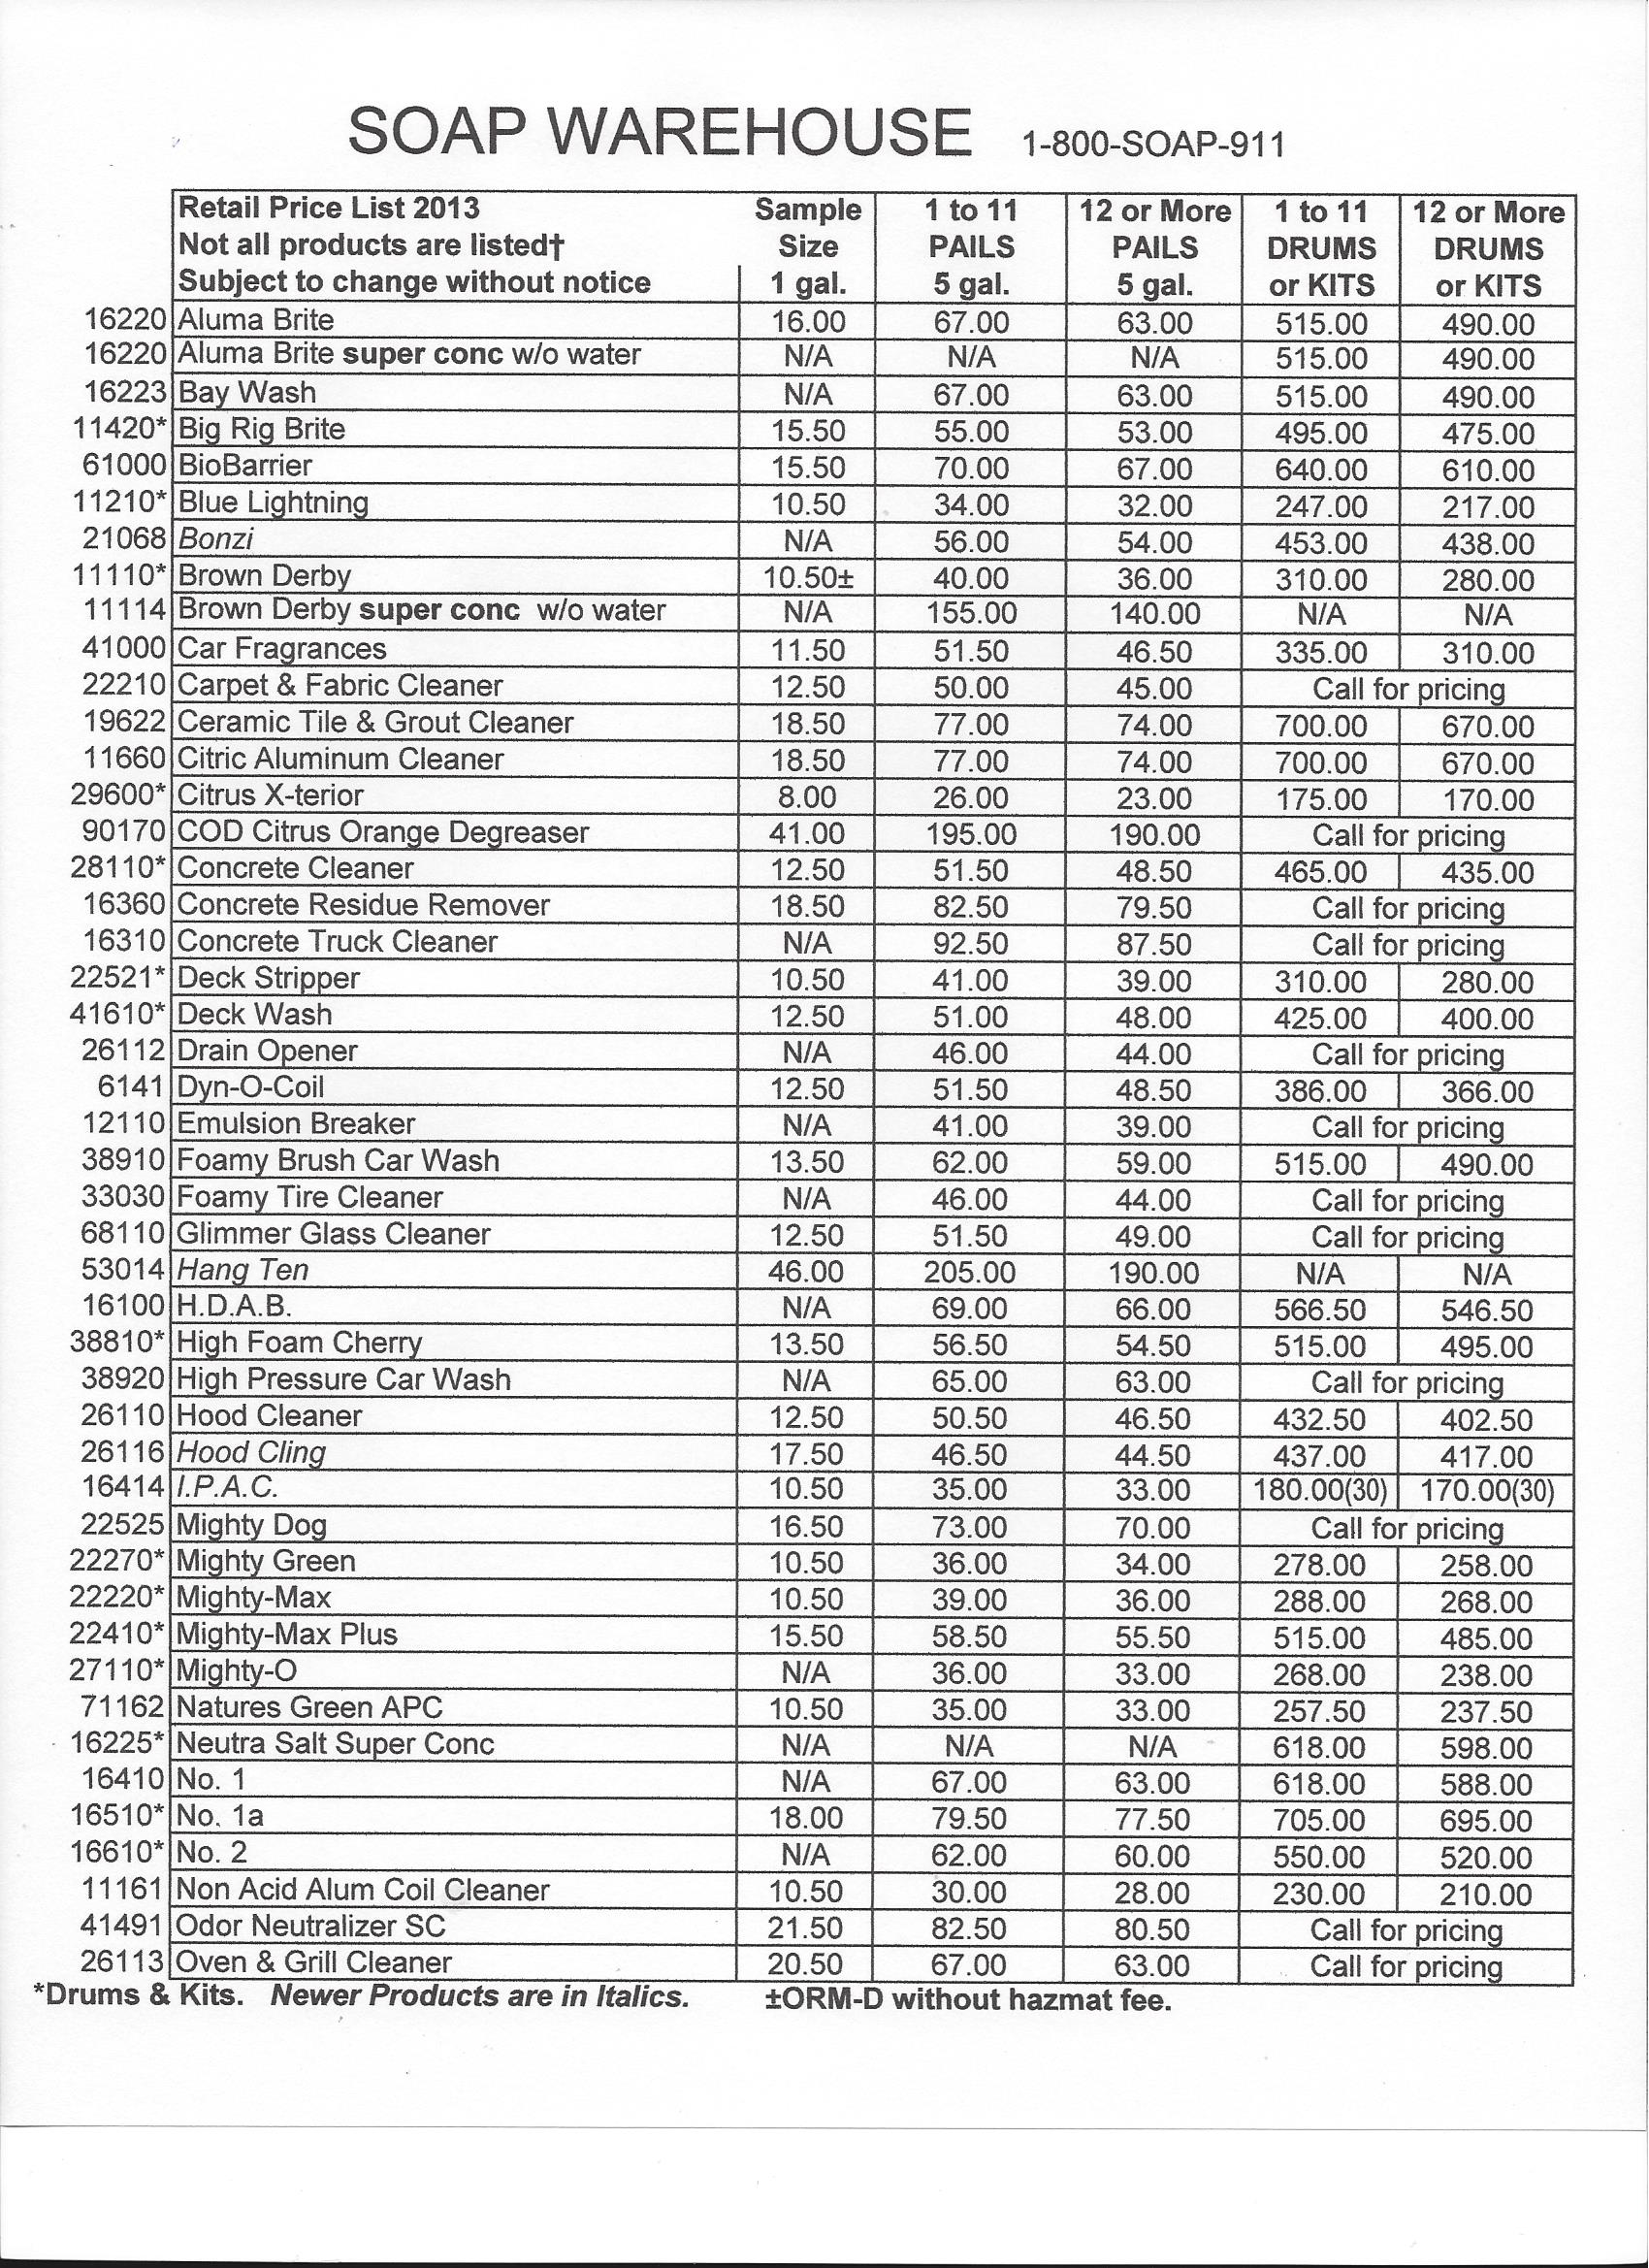
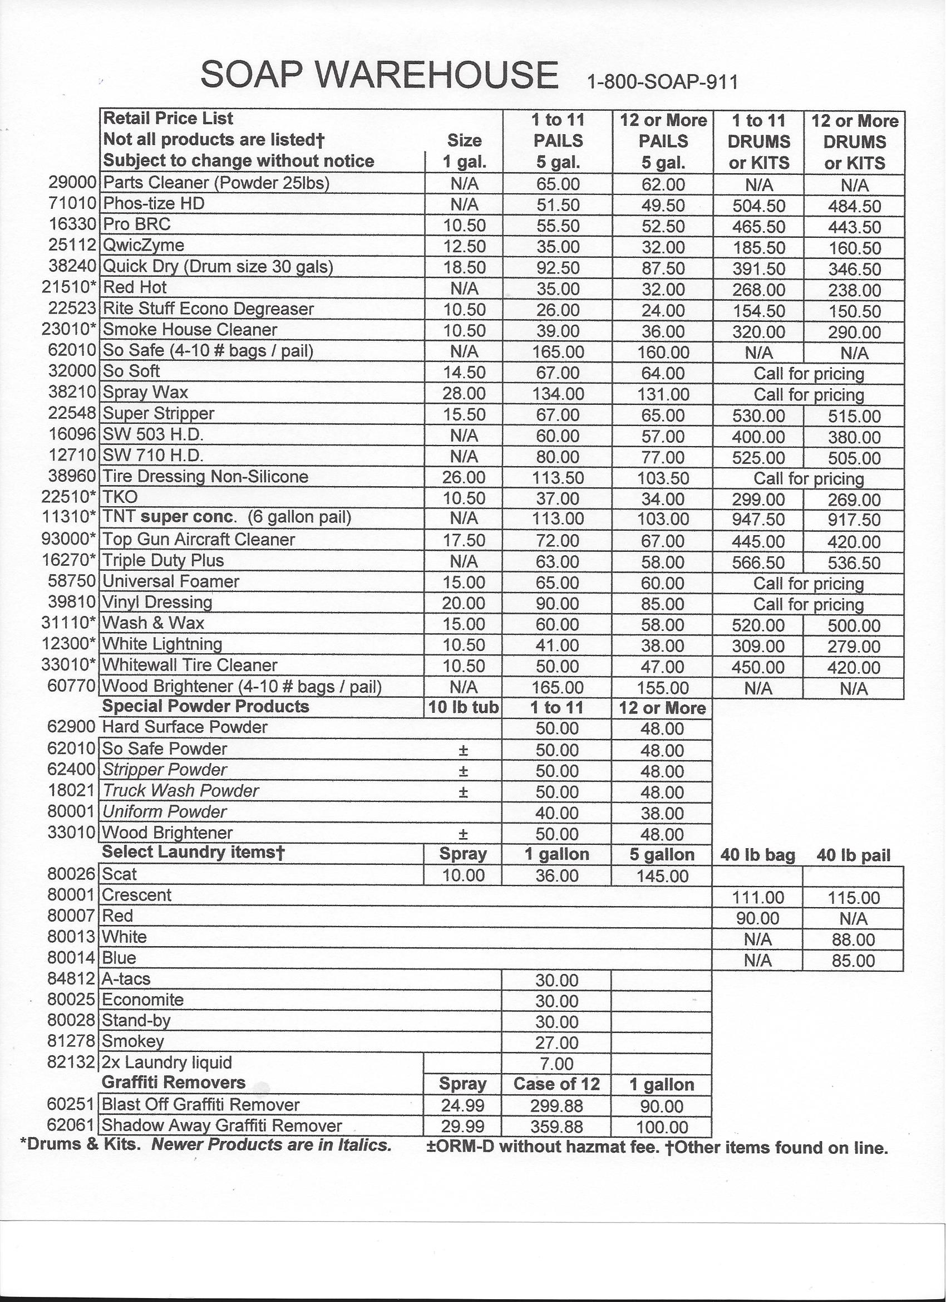

Products for the pressure washing industry!

Products ordered on line do not include shipping which must be added.

To order list the product name and number followed by the size indicator:
-01 for 1 gallon
-01C or C for cases of 1 gallons
-05 for 5 gallon
-55 for 55 gallon drum
-SDK for a single drum kit*
* please notice in description when 1 drum can make 2

Some products may also be available in
-5DK for 5 drum kits or
-10DK for 10 drum kits±
±For these kits you must be able to mix the entire kit at one time in a single large container

Soap Warehouse
P.O. Box 392292
Snellville, GA 30039

800-SOAP 911 (762-7911)
770-939-5488 local , 770-939-5501 fax

E-mail: info@soapwarehouse.biz
Web site found at: www.soapwarehouse.biz

