2014 HubSpot ROI Report
The Return on Investment from Inbound Marketing through Implementing HubSpot Software
January 2014

Every year, HubSpot takes a look at real customer data and commissions an MIT Sloan student to crunch the numbers. This report captures the return on investment HubSpot customers have experienced from conducting inbound marketing with HubSpot software.

The analysis comes from HubSpot customer survey responses and customer web data over a 24-month period for each customer, spanning 2012 and 2013. It is focused on three fundamental pieces of the marketing methodology, as you can see in the diagram below:
1) Attracting strangers to become website visitors
2) Converting website visitors to leads
3) Closing leads into customers
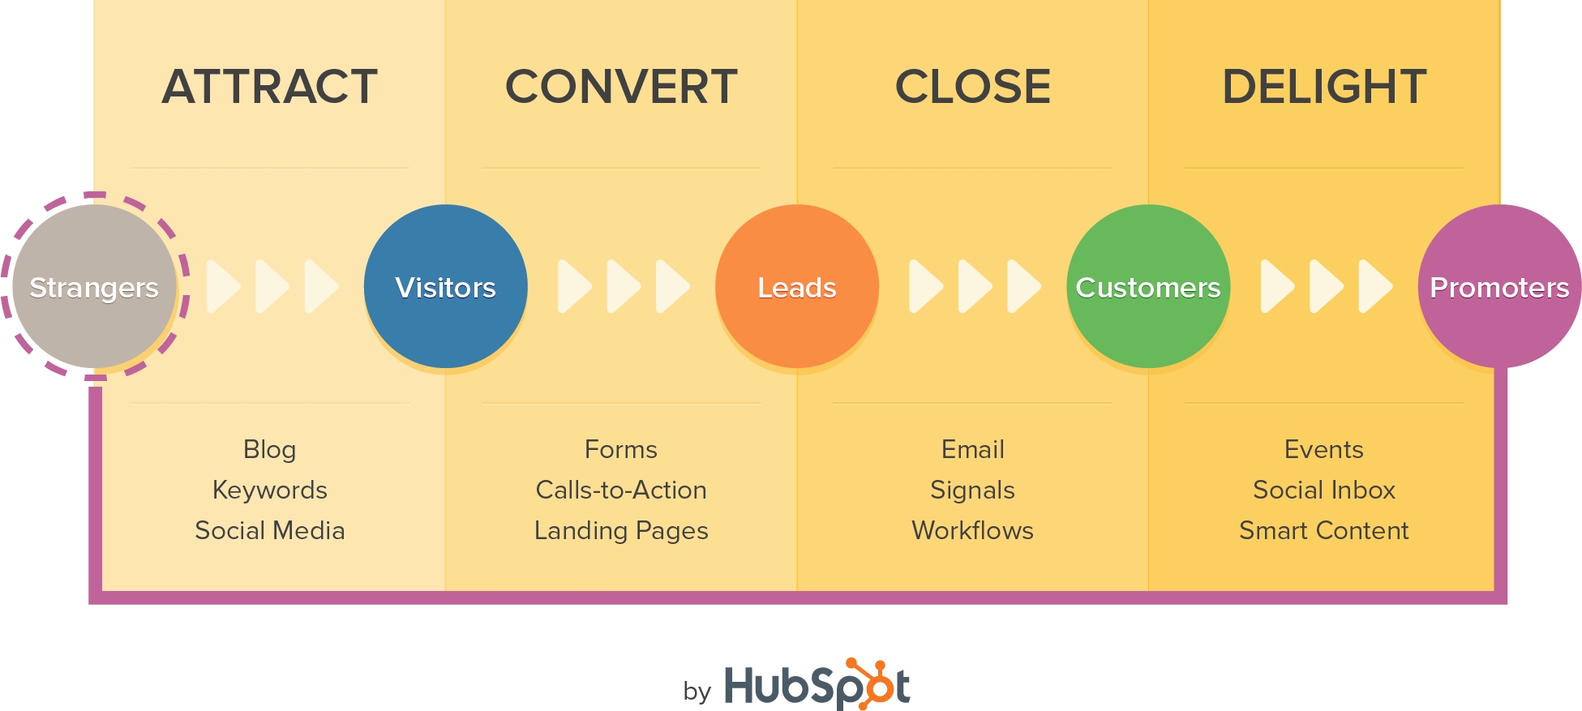

Through this analysis, the following key takeaways have been determined:

- Attracting Site Visitors: Customers reached 2.40 times more visitors per month within 1 year.
- Converting Visitors to Leads: Customers reached 5.99 times more leads per month within 1 year.
- Turning Leads into Customers: 69% of customers saw an increase in sales revenue, 74% of which experienced this increase within 7 months of using HubSpot.

Additional Benefits of HubSpot software and Inbound Marketing
- 93% of customer respondents agree that HubSpot has helped them meet their marketing goals.
- -Over 30% of customers reduced their sales cycle since implementing HubSpot.
- Over 40% of customers saw an increase in their end customer satisfaction since using HubSpot.

HubSpot customers of all sizes saw significant increases in site traffic and lead conversion rates. The following tables break the data down by customer groups:

Gains in Attracting Website Visitors:
 | After active use of HubSpot for
Customer Group | 6 Months | 1 Year | 2 Years
All | 1.80x more visitors | 2.40x more visitors | 3.40x more visitors
1 to 499 starting visitors | 2.19 | 4.08 | 7.45
500 to 2,499 starting visitors | 1.87 | 2.66 | 3.77
2,500 to 9,999 starting visitors | 1.51 | 2.05 | 2.93
10,000 to 99,999 starting visitors | 1.45 | 2.01 | 2.81
100,000+ starting visitors | 1.23 | 1.72 | 2.30

Gains in Converting Leads:

 | After active use of HubSpot for
Customer Group | 6 Months | 1 Year | 2 Years
All | 2.69x more leads | 5.99x more leads | 24.69x more leads
Less than 10 starting leads | 3.09 | 9.38 | 45.66
10 to 49 starting leads | 2.58 | 5.01 | 18.22
50 to 499 starting leads | 2.08 | 3.97 | 13.56
500 to 4,999 starting leads | 1.39 | 3.22 | 10.43
5,000+ starting leads | 1.14 | 2.42 | 6.49

Gains in Closing Customers:
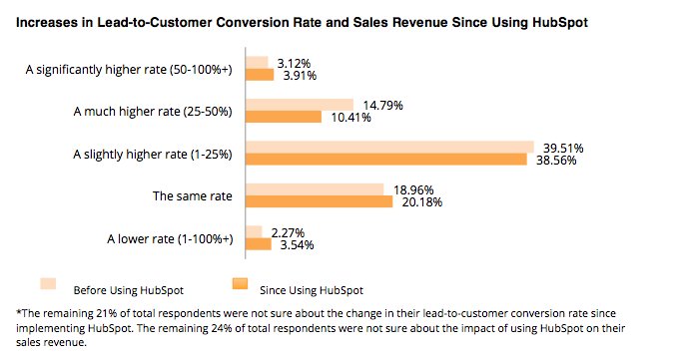

Regardless of the starting volume of visitors or leads, this study indicates that HubSpot customers across various segments experience a fairly significant increase in their marketing metrics. HubSpot’s products have consistently provided a quick and high return on investment for a large majority of its customers.

Find the full ROI report, with more stats and HubSpot customer testimonials, at www.hubspot.com/roi

